A Level Computer Science

NEA 2020



Name: Ellis Joseph Breen

Title: Book Recovery System

Exam ID: 6217

College: Xaverian College

Centre Number: 32455

Contents

Analysis 3

Background and Identification of the Problem 3

Current System 4

Identification of Prospective Users 6

Specific Requirements of the User and Acceptable Limitations 7

Data Dictionary 9

Entity Relationship Diagram 11

Data Flow Diagram 12

Data Volumes 13

Objectives 14

Proposed Method of Solution 16

Design 17

Overview of the System 17

Data Flow Diagram 21

E-R Diagram 22

Design Data Dictionary 23

Description of Data Structures 28

User Interface Design 29

Other Algorithms 42

System Security and Integrity of Data 47

Technical Solution 48

Introduction 48

Complex Procedures 49

Program 51

Database 86

Testing 87

Evaluation 108

User Feedback 113

Additional Adjustments 115

Overall Assessment of Project 116

# Analysis

## Background and Identification of the Problem

I am going to create a book recovery program for the local library service, utilised by the Book Recovery Officer. The idea for this program came about after discussing this project with my mum. She is currently a Library Assistant but was the Book Recovery Officer for the area for many years. As a Book Recovery Officer, she was responsible for the recovery of overdue items for Stockport Libraries. She was to gather the information of all long overdue loans and create reports for each library in Stockport. With this information, she would then alert borrowers of their overdue loans and visit them in an attempt to recover the items.

However, the process was very complicated and tedious due to the system they were using at the time (this will be explained further in the ‘Current System’ section). My program will hopefully improve upon the current system, and will achieve this by consulting with my mum, the end user, about what needed to be worked on and how, overall, this new program could make the role of Book Recovery Officer easier.

## Current System

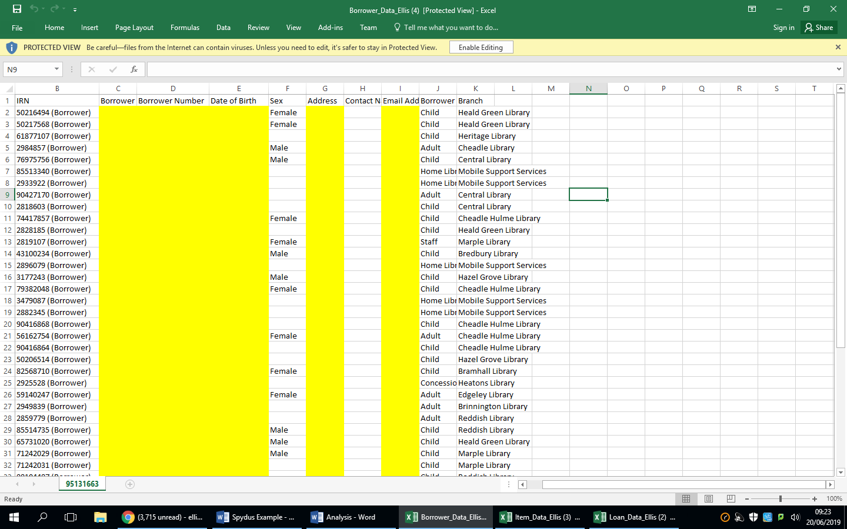The current system in use by the library service is Spydus, a library management system. However, the Book Recovery Officer primarily uses multiple Excel spreadsheets where the information that is presented on Spydus is stored.

The first spreadsheet used by the Book Recovery Officer stores the information of all the borrowers using the Stockport Libraries:

(The yellow columns have been blanked out for privacy reasons)

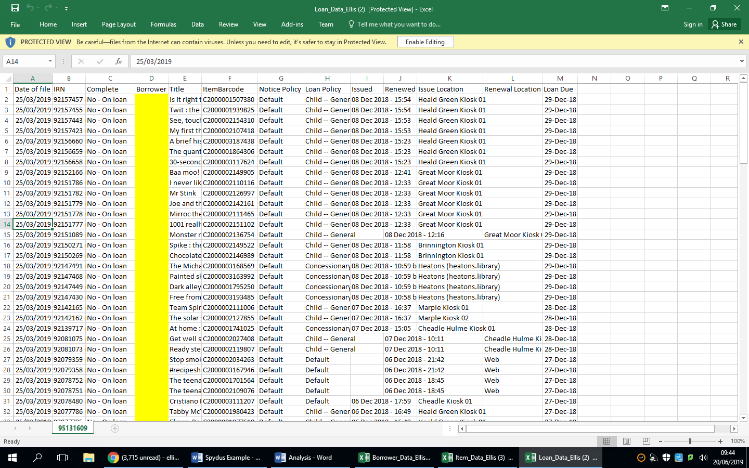The Second stores all the loan information:

(The yellow columns have been blanked out for privacy reasons)

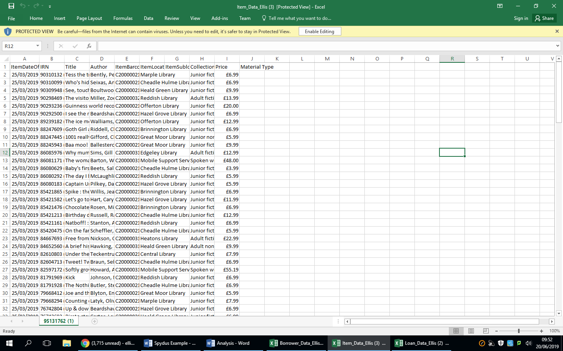The third stores all the item information:

In order to generate their reports, the Book Recovery Officer needed a variety of information from each spreadsheet. This information was not easy to locate, however. The Book Recovery Officer had to run three separate reports using these spreadsheets to gather the information they needed. The first report was run to retrieve borrower information, the second to retrieve loan information (Date due, long overdue status and item details), and the third to retrieve item information, including price. Report 3 is run solely because report 2 does not gather the price of the item on loan. This is important because the Officer only chases items or loans totalling £25 or more.

After these reports are run and opened in Excel, a macro must be run on each of the reports as there is initially too much information to deal with. These macros delete unneeded cells and format the remaining cells. The macros that were used were just under 80 lines long and were all typed out manually by someone who no longer worked for the library service. This wasn’t very efficient, partly because of the amount of work involved in making the macros just to filter information, and because it meant the Book Recovery Officer relying on someone other then themselves to get the job done. Furthermore, because the macros were so temperamental, if there was a slight change to the field names or data types in the spreadsheets they would have to be re-written.

Once they have the required data only, it is then exported into Access, where reports are run for each library branch in that area. All data from these reports are then manually inputted into Excel, including costs recovered, as the Officer must submit a report at every quarter to show how much they recovered for each library branch.

## Identification of Prospective Users

The target user for this program will primarily be the Book Recovery Officer, as it will generate and retrieve data specific to their needs. However, general library staff should be able to use it if needed. Because of this, the program should be easy and straightforward to use, requiring little to no training, unlike the current system.

## Specific Requirements of the User and Acceptable Limitations

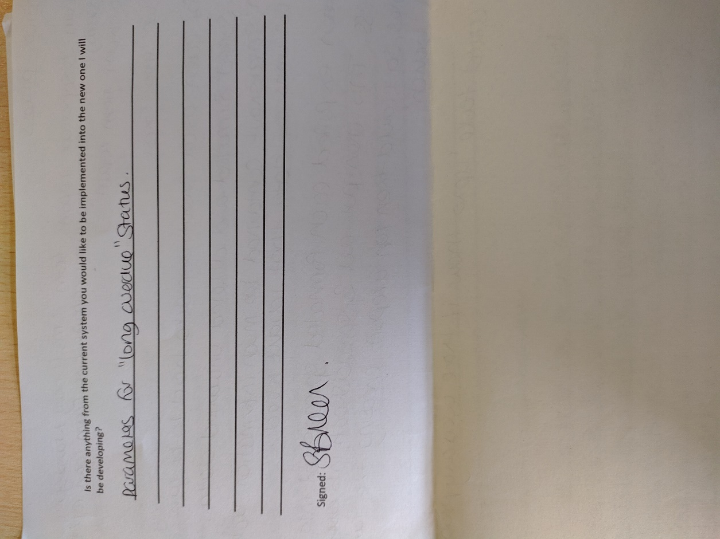

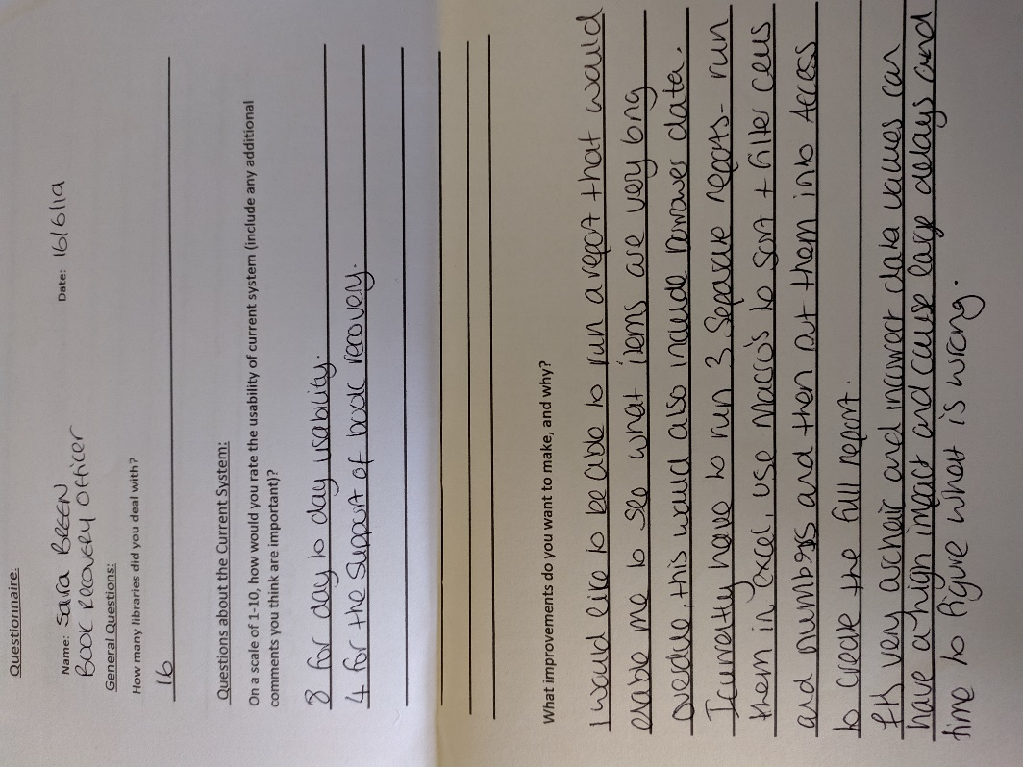

As you can see, the current system is more tailored towards general library assistants, as its usability was rated 8/10 for everyday use. Therefore, its interface and design should be considered when making my program. Where it falls down, however, is when the user wants to perform Book Recovery Officer specific tasks, such as viewing long overdue items. The usability rating given for these type of tasks was 4, so it’s clear that this system isn’t best suited to deal with what the Book Recovery Officer needs. In the Current System section, we saw how arduous the current process is, as many different actions and reports have to be run and taken in order to gain the information needed. The views of the interviewee are clearly expressed when describing it ‘archaic’, so the new system I am developing has to be quick and require little work from the user in order for it to work and be seen as an improvement.

Using the questionnaire and discussing it with the end user, we have come up with the following requirements:

* The user must be able to see items and loans that are long overdue (51 days past the due date). This should be grouped by the addresses of the borrowers with these loans, in order to organise home visits in order to recover the books.
* The user must be able to get the information of borrower’s whose loans are long overdue and whose total value of all of their loans is £25 or more.
* The program must generate a graph showing the months of the year and the number of overdue items/loans for each month. This will help the book recovery officer to plan for the year as it will help them to see how busy they may be based off the previous year.
* The program may generate a report showing how many books the Book Recovery Officer has recovered and the total value of the books.

All of these objectives are reasonable, so I will aim to implement them all into the system. In addition to these requirements, however, the program must also allow the user to enter borrower, item and loan details into the database. Ideally, the program would incorporate the database currently being used by the library service that stores all of this information, but because of its confidentiality, I am going to have to allow the user to create their own and add the aforementioned details manually.

Acceptable Limitations:

One of the tasks that a Book Recovery Officer has to complete is generating a report for each library they are responsible for. This involves creating a table for each library that includes loan and borrower details. According to the questionnaire, there would be 16 separate tables for each library. Because of the large amount of work and data required for this, I will not be creating a report for each separate library, but will give the user the option to group the overdue loans report by library as well as address.

Items are withdrawn from a library using a machine that scans the borrower’s library card and the item they are taking out on loan. From this it determines the borrower number and item being taken out. This technology isn’t available to me, so a member of staff will have to manually enter the borrower number and item barcode each time a loan is made.

## Data Dictionary

|  |  |  |  |  |  |
| --- | --- | --- | --- | --- | --- |
| **Name** | **Data Type** | **Length** | **Validation** | **Example Data** | **Comment** |
| BorrowerNumber | CHAR | 14 | Must = 14 characters and start with ‘D1’ | D1000000345987 | Unique identifier of borrower  Each borrower must have one in order to use the library. |
| BorrowerName | VARCHAR | 50 | - | Sam Alexander | Name of borrower |
| DateOfBirth | DATE | 10 | Must be in the format DD/MM/YYYY | 02/01/2002 | Date of birth of borrower |
| Sex | VARCHAR | 6 | Male or Female | Male | Sex of borrower |
| Address | VARCHAR | 25 | - | 34 Dowesetrepla Avenue | Address of borrower, needed for home visits |
| Contact Number | VARCHAR | 11 | Must start with either ‘07’ or ‘0161’ | 01613681497 | Preferred way of contacting the borrower. Can be either mobile number or home number (landline) |
| Email Address | VARCHAR | 30 | Must contain the ‘@’ symbol | Sam.alexander@gmail.com | Another way of contacting the borrower, used to inform them of less urgent things. |
| BorrowerCategory | VARCHAR | 20 | - | Child | The category of borrower (e.g child, adult, home library service) |
| Branch | VARCHAR | 25 | - | Reddish | The library branch the borrower registered at. |
| ItemBarcode | VARCHAR | 20 | Must start with ‘C’ | C200000565432 | Unique identifier for each item |
| Title | VARCHAR | 50 | - | The Human Rocket | Item title/name |
| Complete | VARCHAR | 15 | - | No – On Loan | Indicates whether the loan has been completed or not |
| Issued | DATE | 10 | Must be in the format DD/MM/YYYY | 26/06/2019 | The date when the loan was made to the borrower |
| IssueLocation | VARCHAR | 30 | - | Heatons | Where the loan was issued |
| LoanDue | DATE | 10 | Must be in the format DD/MM/YYYY | 21/07/2019 | When the loan is due/item should be returned. |
| ItemLocation | VARCHAR | 30 | - | Marple | Library the item is located in. |
| Author | VARCHAR | 50 | - | Jeff Loeb | Name of author of item. |
| Collection | VARCHAR | 25 | - | Junior Fiction | Collection the item belongs to. |
| Price | MONEY | 5 | - | 7.99 | Price of item, needed for book recovery. |
| IRN |  |  |  |  |  |
| DateOfFile | DATE | 10 | - | 07/07/2007 | Date the file (loan data) was made |
| MaterialType | VARCHAR | 15 | - | Hardback | Material the item is made from |
| ItemSublocation |  |  |  |  |  |
| Renewed | CHAR | 3 | - | Yes | Whether the loan was renewed. |
| RenewalLocation | CHAR | 30 | - | Reddish | Location where the loan was renewed. |
| NoticePolicy |  |  |  |  |  |
| ItemDateOfFile | DATE | 10 | - | 14/06/2009 | Date the file (item data) was made. |

## Entity Relationship Diagram

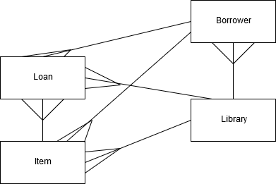

A borrower is registered to one library, and a library has many borrowers. They can also have many loans, but a loan is only registered to one borrower. Likewise, a borrower can have many items out on loan, but an item can only be with one borrower at a time.

An item is registered to one library, but a library can have many items. The library must have only one copy of each item, but each copy has a unique item barcode, and so a separate ‘Copy’ entity is not needed.

Over time, an item can be out on loan many times, hence the one to many, but can only be out on loan one at a time. Each loan is only of one item, hence the many to one.

A loan is issued by one library, but a library can issue many loans.

## Data Flow Diagram

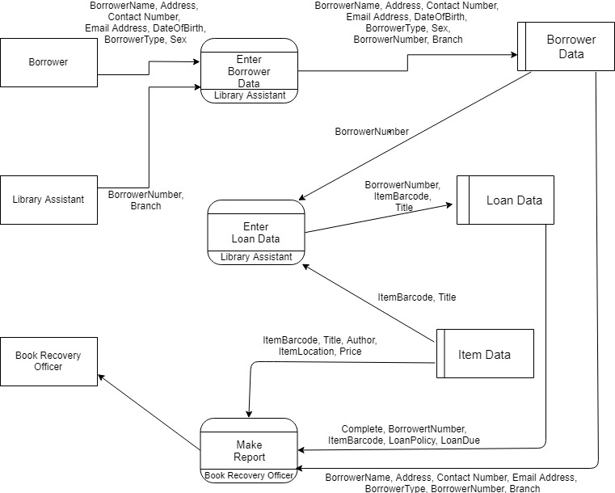

The first process described in this data flow diagram is entering the data for a borrower. Here, the borrower provides the information they have about themselves, and the library assistant provides the branch and the borrower number. These are all entered by the library assistant and stored in the Borrower Data table.

The second process involves entering the loan data for a new loan. The appropriate data is taken from Borrower Data, and along with the item barcode and title of the item, are entered into the Loan Data table by the library assistant. The latter details are taken form the Item Data table.

The final process described in the DFD involves making a report for the book recovery officer. This is done by the book recovery officer themselves by retrieving the appropriate data from all tables in the database.

## Data Volumes

The system must be able to cope with vast amounts of data, as there are many people that use the library. There will be 8 different details needed for each borrower, and many of these details can changed and updated over time (e.g. contact number, address), therefore the database needs to be dynamic. This applies to loan details as well, as the status of a loan can change depending on whether the item has been returned or not. This means that records in the loan details table will be amended more frequently than those in borrower details, as people will return items more frequently than moving house or changing numbers. The loan details will also include 8 different pieces of information. Furthermore, there will be more data stored overall in the loans table as well, as each borrower can have multiple loans. The loan details table will be added to more frequently than borrower details, because loans are taken out more often than new borrowers are added.

The book details table will also store vast amounts of data, due to the high stock the library has, but will not be edited manually by the library staff using this program. It will be updated regularly, however, as new items arrive at the library.

## Objectives

1. When the program is first opened, the database needs to be created.
   1. The program will check if the database exists.
   2. If it doesn’t exist, the program will create a new database, which will include all the necessary tables.
   3. If it does exist, the program will open the existing database when needed.
2. Create a user interface.
   1. The user will be sent to a log in screen.
   2. In order to be sent to the gain access to the system, the user must have a username and password stored in the database. If not and their log in details are wrong, they will not be allowed to use the system.
   3. Once logged in the user will be sent to a menu with options relating to loans, borrowers, reports and users.
   4. There will be separate ‘Loans’, ‘Borrowers’ ,‘Reports’ and ‘Users’ menus that the user will be sent to depending on where they choose to go to from the initial menu.
3. Create the ‘Loans’ menu.
   1. Once on the loans menu, the program will give the user the ability to add loans to the database and edit loans currently in the database.
      1. When adding or editing loans, the program must check that the borrower for which the loan is for exists in the database.
      2. The user must be able to choose which loan they want to edit if the borrower has multiple loans.
   2. When adding loans, the program must check how many loans the borrower already has and the type of item the loan is for.
      1. The loan is rejected if the borrower already has 10 items out.
   3. The program must automatically enter a due date that is 21 days from the day the loan was made.
   4. They can view all loans in the database or search for specific loans.
      1. The program will allow the user to search for loans based off borrower number.
      2. The program will allow the user to display all long overdue loans that have a total price of £25 or more.
4. Create the ‘Borrowers’ menu.
   1. Once there, the user will be able to add new borrowers to the database.
      1. The user must be able to enter the borrower number, name, date of birth, address, email address, contact number, borrower type, sex and branch of the borrower into the database.
   2. The user must be able to update the details of existing borrowers.
   3. The user can search for the details of a specific borrower by entering their unique borrower number. This will include name, address, email address, contact number, borrower type and branch.
5. Creates the ‘Reports’ Menu.
   1. Once there, the user must be able to choose what report they want to run and generate.
   2. The program should be able to generate a graph showing the number of long overdue loans for each month from last year.
   3. The program should be able to show the user how many items the book recovery officer has recovered over the past 12 months and the total value of the items.
   4. The program should generate a report that gathers all the information needed for collecting long overdue loans. This should include the title, author, and price of the item, name, address, date of birth and number of borrower, and the due date of the loan. This should be grouped by address/household.
6. Creates the ‘Users’ Menu.
   1. Allow the book recovery officer to create a new user that can access the system. They should be able to enter a unique username and password.
   2. If the username and password are valid, it should be stored in the Users table in the database.
   3. The current user should be able to change their password, as their original password will be one created by the book recovery officer.
   4. The program should allow the user to enter a new password and re-enter the new password to confirm it. If they match and the password is valid, it will be update the database and store the new password in the Users table.

## Proposed Method of Solution

I will be using C# along with Access to solve the problem. C# allows for the creation and customisation of a user interface using its visual components. This will make it easier to use and more user-friendly. I am also familiar with C#, so solving the problem using this language will be more efficient than using a new one. There is also a lot of support for C#, which means that should I run into any difficulties there will be people that can help.

SQL will be used to create the database in Access. Creating the database in SQL allows for easy initial creation of the database and modification if more attributes need to be added. Furthermore, SQL allows for the running of complex queries to retrieve information. This will be needed as one of the many problems with the current system is that many reports and queries have to be manually run rather than a program running one large complex one for them. SQL also allows you to group and sort information in a way that you need, which will be useful for solving this problem.

# Design

## Overview of the System

Here is a basic overview of the system:

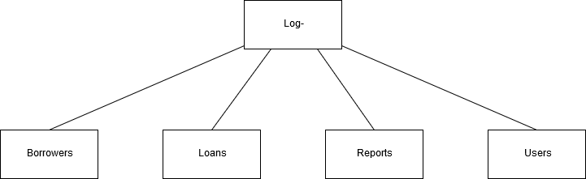

Log-In/Menu

When the program loads, the first form shown will be the Log-In/Menu form. Here the user will be given the chance to log-in, and if successful, will be presented with the menu. From here, they will be able to select which form they want to go to next, the Borrowers Menu, Loans Menu, Reports Menu or Users menu.

Borrowers Menu:

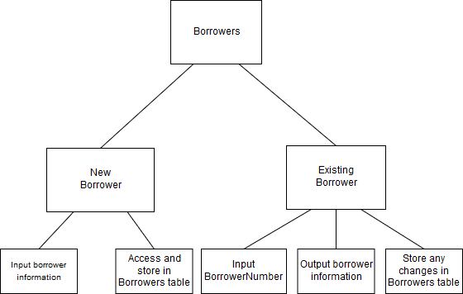

Above is a continuation of the hierarchy chart as it branches off to the borrowers menu. The users will have the option to then choose whether they want to add a new borrower or view/edit an existing one, sending them to the appropriate forms.

Adding a new borrower requires the user to add all the required information into the table via the program, whereas viewing an existing borrower will retrieve this information and show it to the user. In order to do the latter, the user will have to enter the BorrowerNumber, giving the user the option to edit the details of that borrower, saving any changes that may have been made.

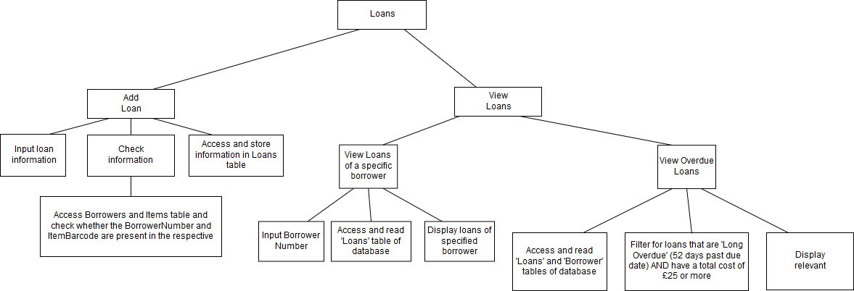Loans Menu:

loans

tables

Above is a continuation of the hierarchy chart once it branches into Loans. The Loans Menu form is first displayed, giving the user the option to add a new loan or view existing loans.

The Add Loan form allows the user to add a new and stores it in the Loans table.

The View Loans form allows the user to view the loans of a specific borrower or view all overdue loans.

When choosing to view the loans of a particular borrower, the user will be required to enter the BorrowerNumber, with the program searching the loans table for the number and displaying all details for that record.

When choosing to view all overdue loans, the program will access the Loans and Items table, filtering and displaying the loans that are long overdue and have a total cost of £25 or more.

Reports Menu:

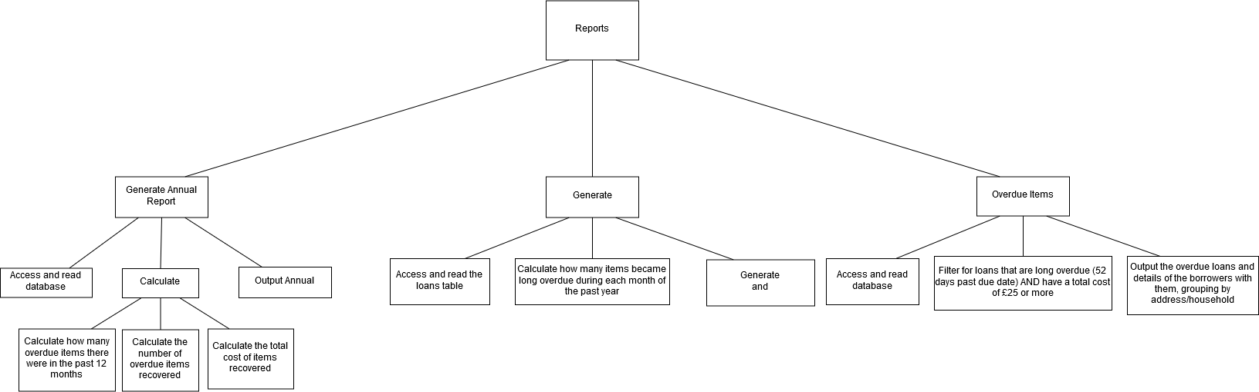

Graph

Above is a continuation of the hierarchy chart as it branches off into Reports. Here, the user will be given the opportunity to generate an annual report, a graph or a list of overdue items and relevant information.

When the user decides to generate an annual report, they will be displayed with figures relating to the overall performance of the book recovery officer in the past year, displaying how many items were long overdue, how many of these that were recovered by the officer and the total cost of the items recovered. This option will only be available to the book recovery officer, as it is not needed by ordinary library assistants and staff.

The second option the user can choose from is to generate a graph displaying the number of overdue loans on the y-axis and the months of the year on the x-axis.

Finally, the user can choose to view the details of all long overdue loans and the details regarding the borrowers who have these loans. This will be grouped by address, making it easier for the book recovery officer to plan home visits.

Users Menu:

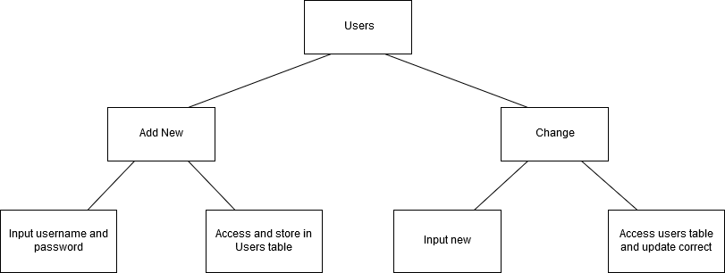



user



record

Above is a continuation of the hierarchy chart as it branches off into Users. Here, the admin will be able to add a new user, with this option being disables for regular users. A new record will be created in the Users table with a new username and password.

Everyone, however, will be given the option to change their password, and the program will update the appropriate record in the Users table with whatever has been entered.

## Data Flow Diagram

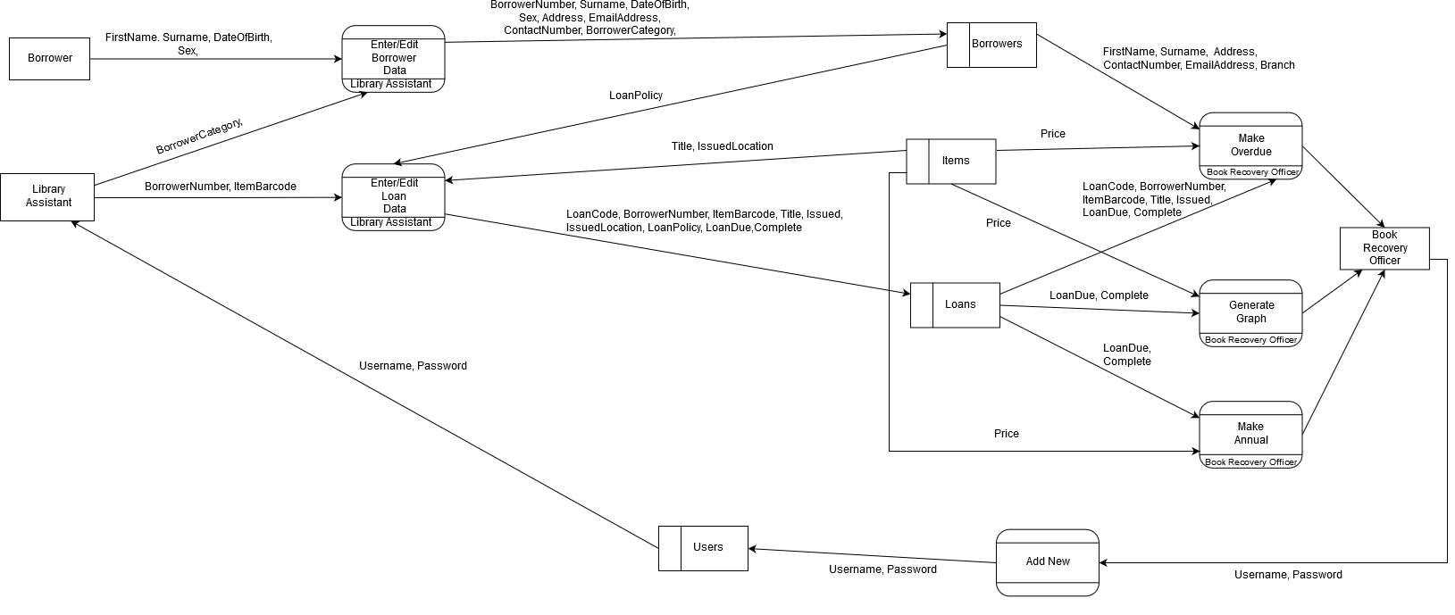

User

## E-R Diagram

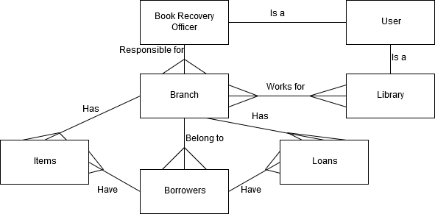

Assistant

The book recovery office and all library assistants with a log in are all users of the database.

The book recovery office is responsible for dealing with all long overdue items for many branches, however a branch only has one book recovery officer.

Library assistants can work in many different branches, and a branch can have many different library assistants working there at a given time.

A branch may contain many different items, but a particular item belongs to only one branch.

A borrower can have up to 10 different items on loan at a given time, but an item can only be loaned to one borrower at a time.

A borrower is registered to one particular branch, but can use all branches in that area.

A borrower can have many different loans, but a particular loan is only registered to one borrower.

A branch deals with all loans that are for items for that particular branch.

## Design Data Dictionary

|  |  |  |  |  |  |
| --- | --- | --- | --- | --- | --- |
| Table: Users – Stored as an MS Access table | | | | Primary Key: Username | |
| **Name** | **Data Type** | **Length** | **Validation** | **Example** | **Comment** |
| Username | VARCHAR | 10 | Presence Check | ADM1N | Primary Key – Uniquely identifies the user |
| Password | VARCHAR | 15 | Presence Check | Pas$w0rD | Password |
| Total Record Length: 25 | | | | | |

This table stores the log in details for the staff able to use the system.

The table will be searched whenever someone tries to log in.

New users are added to the end of the table and can only be added by the admin (the book recovery officer).

|  |  |  |  |  |  |
| --- | --- | --- | --- | --- | --- |
| Table: Borrowers – Stored as an MS Access table | | | | Primary Key: BorrowerNumber | |
| **Name** | **Data Type** | **Length** | **Validation** | **Example Data** | **Comment** |
| BorrowerNumber | CHAR | 14 | Length Check - Must be 14 characters  Format Check- Must start with ‘D1’ | D1000000234678 | Primary Key – Allocated to each borrower, with new numbers allocated sequentially from the last one given. |
| FirstName | VARCHAR | 25 | Presence Check | Ellis Joseph | First name(s) of borrower |
| Surname | VARCHAR | 20 | Presence Check | Breen | Surname of borrower |
| DateOfBirth | DATE | 10 | Format Check - Must be in the format DD/MM/YYYY | 02/01/2002 | Borrower’s date of birth |
| Sex | VARCHAR | 6 | Presence Check | Male | Sex of borrower |
| Address | VARCHAR | 40 | Presence Check | 54 Leaf Road | Borrower’s address |
| EmailAddress | VARCHAR | 25 | Must contain ‘@’ symbol | Name@domain.com | Email address of borrower |
| ContactNumber | CHAR | 11 | Length Check – Must contain 11 digits  Format Check – Must start with ‘0161’ or ‘07’ | 01611349274 | Preferred contact number of borrower |
| BorrowerCategory | VARCHAR | 20 | Selected from list | Child | Category of borrower |
| Branch | VARCHAR | 15 | Selected from list | Reddish | Library branch where borrower registered |
| Total Record Length: 186 | | | | | |

New borrowers can be added at any time throughout the year. They are allocated a borrower number which will be one more than the last one entered.

All fields must contain the required information for the record to be saved.

New records are added to the end of the table whenever a new borrower is registered.

The name, address, email address, contact number and borrower category can all be edited/updated as they are subject to change by the borrower.

The Borrowers table will be queried to find the details of a specific borrower using their unique BorrowerNumber.

Whenever the Loans table is queried for overdue loans, this table will also be queried for the address of each borrower so they can be grouped in that way.

|  |  |  |  |  |  |
| --- | --- | --- | --- | --- | --- |
| Table: Items – Stored as an MS Access table | | | | Primary Key: ItemBarcode | |
| **Name** | **Data Type** | **Length** | **Validation** | **Example** | **Comment** |
| ItemBarcode | CHAR | 14 | Format Check – Must start with ‘C’  Length Check – Must be 14 characters | C2000001234567 | Primary Key – Uniquely identifies each item.  If there are multiple copies of the same item, the item barcode is different and unique for each copy given to each library branch. |
| Title | VARCHAR | 40 | Presence Check | Ready Player One | Title of item |
| Author | VARCHAR | 45 | Presence Check | Ernest Cline | Author of item |
| Price | MONEY | 5 | Type Check – All characters entered must be integers | 8.99 | Price of item |
| Collection | VARCHAR | 20 | Selected from list | Junior Fiction | Collection the item belongs to |
| ItemLocation | VARCHAR | 30 | Selected from list | Reddish Library | Location of item |
| Total Record Length: 154 | | | | | |

This table will be constantly changing as new items are registered to the library service. However, library assistants and the book recovery officer will not be given the ability to edit this table as it is not their job to do so.

Each field needs to contain the appropriate information for the record to be successfully stored.

A new record is added to the end of the table.

The numbers after the first two characters of the ItemBarcode are added sequentially according to the last record entered.

The Items table is queried for the title of the item whenever a new loan is added using the ItemBarcode the loan uses. It will also be queried for the price of the item whenever the Loans table is queried for overdue loans.

|  |  |  |  |  |  |
| --- | --- | --- | --- | --- | --- |
| Table: Loans – Stored as an MS Access table | | | | Primary Key: LoanCode | |
| **Name** | **Data Type** | **Length** | **Validation** | **Example** | **Comment** |
| LoanCode | CHAR | 14 | Length Check - Must be 14 characters  Format Check- Must start with ‘L1’ | L1000000000001 | Primary Key – Uniquely identifies the loan |
| BorrowerNumber | CHAR | 14 | Length Check - Must be 14 characters  Format Check- Must start with ‘D1’  Lookup | D1000000234678 | Identifies who the loan belongs to. |
| ItemBarcode | CHAR | 14 | Format Check – Must start with ‘C’  Length Check – Must be 14 characters.  Lookup | C2000001234567 | Identifies the item that is on loan. |
| Issued | DATE | 10 | Format Check – Must be in the format DD/MM/YYYY | 22/06/2019 | The date when the loan was issued. |
| LoanPolicy | VARCHAR | 25 | Presence check | Child -- General | Loan policy |
| LoanDue | DATE | 10 | Format Check – Must be in the format DD/MM/YYYY | 13/07/2019 | The date when the loan is due back |
| Complete | VARCHAR | 20 | Selected from list | No – On loan | The status of the loan, whether it is still out, has been returned or has been recovered. |
| Total Record Length: 177 | | | | | |

The Loans table is updated whenever a new loan is issued. Library assistants and the book recovery officer will be able to edit and add to the table using the program rather than doing it manually.

Each field needs to have appropriate information for it to be successfully stored.

The only fields that need to be entered by the staff are BorrowerNumber, ItemBarcode and LoanPolicy.

The LoanCode is generated by the program, as the numbers after ‘L1’ are added sequentially according to the last loan in the table.

The Issued field will already be filled with the current date.

The LoanDue field will be updated with a date calculated by the program, which will be 3 weeks from what has been entered in the Issued field.

The Completed field can be edited whenever the item is returned, whether it is by the staff or the book recovery officer.

This table will be queried for overdue loans by looking at the LoanDue and Complete fields, and will display all loans that have not been completed, are 52 days past the due date and have a total cost of £25 or over by looking at the Items table. These will be grouped according to the address by accessing and reading the Borrower table using the BorrowerNumber the loan has been assigned.

It will also be queried for loans for a specific borrower by searching for the BorrowerNumber.

## Description of Data Structures

Due to the project being mainly SQL based, there aren’t going to be many data structures. However, when generating the graph for overdue loans from last year, I will use an array. This array will be a two-dimensional array with 12 elements. Each element will store the month and the overdue loans corresponding to that month. I think an array will be the most efficient way of going about this because it means a loop can be used to input the data into the graph using the array, rather than writing out code to set up all of the x and y values individually for the graph.

## User Interface Design

Log-In/Menu Form:

Group Box:

gbxLogInDetails

Labels:

lbTitle

lbLogIn

lbUsername

lbPassword

Picture Box:

pbLogo

Text Boxes:

tbUsername

tbPassword

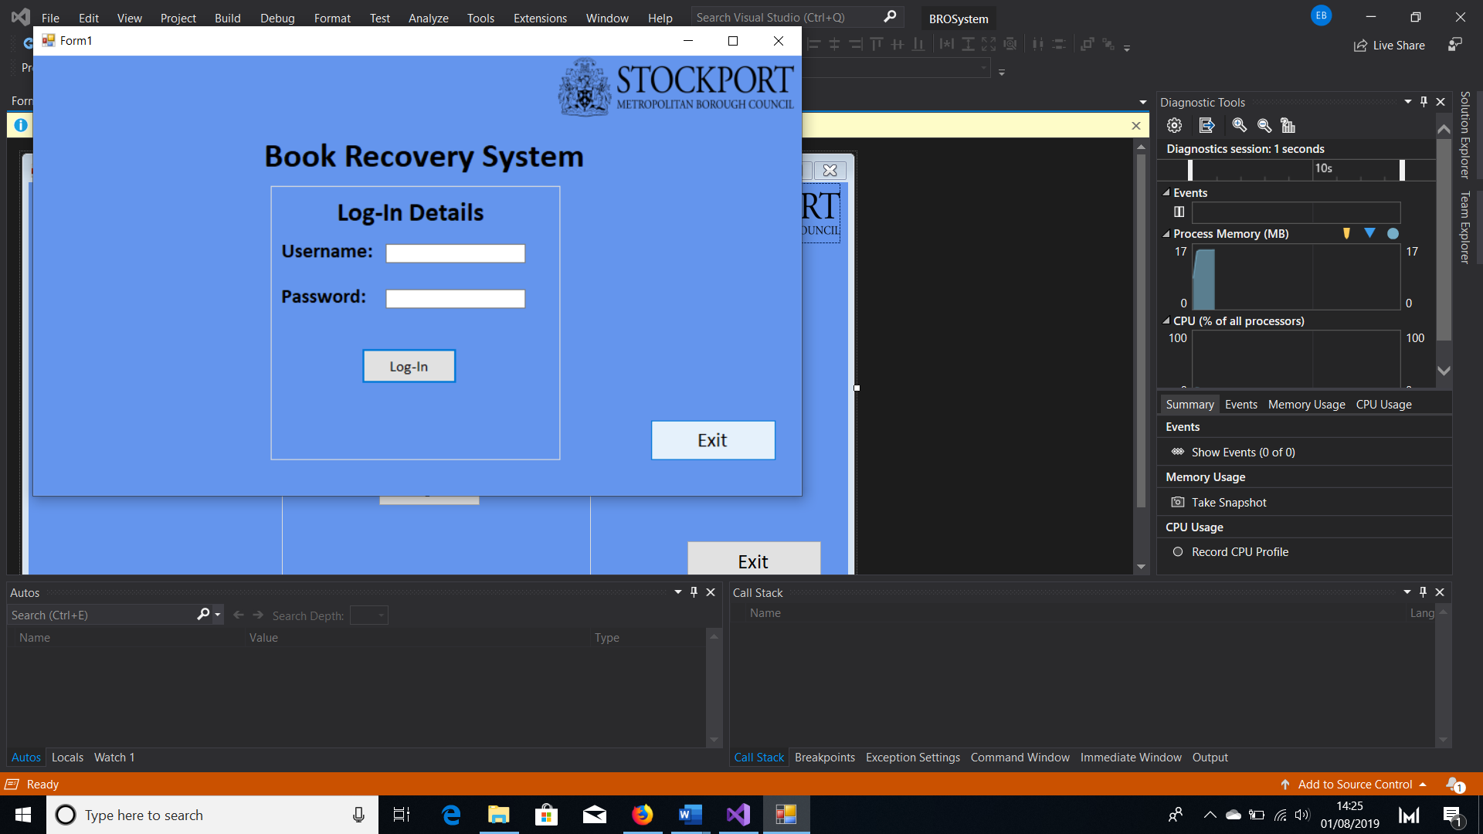

Button:

btLogIn

btExit

This will be the first form the user sees when the program is opened. In the Load event for the form, the program will check whether the database exists or not. If it doesn’t exist, a new database will have to be created, but if one does exist then that will be used. The following DDL commands will be used to create the database:

**CREATE TABLE Users(Username VARCHAR(10), Password VARCHAR(15), PRIMARY KEY(Username))**

**CREATE TABLE Borrowers(BorrowerNumber CHAR(14), FirstName VARCHAR(25), Surname VARCHAR(20), DateOfBirth DATE, Sex VARCHAR(6), Address VARCHAR(40), EmailAddress VARCHAR(25), ContactNumber CHAR(11), BorrowerCategory VARCHAR(20), Branch VARCHAR(15), PRIMARY KEY (BorrowerNumber))**

**CREATE TABLE Items(ItemBarcode CHAR(14), Title VARCHAR(40), Author VARCHAR(45), Price MONEY, Collection VARCHAR(30), ItemLocation VARCHAR(20), PRIMARY KEY (ItemBarcode))**

**CREATE TABLE Loans(LoanCode CHAR(14), BorrowerNumber CHAR(14), ItemBarcode CHAR(14), Issued DATE, LoanPolicy VARCHAR(25), LoanDue DATE, Complete VARCHAR(20), PRIMARY KEY (LoanCode), FOREIGN KEY (BorrowerNumber) REFERENCES Borrowers(BorrowerNumber), FOREIGN KEY (ItemBarcode) REFERENCES Items(ItemBarcode))**

Once the LogInInfo table has been created the Admin’s username and password is added to it:

**INSERT INTO LogInInfo**

**VALUES(“Adm1n”, “Pas$w0rD”)**

The user must enter a valid username and password in order to gain access to the menu. When entering the password, the text will be replaced with asterisks in order to keep it safe and secure. If the username and password are valid, the group box will be hidden to reveal the menu.

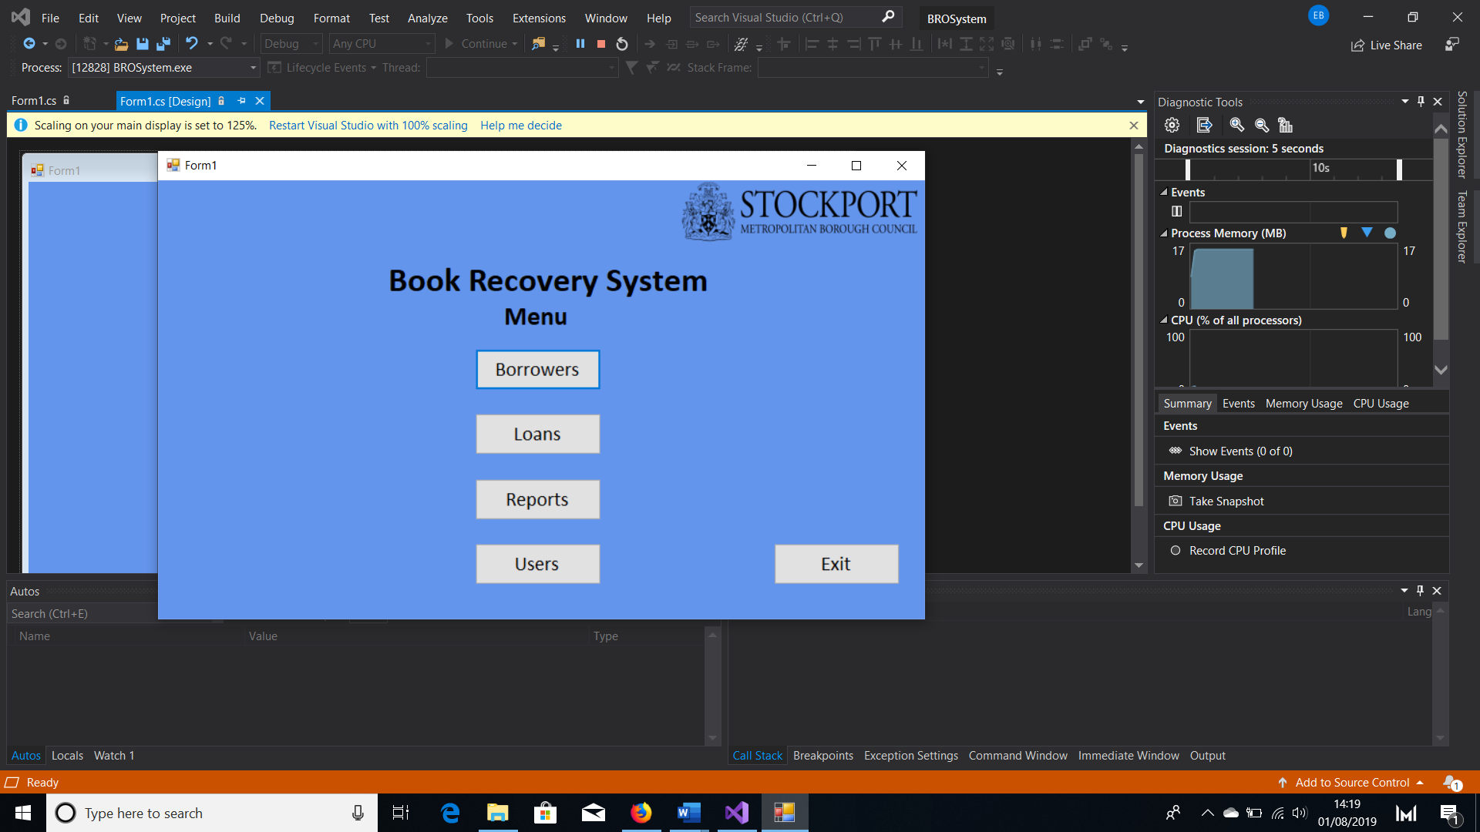

Picture Box:

pbLogo

Labels:

lbTitle

lbMenu

Buttons:

btBorrowers

btLoans

btReports

btUsers

btExit

Here the user will have the option of what they want to do next by clicking on the button of their choosing. Clicking the buttons will send the user to each respective menu, apart from the exit button, which will close the program.

Picture Box:

pbLogo

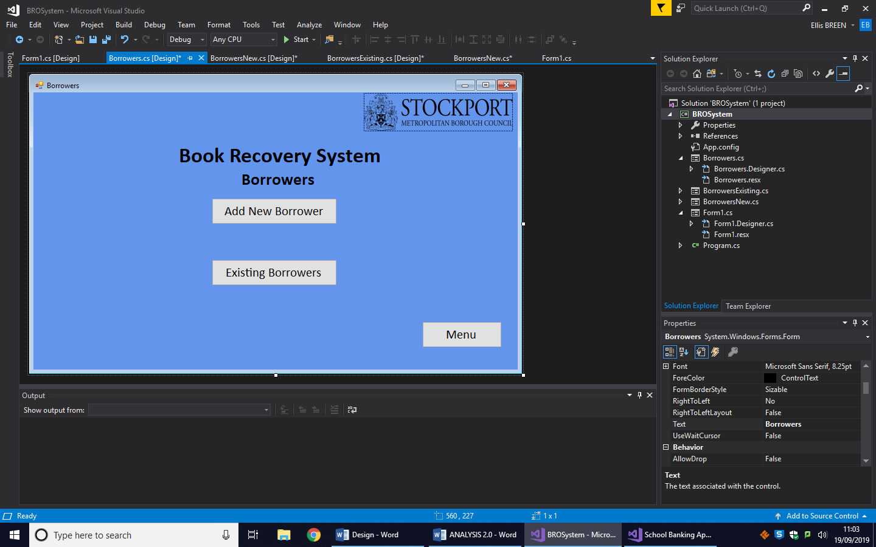

Labels:

lbTitle

lbBorrowers

Buttons:

btNew

btExisting

btMenu

After clicking the ‘Borrowers’ button on the menu, the user will be sent here, the Borrowers menu. Here, the user will be given the option of adding a new borrower, by clicking the ‘Add New Borrower’ button, or view/edit the details of an existing borrower, by clicking the ‘Existing Borrowers’ button.

This time, instead of an exit button, the user can press ‘Menu’ to return to the menu.

Picture Box:

pbLogo

Labels:

lbTitle

lbBorrowerNumber

lbFName

lbSurname

lbDOB

lbSex

lbAddress

lbEmail

lbNumber

lbCategory

lbBranch

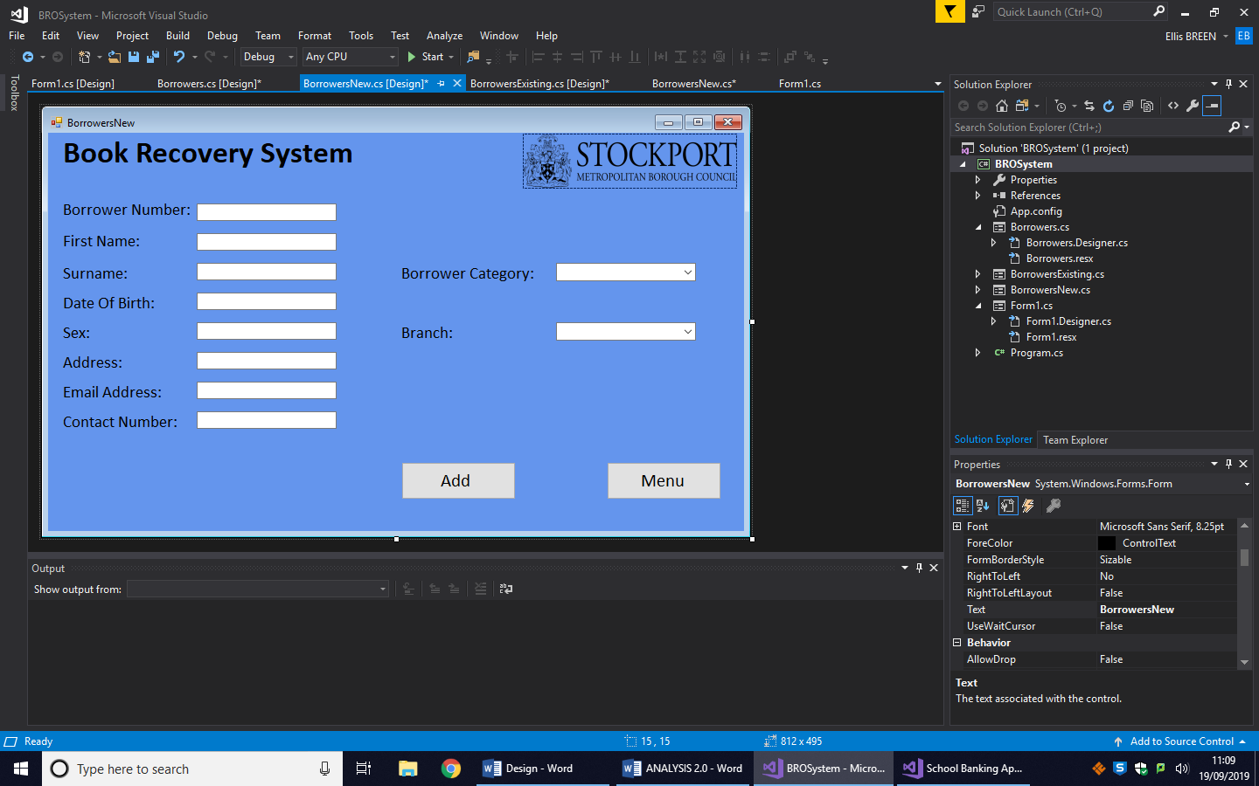

Text Boxes:

tbBorrowerNumber

tbFName

tbSurname

tbDOB

tbSex

tbAddress

tbEmail

tbNumber

Buttons:

btAdd btMenu

Combo Boxes:

cbCategory cbBranch

After the user selects ‘Add New Borrower’, they will be sent to this form. Here they will be able to enter all of the details of a new borrower, leaving nothing blank. The only text box the user will not be able to edit is tbBorrowerNumber, as the borrower number will be allocated automatically. When finished, they will have to click the ‘Add’ button for it to save.

Once again, there is a Menu button that allows the user to go back to the menu.

The following DML will be used to add the borrower to the database.

**INSERT INTO Borrowers**

**Values (“text in tbBorrowerNumber”,”text in tbFName”, “text in tbSurname”, “text in tbDOB”, “text in tbText”, “text in tbAddress”, “text in tbEmail”, “text in tbNumber”, “text in cbCategory”, “text in cbBranch”)**

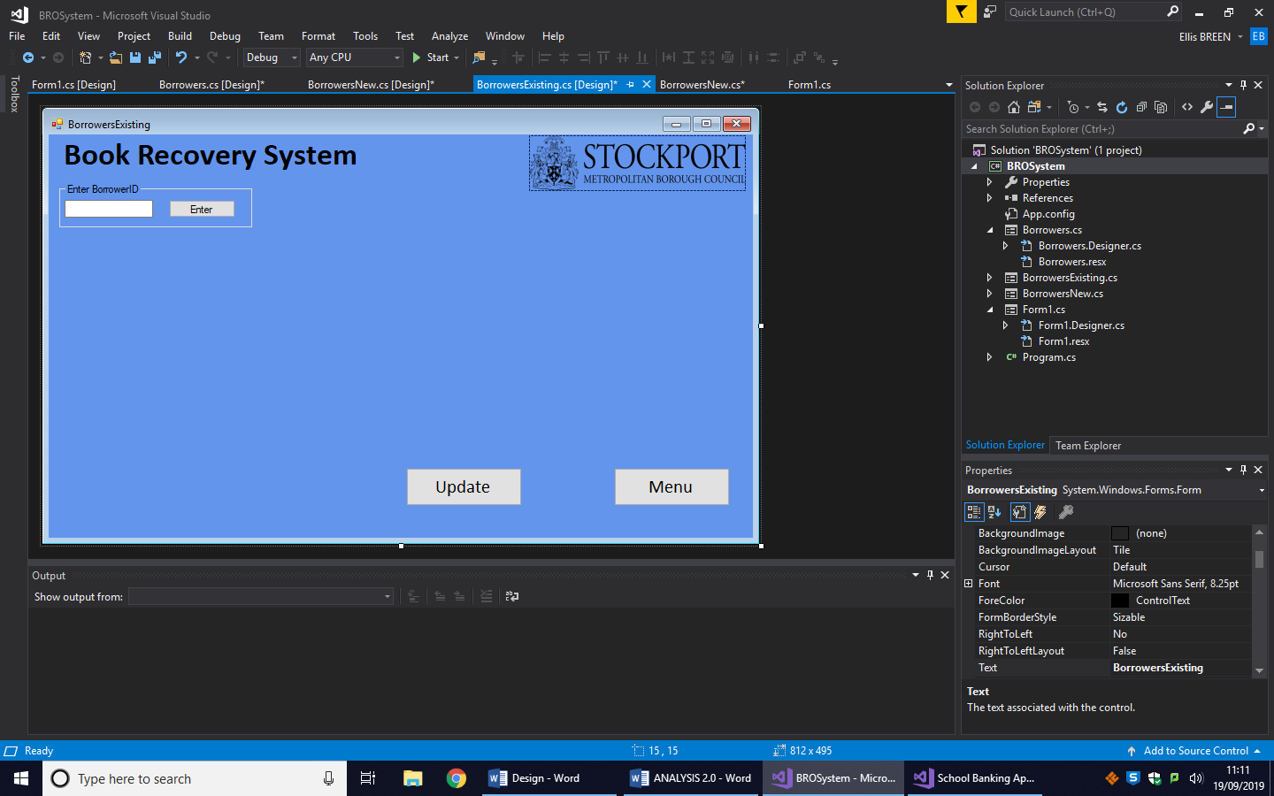

Picture Box:

pbLogo

Labels:

lbTitle

Buttons:

btEnter

btUpdate

btMenu

Group Boxes:

gbxBorrowerID

Text Boxes:

tbBorrowerID

Upon clicking the ‘Existing Borrowers’ button on the Borrowers Menu, the user will be sent to this form, where initially they will be asked to enter the BorrowerID. After entering a correct ID, a group box will appear displaying all of the borrower’s information. The following DDL is used to retrieve the borrowers details:

**SELECT Firstname, Surname, DateOfBirth, Sex, Address, EmailAddress, ContactNumber, BorrowerCategory, Branch**

**FROM Borrowers**

**WHERE BorrowerNumber = “BorrowerNumber entered into text box”**

If needed, the user can edit this information. This can be seen in the following image:

Picture Box:

pbLogo

Group Boxes:

gbxBorrowerID gbxBorrowerData

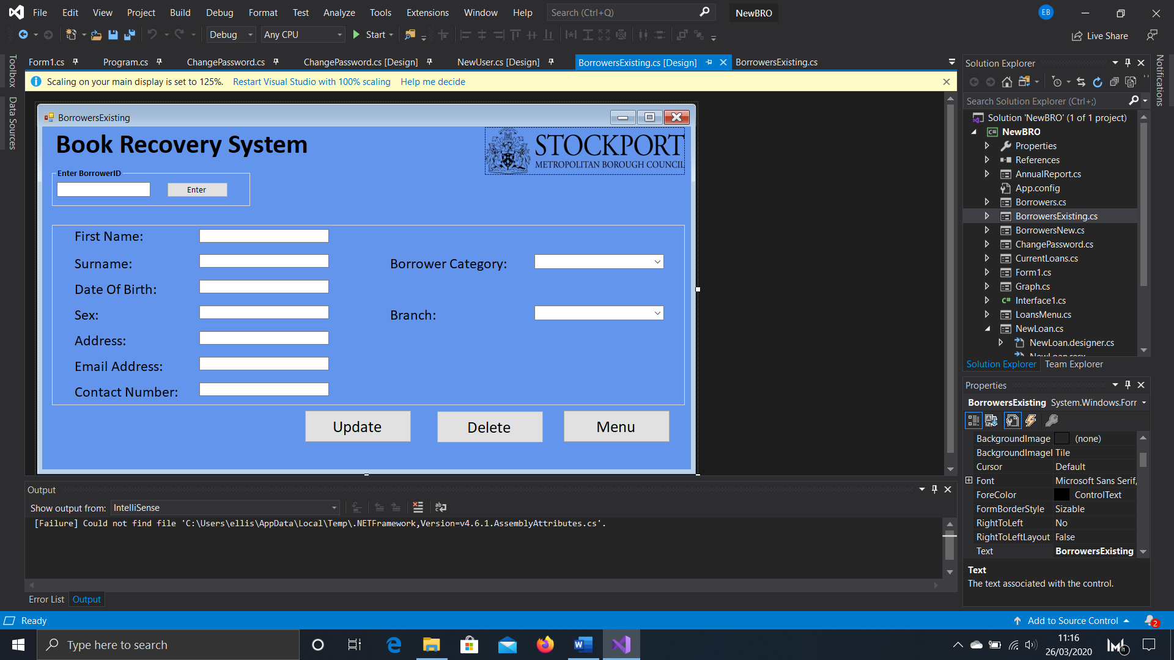

The following DML is used to update the borrowers details once btUpdate is clicked:

**UPDATE Borrowers**

**SET Firstname = “text in tbFName”, Surname = “text in tbSurname”, DateOfBirth = “text in tbDOB”, Sex = “text in tbSex”, Address = “text in tbAddress”, EmailAddress = “text in tbEmail”, ContactNumber = “text in tbNumber”, BorrowerCategory = “text in cbCategory”, Branch = “text in cbBranch”**

**WHERE BorrowerNumber = “text in tbBorrowerID”**

To delete a borrower, the following will be used:

**DELETE FROM Loans**

**WHERE BorrowerNumber = “text in tbBorrowerID”**

**DELETE FROM Borrowers**

**WHERE BorrowerNumber = “text in tbBorrowerID”**

Any loans made by the borrower being removed need to be deleted first in order to keep the database normalised. Only then can their details be deleted from the Borrower’s table.

Buttons:

btUpdate btMenu

btEnter btDelete

Combo Boxes:

cbCategory cbBranch

Text Boxes:

tbFName

tbSurname

tbBorrowerID

tbDOB

tbSex

tbAddress

tbEmail

tbNumber

Labels:

lbTitle

lbFName

lbSurname

lbDOB

lbSex

lbAddress

lbEmail

lbNumber

lbCategory

lbBranch

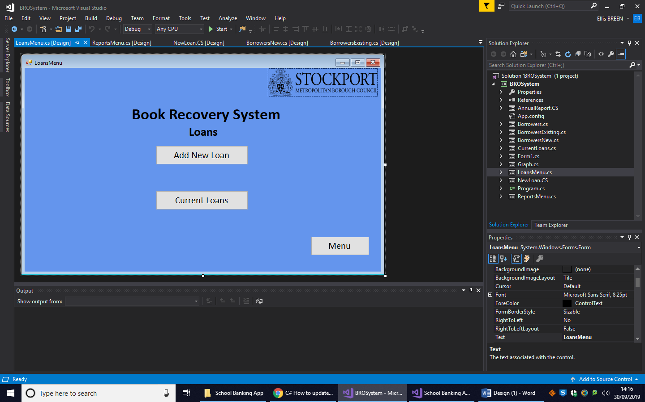

Labels:

lbTitle

lbLoans

Picture Box:

pbLogo

Buttons:

btNewLoan

btCurrentLoans

btMenu

If the user presses the ‘Loans’ button in the menu, they will be taken here. From this form, they will be able to choose whether they want to add a new loan or view current loans.

Labels:

lbTitle

lbLoanCode

lbBorrowerNumber

lbItemBarcode

lbDateIssued

lbLoanDue

lbLoanPolicy

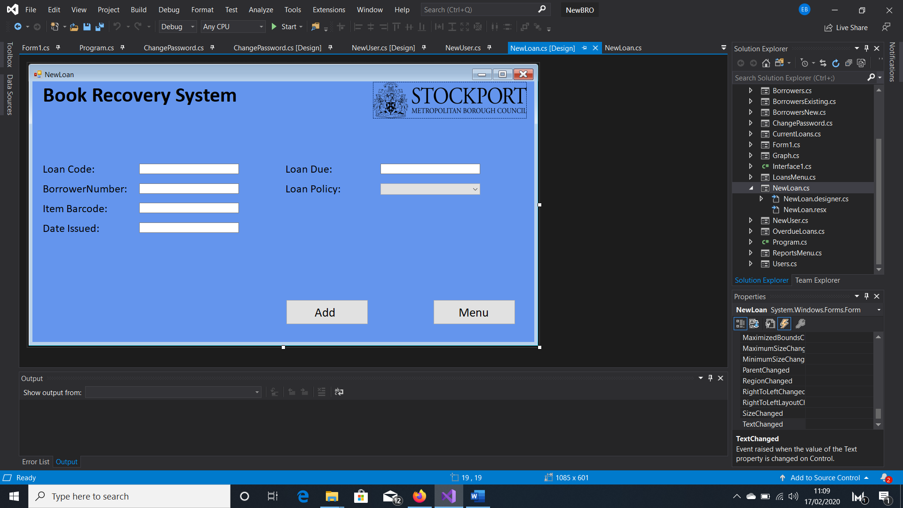

Picture Box:

pbLogo

Text Boxes:

tbLoanCode tbBorrowerNumber tbBarcode tbIssued tbLoanDue

Combo Box:

cbLoanPolicy

Buttons:

btAdd btMenu

If the user selected to add a new loan, they will be taken to this form. Here, they will have to enter information into tbLoanCode, tbBorrowerNumber and tbItemBarcode and select options from cbLoanPolicy and cbIssuedLoaction. The tbDateIssued box will be filled with the current date, and tbLoanDue with a date generated by the program. Once everything has been entered, the user will press ‘Add’ for it to be stored in the Loans table. There is one attribute in the loans table that is missing from this form, Complete. This will automatically be set to ‘No – On Loan’ when the rest of the record is added to the table.

Before it is stored in the database however, the program will check how many loans the borrower currently has out using the following algorithm:

**SELECT Borrowers.BorrowerNumber, Items.ItemBarcode, Items.ItemLocation**

**FROM Borrowers, Items**

**WHERE** **Borrowers.BorrowerNumber = '" + text in tbBorrowerNumber + "' AND Items.ItemBarcode = '" + text in tbBarcode + "'**

**if the query has a result**

**{**

**SELECT COUNT(BorrowerNumber) AS BN FROM Loans WHERE BorrowerNumber = '" +**

**text in tbBorrowerNumber + "' AND Complete = 'No - On Loan'**

**int temp = result of COUNT query**

**if temp < 10**

**{**

**INSERT INTO Loans**

**VALUES('" + text in tbLoanCode + "','" + text in tbBorrowerNumber + "','" + text in**

**tbBarcode + "', #" + text in tbIssued + "#, '" + text in cbLoanPolicy + "', #" + text in**

**tbLoanDue + "#, 'No - On Loan')**

**}**

**else**

**{**

**Display message “Borrower already has max number of items out”**

**}**

**}**

Combo Box:

cbComplete

Picture Box:

pbLogo

Group Boxes:

gbxSelect gbxBorrowerID

Labels:

lbTitle

lbComplete

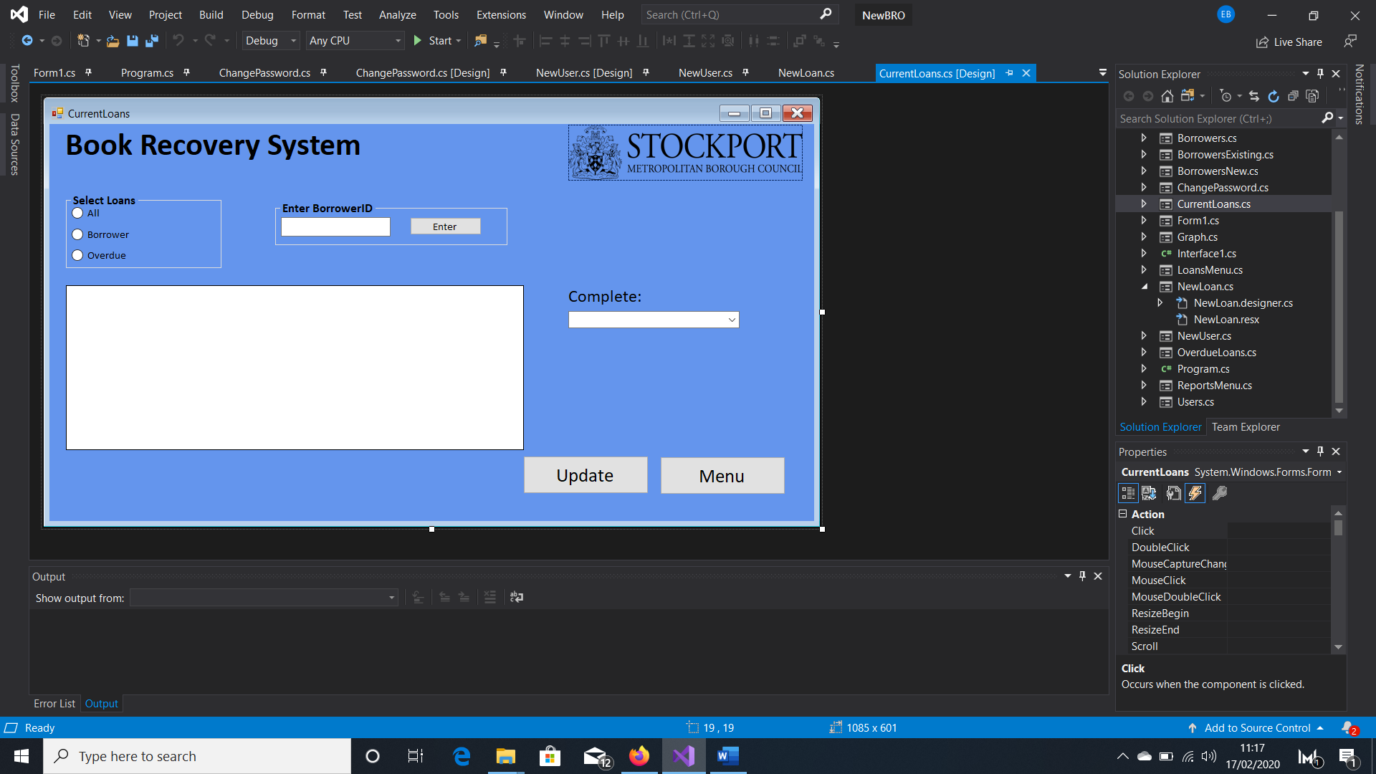

Radio Buttons:

rbAll

rbBorrower

rbOverdue

Text Box:

tbBorrowerID

Buttons:

btEnter

btUpdate

btMenu

Data Grid View

dgvLoans

If the user selected ‘Current Loans’ in the Loans Menu, they will be sent to this form. At first, only gbxSelect and its’ contents will be visible. If the user decides to view the loans of a specific borrower by selecting the appropriate radio button, gbxBorrowerID will appear, and the user will enter a BorrowerID. Once either a BorrowerID has been entered, rbOverdue or rbAll has been selected, dgvLoans will appear and display all the relevant loans. The user should be able to edit the ‘Complete’ status of a selected loan and have that change saved to the database.

The following DDL will be used if rbAll is checked:

**SELECT * FROM Loans**

**WHERE Complete = 'No - On Loan'**

If rbBorrower is checked:

**SELECT * FROM Loans**

**WHERE BorrowerNumber = 'text in tbBorrowerID' AND Complete = 'No - On Loan'**

If rbOverdue is checked:

**SELECT * FROM Loans WHERE Complete = 'No - On Loan' AND # today’s date – 51 days # >= LoanDue**

When the user wants to update a specific loan, the following DML will be used:

**UPDATE Loans**

**SET Complete = 'text in cbComplete'**

**WHERE LoanCode = 'loan code of the row selected in dgvLoans’**

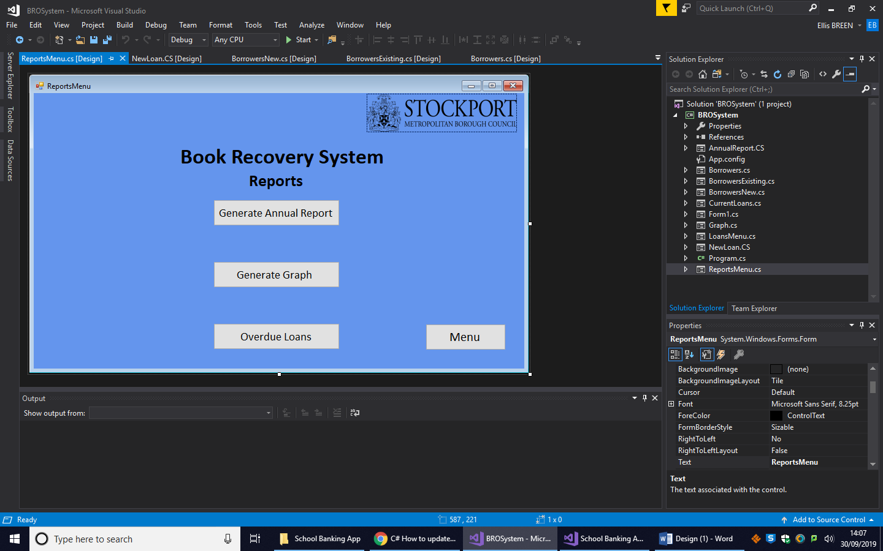

Picture Box:

pbLogo

Labels:

lbTitle

lbReports

Buttons:

btAnnual

btGraph

btOverdueLoans

btMenu

If the user clicks on the reports button on the menu, they will be sent to this form. Here they can decide what type of report they want to see and generate by clicking on the appropriate button.

Labels:

lbTitle

lbItems

lbItemsRecovered

lbCostRecovered

Picture Box:

pbLogo

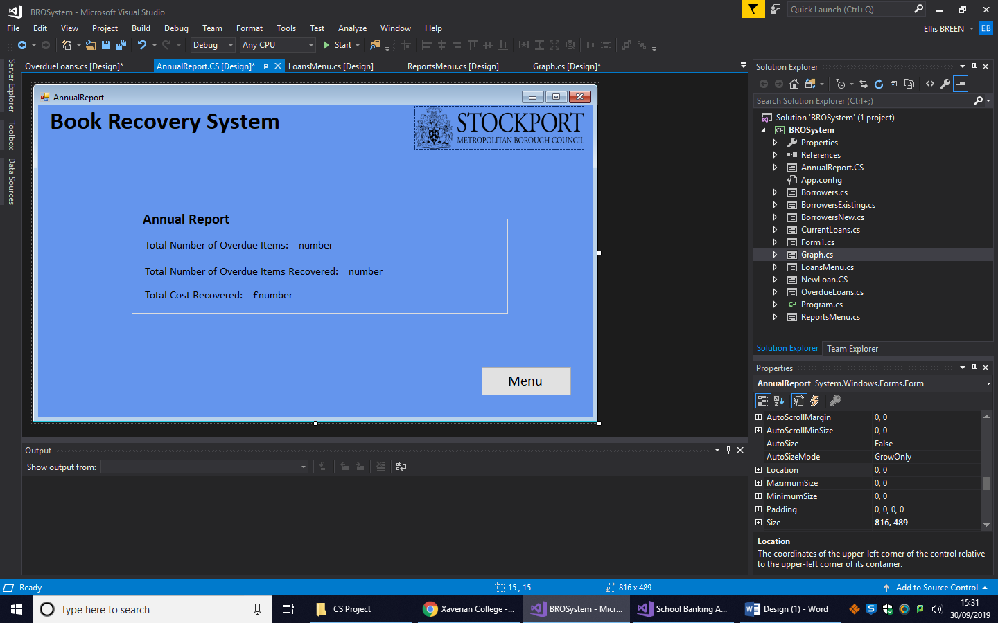

Group Boxes:

gbxAnnualReport

(More) Labels:

lbItemsValue

lbItemsRecoveredValue

lbCostRecoveredValue

Button:

btMenu

If the user clicks the ‘Generate Annual Report’ button on the Reports form they will be sent to this form. Here they will see the total number of overdue items, number of overdue items recovered and the total cost of the items recovered from the past 12 months. The labels lbItemsValue, lbItemsRecoveredValue and lbCostRecoveredValue will all be updated by the program to the correct values when the form is loaded.

The following DDL will be used to make the report for lbItemsValue:

**SELECT COUNT (COMPLETE) AS C**

**FROM Loans**

**WHERE (Complete = 'BRO' AND # today’s date – 51 days # >= LoanDue AND (YEAR(LoanDue) = " this year " OR YEAR(LoanDue) = " last year ") AND LoanDue >= #11/11/last year#)**

**OR (Complete = 'No - On Loan' AND # today’s date – 51 # >= LoanDue)**

For lbItemsRecoveredValue:

**SELECT COUNT (COMPLETE) AS C**

**FROM Loans**

**WHERE Complete = 'BRO' AND (YEAR(LoanDue) = " this year " OR Year(LoanDue) = " last year ") AND LoanDue >= #11/11/last year#**

For lbCostRecoveredValue:

**SELECT SUM (Price)**

**FROM Loans, Items**

**WHERE Loans.ItemBarcode = Items.ItemBarcode AND (Loans.Complete = 'BRO' AND YEAR(LoanDue) = " this year " OR Loans.Complete = 'BRO' AND LoanDue >= #11/11/last year#**

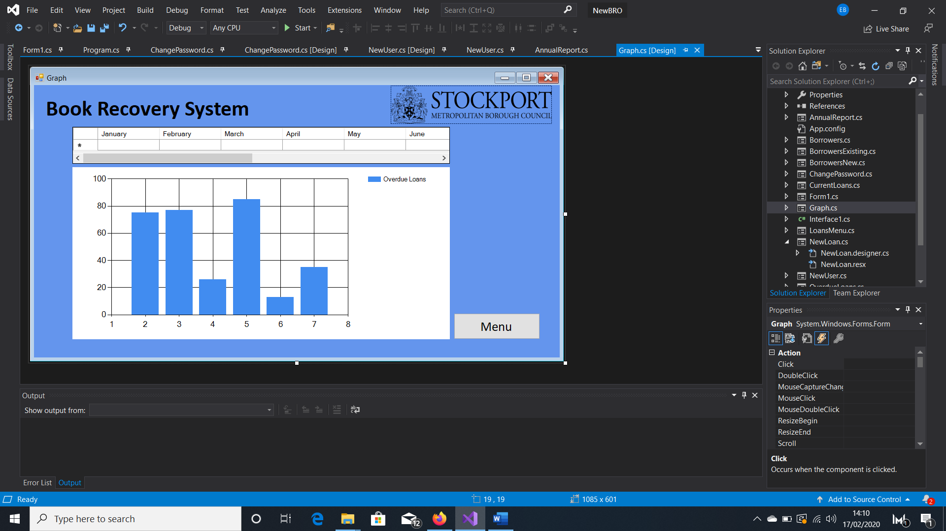

Label:

lbTitle

Picture Box:

pbLogo

Data Grid View:

dgvForGraph

Chart:

cGraph

Button:

btMenu

On clicking the ‘Generate Graph’ button, the user is sent to this form. When the form loads, both dgvForGraph and cGraph will be updated to show the number of overdue items for each month during last year using the following DDL:

**SELECT COUNT (COMPLETE) AS C**

**FROM Loans**

**WHERE (Complete = 'No - On Loan' OR Complete = 'BRO') AND LoanDue >= #01/month/last year - 51 days# AND LoanDue <= #last day of month/month/last year -51 days#**

Once this SQL is run for each month, the month names and results for each months are stored in an array. This array is then used to enter the x and y values for the graph:

**string[,] XYValues = new string[12, 2] { { "Janaury", result for January }, { "February", result for february}, { "March", result for march }, { "April", result for april }, { "May", result for may}, { "June", result for June }, { "July", result for July }, { "August", result for August }, { "September", result for September }, { "October", result for October }, { "November", result for November }, { "December", result for December} };**

**for (int i=0; i < 12; i++)**

**{**

**XValue = XYValues[i,0]**

**YValue = XYValues[i,1]**

**}**

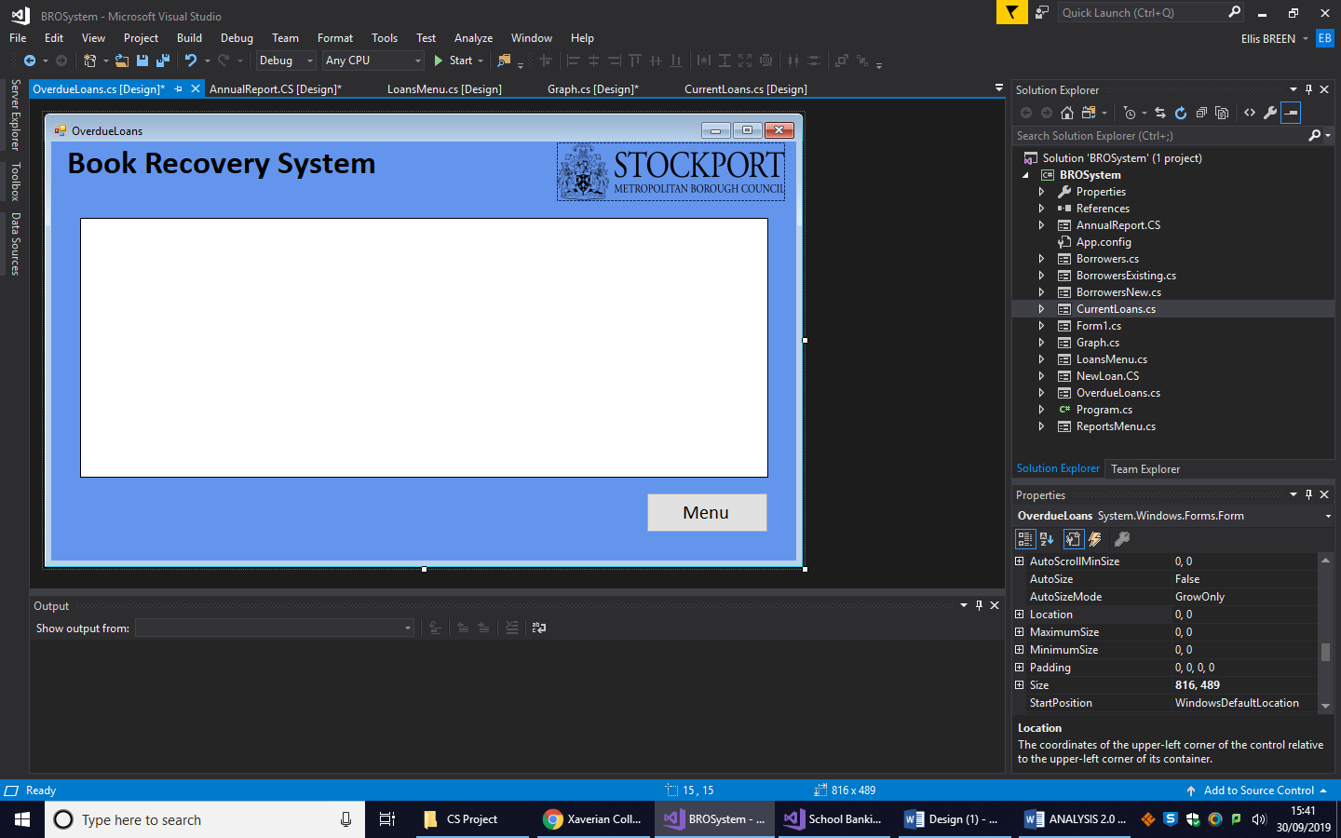

Label:

lbTitle

Picture Box:

pbLogo

Data Grid View:

dgvOverdue

Button:

btMenu

On clicking the ‘Overdue Loans’ button, the user will be sent to this form. All overdue loans will be displayed in dgvOverdue and grouped by address. The following DDL will be used to retrieve the data:

**SELECT Loans.LoanCode, Borrowers.BorrowerNumber, Borrowers.FirstName, Borrowers.Surname, Borrowers.Address, Borrowers.ContactNumber, Borrowers.EmailAddress, Items.Title, Items.Price**

**FROM Borrowers, Loans, Items**

**WHERE Borrowers.BorrowerNumber = Loans.BorrowerNumber AND Items.ItemBarcode = Loans.ItemBarcode AND Complete = 'No - On Loan' AND LoanDue <= #today’s date – 51 days#**

**ORDER BY Address ASC**

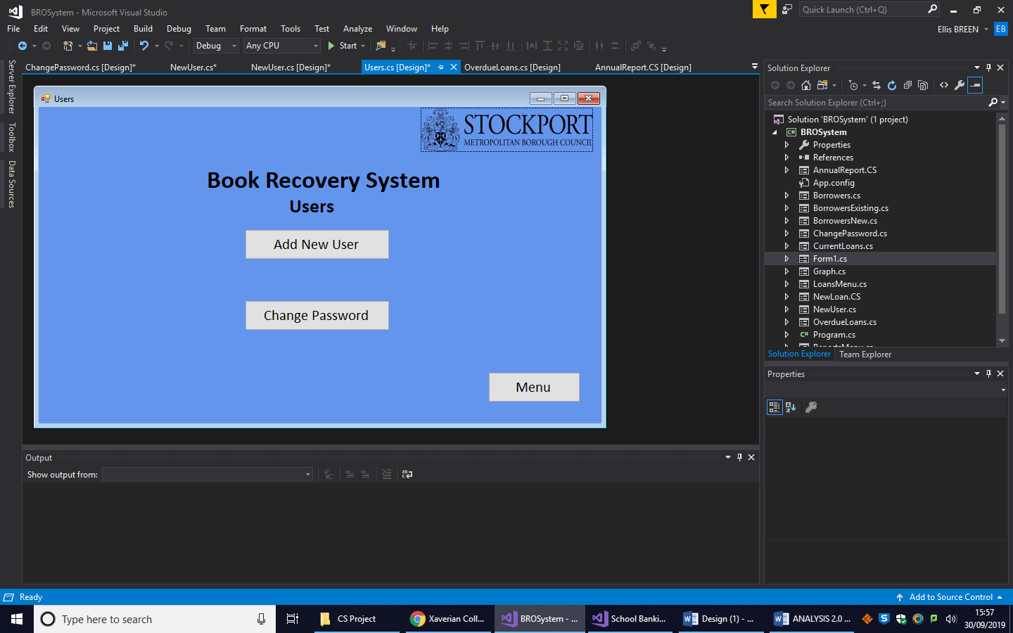

Picture Box:

pbLogo

Label:

lbTitle

lbUsers

Buttons:

btAdd

btChange

btMenu

If the user clicked the ‘Users’ button in the Menu, they will be sent to this form. Here, they will be given the option to add a new user or change their password. Only the admin, the book recovery officer, can add a new user, so if someone else were to click this button a message will appear that says ‘Request Denied’. If it is the book recovery that wants to add a new user they will be sent to the form below. Any user can change their own password, and will be sent to the final form if they choose to do so.

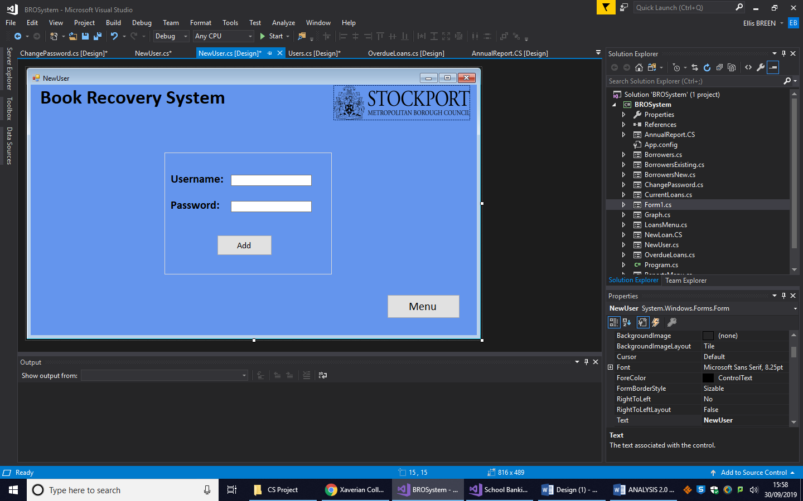

Label:

lbTitle

lbUsername

lbPassword

Picture Box:

pbLogo

Text Box:

tbUsername

tbPassword

Group Box:

gbxLogInDetails

Buttons:

btAdd

btMenu

On this form the admin will be able to add new user by entering a new set of log in details and clicking btAdd when done. The new details will be stored in the Users table in the database using the following DML:

**INSERT INTO Users**

**VALUES(‘text in tbUsername’, ‘text in tbPassword’)**

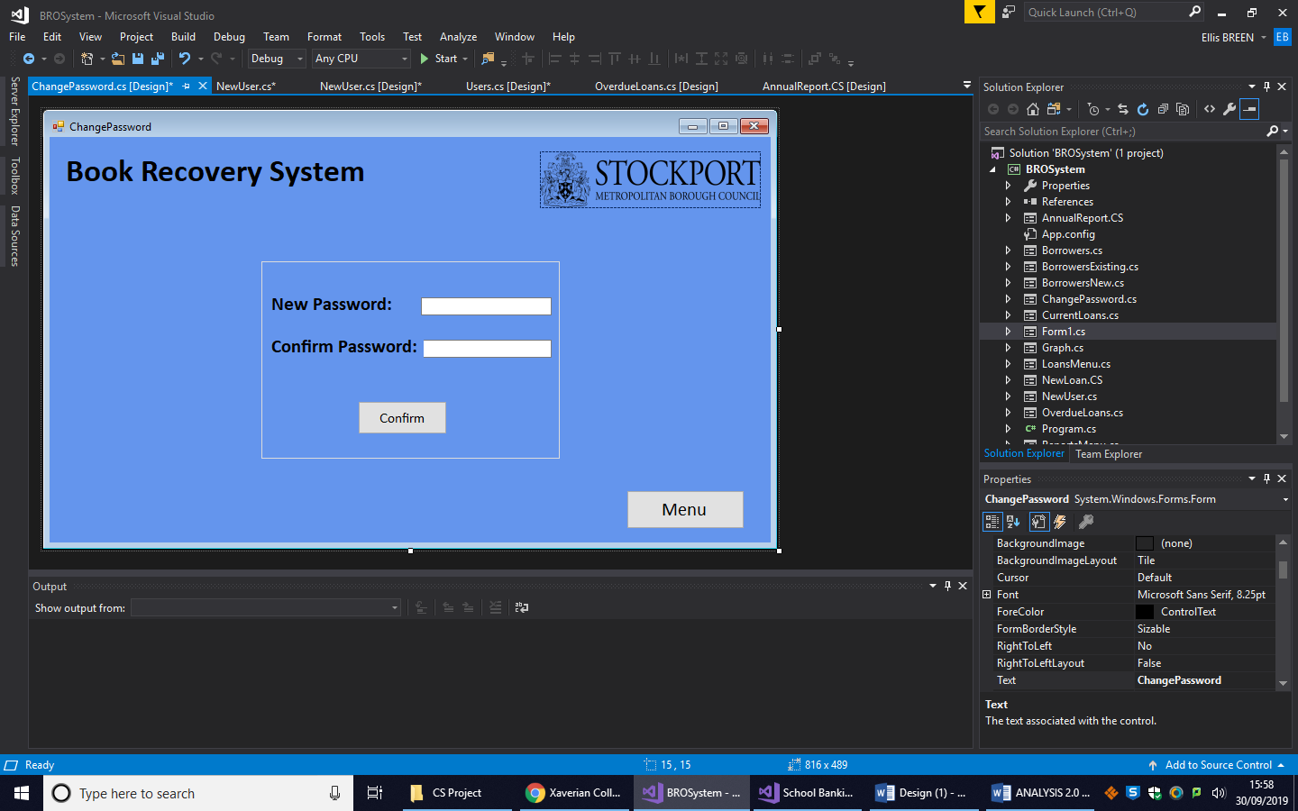

Label:

lbTitle

lbNewPassword

lbConfirm

Picture Box:

pbLogo

Text Box:

tbNewPassword

tbConfirm

Group Box:

gbxPassword

Buttons:

btConfirm

btMenu

On this form, the user will be able to change their password by entering a new password into tbNewPassword and then entering it again into tbConfirm. Once they press btConfirm and the contents of the two text boxes are the same their password will be updated in the database using the following DML:

**UPDATE Users**

**SET Password = ‘text in tbNewPassword’**

**WHERE Username = ‘username of the current user’**

## Other Algorithms

For generating a new BorrowerNumber:

**SELECT Top 1 * FROM Borrowers ORDER BY BorrowerNumber DESC**

**if a record is found**

**{**

**Read the record**

**LastID = the BorrowerNumber of the record being read**

**FirstHalf = the first two characters of LastID**

**SecondHalf = the last 12 characters of LastID**

**SecondHalfI = Convert SecondHalf to an integer and add 1**

**SecondHalf = Convert SecondHalfI to a string**

**NoOfZeros = 13 - SecondHalf.Length**

**SecondHalf = Add the number stored in NoOfZeros of 0s to the left of SecondHalf**

**NewID = FirstHalf + SecondHalf**

**}**

**else**

**{**

**NewID = D1000000000001**

**}**

A similar algorithm will be used to generate a new LoanCode.

For checking user’s log in details:

**SELECT * FROM Users WHERE Username = ‘text in tbUsername’**

**if the username is found**

**{**

**read the record**

**if the text in tbPassword == the password stored in the record**

**{**

**Username = text in tbUsername**

**Password = text in tbPassword**

**hide gbxLogInDetails**

**}**

**else**

**{**

**Display the message ‘Wrong Password’**

**}**

**}**

**else**

**{**

**Display the message ‘Username Not Found’**

**}**

## The following class is a library for sub routines used for validation:

**class InputValidation**

**{**

**function DateValid(DATE)**

**{**

**try**

**{**

Checks whether the date passed as a parameter can be converted into DateTime. If it can it returns ‘true’, but if it can’t it returns ‘false’.

**Convert DATE to DateTime**

**return true**

**}**

**catch (FormatException)**

**{**

**return false;**

**}**

**}**

**function Null(textbox)**

**{**

**if textbox == ""**

**{**

Checks whether the parameter textbox has anything in it. If it is empty, the procedure returns ‘true’. If it isn’t empty, the procedure returns ‘false’.

**return true;**

**}**

**else**

**{**

**return false;**

**}**

**}**

**function LengthCheck1(textbox, length)**

**{**

**if Length of textbox == length**

Checks the length of parameter textbox against the parameter length. If the length of the textbox is the same as the value passed as length, ‘true’ is returned as it is the correct length. ‘False’ is returned if its length is invalid. Used to check against CHAR attributes.

**{**

**return true;**

**}**

**else**

**{**

**return false;**

**}**

**}**

**function LengthCheck2(textbox, length)**

**{**

**if Length of textbox <= length**

Checks the length of parameter textbox against the parameter length. If the length of the textbox is the same as or less than the value passed as length, ‘true’ is returned as it is a correct length. ‘False’ is returned if its length is invalid. Used to check against VARCHAR attributes.

**{**

**return true;**

**}**

**else**

**{**

**return false;**

**}**

**}**

**function CharCheck(textbox, cont)**

**{**

**if textbox contains cont**

**{**

Checks whether the parameter textbox contains the character passed as cont. If it does, the procedure returns ‘true’. ‘False’ is returned if not.

**return true;**

**}**

**else**

**{**

**return false;**

**}**

**}**

**function CharCheck2(textbox, cont)**

**{**

**if textbox starts with cont**

**{**

Checks whether the parameter textbox starts with the character passed as cont. If it does, the procedure returns ‘true’. ‘False’ is returned if not.

**return true;**

**}**

**else**

**{**

**return false;**

**}**

**}**

**}**

**}**

This class is used to check the details of a new borrower when entered and the details of a borrower whose details are being updated. This is done so in the following way:

Declares a new instance of the InputValidation class found in SampleLibrary.

**InputValidation IV = new InputValidation()**

**procedure LengthCheck2(textbox, length, temp, ref count)**

**{**

**temp = IV.LengthCheck2(textbox, length)**

These two subroutines incorporate the methods found in the InputValidation class to check the lengths of particular attributes. A count is used to keep track of the validation, as only when the count is a certain value can the values be entered into the database

**if temp == true**

**{**

**Increment count by 1**

**}**

**}**

**procedure LengthCheck1(textbox, length, temp, ref count)**

**{**

**temp = IV.LengthCheck1(textbox, length)**

**if temp == true**

**{**

**Increment count by 1**

**}**

**}**

The following algorithm is used to validate the information the user enters when creating a new user using the methods found in SampleLibrary and procedures outlined on the previous page. Only when everything is valid will the program execute the DDL to enter it into the database.

**temp = IV.DateValid(text in tbDOB)**

**if temp = false**

**{**

**Display the message "Please enter Date Of Birth in format dd/mm/yyyy"**

**}**

**else**

**{**

**Increment count by 1**

**}**

**foreach textbox in BorrowersNew.cs**

**{**

**temp = IV.Null(text in textbox);**

**if temp = false**

**{**

**count++**

**}**

**}**

**foreach combox in BorrowersNew.cs**

**{**

**temp = IV.Null(text in combobox);**

**if (temp == false)**

**{**

**count++**

**}**

**}**

**temp = IV.CharCheck(text in tbEmail, @)**

**if temp = true**

**{**

**count++**

**}**

**else**

**{**

**Display the message "Please enter a valid email address"**

**}**

**temp = IV.CharCheck2(text in tbNumber, 07)**

**temp2 = IV.CharCheck2(text in tbNumber, 0161)**

**if temp = false AND temp2 = false**

**{**

**Display message “Please enter a valid contact number"**

**}**

**else**

**{**

**count++**

**}**

**LengthCheck2(text in tbFName, 25, temp, ref count)**

**LengthCheck2(text in tbSurname, 20, temp, ref count)**

**LengthCheck2(text in tbSex, 6, temp, ref count)**

**LengthCheck1(text in tbNumber, 11, temp, ref count)**

**LengthCheck2(text in tbAddress, 40, temp, ref count)**

**LengthCheck2(text in tbEmail, 25, temp, ref count)**

**if count = 19**

**{**

**INSERT INTO Borrowers**

**Values (“text in tbBorrowerNumber”,”text in tbFName”, “text in tbSurname”, “text in tbDOB”, “text in tbText”, “text in tbAddress”, “text in tbEmail”, “text in tbNumber”,**

**“text in cbCategory”, “text in cbBranch”)**

**}**

**else**

**{**

**Display message "Please make sure that there are no empty fields and everything entered is valid.”**

**count = 0;**

**}**

## System Security and Integrity of Data

Due to a foreign key in Loans referencing the primary key in Borrowers, if a point arises where a borrowers details are to be deleted from the database, all of the records in Loans relating to this borrower are also to be deleted. This is because there will be no way of identifying who this borrower is if their record has been deleted from Borrowers, and it will also ensure that certain SQL queries using these two tables will run without error. Usually, the same would also be done if a record is deleted from Items and there are Loans with that ItemBarcode. However, because this program does not give the user the ability to add, edit or delete records from Items, there should be no problem with maintaining the integrity of the two tables in this regard, so isn’t needed for this example.

In order to keep the data as accurate as possible, certain instances where attributes are included in more than one table, they will be automatically added without user interference once the relevant information has been added. For example, once a user enters the ItemBarcode in Loans, the program will use the Items table to add the Title rather than the user manually inputting it.

In order to use the program, users will have to log in. This is because you can gain access to sensitive information using the program, so it wouldn’t be wise if anyone and everyone could use it. Each member of staff that has been trained to use the system will be given a username and password by the admin; the book recovery officer.

# Technical Solution

## Introduction

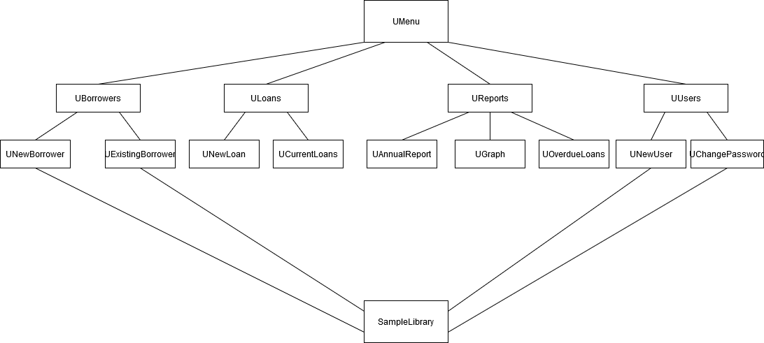The project consists of 15 units and 14 forms and is linked to a database in Access with 4 tables. The units and how they are linked are displayed below:

|  |  |  |  |  |
| --- | --- | --- | --- | --- |
| **Unit** | **Associated Form** | **Uses (Linked to)** | **Table Used** | **Description** |
| UMenu | Form1 | UBorrowers, ULoans, UReports, UUsers | Users | Main menu of the program |
| UBorrowers | Borrowers | UNewBorrower, UExistingBorrower |  | Displays the borrowers menu |
| ULoans | LoansMenu | UNew Loan, UCurrentLoans |  | Displays the loans menu |
| UReports | ReportsMenu | UAnnualReport, UGraph, UOverdueLoans |  | Displays the reports menu |
| UUsers | Users | UNewUser, UChangePassword |  | Displays the users menu |
| UNewBorrower | BorrowersNew | SampleLibrary | Borrowers | User can enter a new borrower here |
| UExistingBorrower | BorrowerExisting | SampleLibrary | Borrowers | User can view and edit existing borrowers |
| UNewLoan | NewLoan |  | Borrowers, Loans, Items | User can add a new loan here |
| UCurrentLoans | CurrentLoans |  | Loans | User can view loans that are currently out here |
| UAnnualReport | AnnualReport | - | Loans | Generates the annual report needed by the book recovery officer |
| UGraph | Graph |  | Loans | Generates a graph that shows overdue loans in each month |
| UOverdueLoans | OverdueLoans | - | Borrowers, Loans, Items | Displays all overdue loans and the information needed by the book recovery officer |
| UNewUser | NewUser | SampleLibrary | Users | Where a new user can be created |
| UChangePassword | ChangePassword | SampleLibrary | Users | Where the user can change their password |

## Complex Procedures

|  |  |  |
| --- | --- | --- |
| Identifier | Description | Page |
| **Procedure** ID | Creates a new borrower number by looking at the last one to be entered into the database and incrementing it by 1. |  |
| **Function** LengthCheck1 | Found in SampleLibrary. Checks the length of the parameter being passed. Returns ‘True’ if the length is valid. |  |
| **Function** LengthCheck2 | Found in SampleLibrary. Checks the length of the parameter being passed. Returns ‘True’ if the length is valid. |  |
| **Procedure** LengthCheck1 | Uses the function LengthCheck1 found in SampleLibrary to check the length of an attribute with data type CHAR. Increments count if the length is valid. |  |
| **Procedure** LengthCheck2 | Uses the function LengthCheck2 found in SampleLibrary to check the length of an attribute with data type VARCHAR. Increments count if the length is valid. |  |
| **Function** DateValid | Found in SampleLibrary. Checks whether a Date is entered is valid by attempting to convert it into a DateTime. Return True if successful. |  |
| **Function** Null | Found in SampleLibrary. Checks whether the parameter being passed is empty. Returns True if empty. |  |
| **Function** CharCheck1 | Found in SampleLibrary. Checks whether the parameter being passed contains a specific character (also a parameter). |  |
| **Function** CharCheck2 | Found in SampleLibrary. Checks whether the parameter being passed starts with a specific set of characters (also a parameter). |  |
| **Function** NL | Used to generate and return a new LoanCode in a similar way to the ID procedure. |  |
| **Procedure** Overdue | Runs the SQL query to find all overdue loans from the database and display them in the data grid. |  |
| **Procedure** Borrower | Runs the SQL query to find all current loans of a particular borrower from the database and display them in the data grid. |  |
| **Procedure** All | Runs the SQL query to find all current loans from the database and display them in the data grid. |  |
| **Procedure** UpdateLoan | Runs the SQL to update a loan. |  |
| **Function** SELECTResult | Runs the SQL for a SELECT COUNT or SUM query and returns the value |  |
| **Procedure** NoForMonth | Runs the SQL for the parameters given to find the number of loans that became long overdue in a specific month of last year. Stores the answer in a referenced parameter. |  |

## Program

Program.cs:

using System;

using System.Collections.Generic;

using System.Linq;

using System.Threading.Tasks;

using System.Windows.Forms;

using SampleLibrary;

namespace NewBRO

{

static class Program

{

/// <summary>

/// The main entry point for the application.

/// </summary>

public const String ConnString = "Provider=Microsoft.ACE.OLEDB.12.0; Data Source = DatabaseCS.accdb"; //links database to the program, DatabaseCS.accdb is the name of the database

[STAThread]

static void Main()

{

Application.EnableVisualStyles();

Application.SetCompatibleTextRenderingDefault(false);

Application.Run(new Form1());

}

}

}

Form1.cs:

using System;

using System.Collections.Generic;

using System.ComponentModel;

using System.Data;

using System.Drawing;

using System.Linq;

using System.Text;

using System.Threading.Tasks;

using System.Windows.Forms;

using System.IO;

using System.Data.OleDb;

namespace NewBRO

{

public partial class Form1 : Form

{

public static string Username, Password;

public Form1()

{

InitializeComponent();

}

private void Form1_Load(object sender, EventArgs e)

{

if (File.Exists("DatabaseCS.accdb") == false)//If the database doesn't exist

{

ADOX.Catalog cat = new ADOX.Catalog();

cat.Create(Program.ConnString); //Use constant defined in Program.cs to create database

OleDbConnection Conn = new OleDbConnection(Program.ConnString);

Conn.Open();

OleDbCommand Cmd = new OleDbCommand();

Cmd.Connection = Conn;

//Create Classes Users - The CREATE command needs to be constructed as one string.

Cmd.CommandText = "CREATE TABLE Users(Username VARCHAR(10),";

Cmd.CommandText += " PWord VARCHAR(15), PRIMARY KEY (Username))";

Cmd.ExecuteNonQuery(); //Used because no result is returned

Cmd.CommandText = "INSERT INTO Users VALUES('Adm1n','Pas$w0rd')";

Cmd.ExecuteNonQuery();

//Create the Borrowers table

Cmd.CommandText = "CREATE TABLE Borrowers(BorrowerNumber CHAR(14),";

Cmd.CommandText += " Firstname VARCHAR(25), Surname VARCHAR(20),";

Cmd.CommandText += " DateOfBirth DATE, Sex VARCHAR(6),";

Cmd.CommandText += " Address VARCHAR(40), EmailAddress VARCHAR(25), ContactNumber CHAR(11),";

Cmd.CommandText += " BorrowerCategory VARCHAR(20), Branch VARCHAR(15),";

Cmd.CommandText += " PRIMARY KEY (BorrowerNumber))";

Cmd.ExecuteNonQuery();

//Create the Items table

Cmd.CommandText = "CREATE TABLE Items(ItemBarcode CHAR(14), Title VARCHAR(50),";

Cmd.CommandText += " Author VARCHAR(45), Price MONEY, Collection VARCHAR(30), ItemLocation VARCHAR(20),";

Cmd.CommandText += " PRIMARY KEY(ItemBarcode))";

Cmd.ExecuteNonQuery();

//Create the Loans table

Cmd.CommandText = "CREATE TABLE Loans(LoanCode CHAR(14), BorrowerNumber CHAR(14), ItemBarcode CHAR(14),";

Cmd.CommandText += " Issued DATE, LoanPolicy VARCHAR(25), LoanDue DATE,";

Cmd.CommandText += " Complete VARCHAR(20), Primary Key(LoanCode),";

Cmd.CommandText += " FOREIGN KEY(BorrowerNumber) REFERENCES Borrowers(BorrowerNumber),";

Cmd.CommandText += " FOREIGN KEY(ItemBarcode) REFERENCES Items(ItemBarcode))";

Cmd.ExecuteNonQuery();

Conn.Close();

}

//causes whatever is entered as the password to be displayed as asterisks

tbPassword.Text = "";

tbPassword.PasswordChar = '*';

}

private void gbxLogInDetails_Enter(object sender, EventArgs e)

{

}

private void btExit_Click(object sender, EventArgs e)

{

Close(); //closes the form

}

private void btLogIn_Click(object sender, EventArgs e)

{

OleDbConnection Conn = new OleDbConnection(Program.ConnString);

Conn.Open();

OleDbCommand Cmd = new OleDbCommand();

Cmd.Connection = Conn;

Cmd.CommandText = "SELECT * FROM Users WHERE Username ='" + tbUsername.Text + "'";//searches database for the username entered by the user

OleDbDataReader reader = Cmd.ExecuteReader();

if (reader.HasRows)//if the username is found

{

reader.Read();

if (tbPassword.Text == reader["Pword"].ToString())//compares password entered to the corresponding password in the databse

{

//stores the user's username and password if correct

Username = tbUsername.Text;

Password = tbPassword.Text;

gbxLogInDetails.Hide();//reveals main menu

}

else

{

MessageBox.Show("Wrong Password");//notifies user if password is incorrect

}

}

else

{

MessageBox.Show("Username not found");//notifies user if username is incorrect

}

Conn.Close();

}

private void btBorrowers_Click(object sender, EventArgs e)

{

//form link to Borrowers.cs

Borrowers FmB = new Borrowers();

FmB.ShowDialog();

}

private void btLoans_Click(object sender, EventArgs e)

{

//form link to LoansMenu.cs

LoansMenu FmLoansMenu = new LoansMenu();

FmLoansMenu.ShowDialog();

}

private void btReports_Click(object sender, EventArgs e)

{

//form link to ReportsMenu.cs

ReportsMenu FmReportsMenu = new ReportsMenu();

FmReportsMenu.ShowDialog();

}

private void btUsers_Click(object sender, EventArgs e)

{

//form link to Users.cs

Users FmUsers = new Users();

FmUsers.ShowDialog();

}

}

}

Borrowers.cs:

using System;

using System.Collections.Generic;

using System.ComponentModel;

using System.Data;

using System.Drawing;

using System.Linq;

using System.Text;

using System.Threading.Tasks;

using System.Windows.Forms;

namespace NewBRO

{

public partial class Borrowers : Form

{

public Borrowers()

{

InitializeComponent();

}

private void Borrowers_Load(object sender, EventArgs e)

{

}

private void btNew_Click(object sender, EventArgs e)

{

//form link to BorrowersNew.cs

BorrowersNew FmNewB = new BorrowersNew();

FmNewB.ShowDialog();

}

private void btExisting_Click(object sender, EventArgs e)

{

//form link to BorrowersExisting.cs

BorrowersExisting FmExistingB = new BorrowersExisting();

FmExistingB.ShowDialog();

}

private void btMenu_Click(object sender, EventArgs e)

{

Close(); //closes form

}

}

}

BorrowersNew.cs:

using System;

using System.Collections.Generic;

using System.ComponentModel;

using System.Data;

using System.Drawing;

using System.Linq;

using System.Text;

using System.Threading.Tasks;

using System.Windows.Forms;

using System.IO;

using System.Data.OleDb;

using SampleLibrary; //links to SampleLibrary

namespace NewBRO

{

public partial class BorrowersNew : Form

{

string LastID = "", NewID, FirstHalf, SecondHalf; bool temp, temp2; int SecondHalfI, NoOfZeros, count = 0;

InputValidation IV = new InputValidation(); //declaring an instance of InputValidation from SampleLibrary

public void ID()//procedure to create a new BorrowerNumber

{

OleDbConnection Conn = new OleDbConnection(Program.ConnString);

Conn.Open();

OleDbCommand Cmd = new OleDbCommand();

Cmd.Connection = Conn;

Cmd.CommandText = "SELECT Top 1 * FROM Borrowers ORDER BY BorrowerNumber DESC"; //selects everything from borrowers

OleDbDataReader reader = Cmd.ExecuteReader();

if (reader.HasRows)//If a record is found display details

{

reader.Read();

LastID = Convert.ToString(reader["BorrowerNumber"]); //gets the borrowernumber from borrowers

FirstHalf = LastID.Substring(0, 2);

SecondHalf = LastID.Substring(2, 12);

SecondHalfI = Convert.ToInt32(SecondHalf) + 1; //incrementing the borrowernumber by 1 each time a new borrower is added

SecondHalf = SecondHalfI.ToString();

NoOfZeros = 13 - SecondHalf.Length;

SecondHalf = SecondHalf.PadLeft(NoOfZeros, '0');

NewID = FirstHalf + SecondHalf;

}

else

{

NewID = "D1000000000001";//first BorrowerNumber if database has just been created

}

reader.Close();

Conn.Close();

tbBorrowerNumber.Text = NewID;//displays the new BorrowerNumber in tbBorrowerNumber

}

public void LengthCheck2(string textbox, int length, bool temp, ref int count)//procedure for checking the length of an attribute that doesn't have to be a certtain length

{

temp = IV.LengthCheck2(textbox, length);//uses the routine found in SampleLibrary

if (temp == true)

{

count++;//if the attribute is the correct length, count is incremented

}

}

public void LengthCheck1(string textbox, int length, bool temp, ref int count)//procedure for checking the length of an attribute that has to be a certain length

{

temp = IV.LengthCheck1(textbox, length);//uses the routine found in SampleLibrary

if (temp == true)

{

count++;//if the attribute is the correct length, count is incremented

}

}

public BorrowersNew()

{

InitializeComponent();

}

private void btMenu_Click(object sender, EventArgs e)

{

Close();

}

private void BorrowersNew_Load(object sender, EventArgs e)

{

ID();//uses the routine ID to generate a new BorrowerNumber

tbBorrowerNumber.ReadOnly = true;//sets tbBorrowerNumber to read only so it can't be editted by the user

}

private void btAdd_Click(object sender, EventArgs e)

{

//Validation for all tbs

temp = IV.DateValid(tbDOB.Text);//uses the routine found in SampleLibrary to check whether the date of birth entered by the user is valid

if (temp == false)

{

MessageBox.Show("Please enter Date Of Birth in format dd/mm/yyyy");//message telling user the date is invalid and why

}

else

{

count++;//count is incremented if the date is valid

}

foreach (var c in this.Controls)//checks to see whether something has been entered in each textbox

{

if (c is TextBox)

{

temp = IV.Null(((TextBox)c).Text);

if( temp == false)

{

count++;//count is incremented if the textbox has something in it

}

}

if (c is ComboBox)//checks to see whether something has been selected for each combobox

{

temp = IV.Null(((ComboBox)c).Text);

if (temp == false)

{

count++;//count is incremented if the something has been selected for the combobox

}

}

}

temp = IV.CharCheck(tbEmail.Text, Convert.ToString('@'));//checks to see whether the email entered is valid using the routine found in SampleLibrary

if (temp == true)

{

count++;//count is incremented if email is valid

}

else

{

MessageBox.Show("Please enter a valid email address");//notifies user if email is invalid

}

//checks to see whether the contact number is valid

temp = IV.CharCheck2(tbNumber.Text, "07");

temp2 = IV.CharCheck2(tbNumber.Text, "0161");

if (temp == false && temp2 == false)//if the number doesn't start with '07' or '0161' then it is invalid

{

MessageBox.Show("Please enter a valid contact number");//tells user number is invalid

}

else

{

count++;// count is incremented if valid

}

//checks whether everything entered is the correct length barring what is in the combo boxes as all the options they can choose from are correct

//count is incremented each time the lenght of an input is correct

LengthCheck2(tbFName.Text, 25, temp, ref count);

LengthCheck2(tbSurname.Text, 20, temp, ref count);

LengthCheck2(tbSex.Text, 6, temp, ref count);

LengthCheck1(tbNumber.Text, 11, temp, ref count);

LengthCheck2(tbAddress.Text, 40, temp, ref count);

LengthCheck2(tbEmail.Text, 25, temp, ref count);

if (count == 19)//count = 19 if all inputs are valid

{

//MessageBox.Show(count.ToString());

OleDbConnection Conn = new OleDbConnection(Program.ConnString);

Conn.Open();

OleDbCommand Cmd = new OleDbCommand();

Cmd.Connection = Conn;

//adds the new borrower to the database

string SQL = "INSERT INTO Borrowers ";

SQL += " VALUES('" + Convert.ToString(tbBorrowerNumber.Text) + "', '" + tbFName.Text + "',' " + tbSurname.Text + "', #" + tbDOB.Text + "#, '" + tbSex.Text + "', '" + tbAddress.Text + "', '" + tbEmail.Text + "','" + Convert.ToString(tbNumber.Text) + "','";

SQL += cbCategory.SelectedItem + "', '" + cbBranch.SelectedItem + "')";

Cmd.CommandText = SQL;

Cmd.ExecuteNonQuery();

Conn.Close();

count = 0;//resets count

foreach (var c in this.Controls)//clears all text boxes and combo boxes

{

if (c is TextBox && c != tbBorrowerNumber)

{

((TextBox)c).Text = String.Empty;

}

if (c is ComboBox)

{

((ComboBox)c).Text = String.Empty;

}

}

ID();//generates a new BorrowerNumber after all text boxes have been cleared

}

else//if there are any invalid inputs

{

//MessageBox.Show(count.ToString());

MessageBox.Show("Please make sure that there are no empty fields and everything entered is valid. ");//displays an error message

count = 0;//restes count

}

}

}

}

BorrowersExisting.cs:

using System;

using System.Collections.Generic;

using System.ComponentModel;

using System.Data;

using System.Drawing;

using System.Linq;

using System.Text;

using System.Threading.Tasks;

using System.Windows.Forms;

using System.IO;

using System.Data.OleDb;

using SampleLibrary;

namespace NewBRO

{

public partial class BorrowersExisting : Form

{

InputValidation IV = new InputValidation();

string BorrowerNumber; bool temp, temp2; int count = 0;

public void LengthCheck2(string textbox, int length, bool temp, ref int count)

{

temp = IV.LengthCheck2(textbox, length);

if (temp == true)

{

count++;

}

}

public void LengthCheck1(string textbox, int length, bool temp, ref int count)

{

temp = IV.LengthCheck1(textbox, length);

if (temp == true)

{

count++;

}

}

public BorrowersExisting()

{

InitializeComponent();

}

private void groupBox1_Enter(object sender, EventArgs e)

{

}

private void BorrowersExisting_Load(object sender, EventArgs e)

{

gbxBorrowerData.Hide();

}

private void btEnter_Click(object sender, EventArgs e)

{

OleDbConnection Conn = new OleDbConnection(Program.ConnString);

Conn.Open();

OleDbCommand Cmd = new OleDbCommand();

Cmd.Connection = Conn;

Cmd.CommandText = "SELECT * FROM Borrowers WHERE BorrowerNumber = '" + tbBorrowerID.Text + "'"; //selects everything from borrowers

OleDbDataReader reader = Cmd.ExecuteReader();

if (reader.HasRows)//If the borrower number is found the following code will be executed

{

gbxBorrowerData.Show();

reader.Read();

BorrowerNumber = Convert.ToString(reader["BorrowerNumber"]);

//The text boxes are all filled with the information found for the enetered BorrowerNumber found in the database

tbFName.Text = Convert.ToString(reader["Firstname"]);

tbSurname.Text = Convert.ToString(reader["Surname"]);

tbDOB.Text = Convert.ToString(reader["DateOfBirth"]);

tbSex.Text = Convert.ToString(reader["Sex"]);

tbAddress.Text = Convert.ToString(reader["Address"]);

tbEmail.Text = Convert.ToString(reader["EmailAddress"]);

tbNumber.Text = Convert.ToString(reader["ContactNumber"]);

cbBranch.Text = Convert.ToString(reader["Branch"]);

cbCategory.Text = Convert.ToString(reader["BorrowerCategory"]);

Conn.Close();

}

else

{

MessageBox.Show("BorrowerNumber not found");//tells user the BorrowerNumber has not been found

gbxBorrowerData.Hide();

}

}

private void btUpdate_Click(object sender, EventArgs e)//Used to update an existing record

{

//validation for the textboxes being updated

temp = IV.DateValid(tbDOB.Text);

if (temp == false)

{

MessageBox.Show("Please enter Date Of Birth in format dd/mm/yyyy");

}

else

{

count++;

}

foreach (var c in gbxBorrowerData.Controls)

{

if (c is TextBox)

{

temp = IV.Null(((TextBox)c).Text);

if (temp == false)

{

count++;

}

}

if (c is ComboBox)

{

temp = IV.Null(((ComboBox)c).Text);

if (temp == false)

{

count++;

}

}

}

temp = IV.CharCheck(tbEmail.Text, Convert.ToString('@'));

if (temp == true)

{

count++;

}

else

{

MessageBox.Show("Please enter a valid email address");

}

temp = IV.CharCheck2(tbNumber.Text, "07");

temp2 = IV.CharCheck2(tbNumber.Text, "0161");

if (temp == false && temp2 == false)

{

MessageBox.Show("Please enter a valid contact number");

}

else

{

count++;

}

LengthCheck2(tbFName.Text, 25, temp, ref count);

LengthCheck2(tbSurname.Text, 20, temp, ref count);

LengthCheck2(tbSex.Text, 6, temp, ref count);

LengthCheck1(tbNumber.Text, 11, temp, ref count);

LengthCheck2(tbAddress.Text, 40, temp, ref count);

LengthCheck2(tbEmail.Text, 25, temp, ref count);

if (count == 18)//count = 18 when everything is valid

{

OleDbConnection Conn = new OleDbConnection(Program.ConnString);

Conn.Open();

OleDbCommand Cmd = new OleDbCommand();

Cmd.Connection = Conn;

//updates the databse to include what the user has changed

Cmd.CommandText = "UPDATE Borrowers";

Cmd.CommandText += " SET Firstname = '" + tbFName.Text + "', Surname = '" + tbSurname.Text + "', ";

Cmd.CommandText += " DateOfBirth = '" + tbDOB.Text + "', Sex = '" + tbSex.Text + "', ";

Cmd.CommandText += " Address = '" + tbAddress.Text + "', EmailAddress = '" + tbEmail.Text + "', ";

Cmd.CommandText += " ContactNumber = '" + tbNumber.Text + "', BorrowerCategory = '" + cbCategory.Text + "', Branch = '" + cbBranch.Text + "'";

Cmd.CommandText += " WHERE BorrowerNumber = '" + BorrowerNumber + "'";

Cmd.ExecuteNonQuery();

Conn.Close();

count = 0;//resets count

}

else

{

//MessageBox.Show(count.ToString());

MessageBox.Show("Please make sure that there are no empty fields and everything entered is valid. ");//tells the user to check the inputs

count = 0;//resets count

}

}

private void btDelete_Click(object sender, EventArgs e)//deletes all records involving this borrower from the database

{

DialogResult Confirmation = MessageBox.Show("Are you sure you wish to delete this student?", "Confirmation", MessageBoxButtons.YesNo);//confirms with the user that they want to delete the borrower

if (Confirmation == DialogResult.Yes)

{

OleDbConnection Conn = new OleDbConnection(Program.ConnString);

Conn.Open();

OleDbCommand Cmd = new OleDbCommand();

Cmd.Connection = Conn;

//deletes all loans that the borrower has ever made

Cmd.CommandText = "DELETE FROM Loans ";

Cmd.CommandText += "WHERE BorrowerNumber = '" + BorrowerNumber + "'";

Cmd.ExecuteNonQuery();

MessageBox.Show(Cmd.CommandText);

//deletes the borrower and all of their details

Cmd.CommandText = "DELETE FROM Borrowers ";

Cmd.CommandText += "WHERE BorrowerNumber = '" + BorrowerNumber + "'";

Cmd.ExecuteNonQuery();

Conn.Close();

MessageBox.Show("Deleted");

//clears all text boxes and combo boxes

foreach (var c in gbxBorrowerData.Controls)

{

if (c is TextBox)

{

((TextBox)c).Text = String.Empty;

}

if( c is ComboBox)

{

((ComboBox)c).Text = String.Empty;

}

}

tbBorrowerID.Clear();

}

}

private void btMenu_Click(object sender, EventArgs e)

{

Close();//closes the form

}

}

}

LoansMenu.cs:

using System;

using System.Collections.Generic;

using System.ComponentModel;

using System.Data;

using System.Drawing;

using System.Linq;

using System.Text;

using System.Threading.Tasks;

using System.Windows.Forms;

namespace NewBRO

{

public partial class LoansMenu : Form

{

public LoansMenu()

{

InitializeComponent();

}

private void LoansMenu_Load(object sender, EventArgs e)

{

}

private void btNewLoan_Click(object sender, EventArgs e)

{

//form link to NewLoan.cs

NewLoan FmNL = new NewLoan();

FmNL.ShowDialog();

}

private void btCurrent_Click(object sender, EventArgs e)

{

//form link to CurrentLoans.cs

CurrentLoans FmCL = new CurrentLoans();

FmCL.ShowDialog();

}

private void btMenu_Click(object sender, EventArgs e)

{

Close();//closes the form

}

}

}

NewLoan.cs:

using System;

using System.Collections.Generic;

using System.ComponentModel;

using System.Data;

using System.Drawing;

using System.Linq;

using System.Text;

using System.Threading.Tasks;

using System.Windows.Forms;

using System.IO;

using System.Data.OleDb;

using SampleLibrary;

namespace NewBRO

{

public partial class NewLoan : Form

{

InputValidation IV = new InputValidation();

bool temp, temp2;

public string NL()//function to generate a new LoanCode

{

string LastID = "", NewCode, FirstHalf, SecondHalf;

int SecondHalfI, NoOfZeros;

OleDbConnection Conn = new OleDbConnection(Program.ConnString);

Conn.Open();

OleDbCommand Cmd = new OleDbCommand();

Cmd.Connection = Conn;

Cmd.CommandText = "SELECT Top 1 * FROM Loans ORDER BY LoanCode DESC"; //selects everything from borrowers

OleDbDataReader reader = Cmd.ExecuteReader();

if (reader.HasRows)//If a record is found display details

{

reader.Read();

LastID = Convert.ToString(reader["LoanCode"]); //gets the borrowernumber from borrowers

FirstHalf = LastID.Substring(0, 2);

SecondHalf = LastID.Substring(2, 12);

SecondHalfI = Convert.ToInt32(SecondHalf) + 1; //incrementing the borrowernumber by 1 each time a new borrower is added

SecondHalf = SecondHalfI.ToString();

NoOfZeros = 13 - SecondHalf.Length;

SecondHalf = SecondHalf.PadLeft(NoOfZeros, '0');

NewCode = FirstHalf + SecondHalf;

}

else

{

NewCode = "L1000000000001";//if it is the first loan

}

reader.Close();

Conn.Close();

return NewCode;

}

private void btAdd_Click(object sender, EventArgs e)

{

OleDbConnection Conn = new OleDbConnection(Program.ConnString);

Conn.Open();

OleDbCommand Cmd = new OleDbCommand();

Cmd.Connection = Conn;

Cmd.CommandText = "SELECT Borrowers.BorrowerNumber, Items.ItemBarcode, Items.ItemLocation ";

Cmd.CommandText += "FROM Borrowers, Items ";

Cmd.CommandText += "WHERE ";

Cmd.CommandText += "Borrowers.BorrowerNumber = '" + tbBorrowerNumber.Text + "' AND Items.ItemBarcode = '" + tbBarcode.Text + "'";

OleDbDataReader reader = Cmd.ExecuteReader();

if (reader.HasRows)//checks whether the BorrowerNumber and ItemBarcode exist

{

//Counts how many items the borrower currently has out on loan

Conn.Close();

Conn.Open();

Cmd.CommandText = "SELECT COUNT(BorrowerNumber) AS BN FROM Loans WHERE BorrowerNumber = '" + tbBorrowerNumber.Text + "' AND Complete = 'No - On Loan'";

int temp;

if(Cmd.ExecuteScalar() != DBNull.Value)

{

temp = Convert.ToInt32(Cmd.ExecuteScalar());//stores the number of loans the borrower currently has out

}

else

{

temp = 0;//if no loans are found, then temp = 0

}

Conn.Close();

MessageBox.Show(temp.ToString());//shows the number of loans the borrower currently has out

if ( temp < 10)//if the number of current loans is less than ten, the new loan will be made

{

Conn.Close();

Conn.Open();

Cmd.CommandText = "INSERT INTO Loans ";

Cmd.CommandText += "VALUES('" + tbLoanCode.Text + "','" + tbBorrowerNumber.Text + "','" + tbBarcode.Text + "', #" + tbIssued.Text + "#, '" + cbLoanPolicy.Text + "', #" + tbLoanDue.Text + "#, 'No - On Loan')";

Cmd.ExecuteNonQuery();

Conn.Close();

MessageBox.Show("Recorded");

//resets the textboxes and produces a new loan code

foreach (var c in this.Controls)

{

if (c is TextBox)

{

((TextBox)c).Text = String.Empty;

}

if (c is ComboBox)

{

((ComboBox)c).Text = String.Empty;

}

tbLoanCode.Text = NL();

}

}

else //if the number of loans is = 10 than the loan will not be made

{

MessageBox.Show("Borrower already has max number of items out");//tells user the loan cannot be made

}

}

else

{

MessageBox.Show("Not Found");//tells the user that the BorrowerNumber or the ItmeBarcode has not been found

}

}

public NewLoan()

{

InitializeComponent();

}

private void NewLoan_Load(object sender, EventArgs e)

{

//Automatically sets the LoanCode of a new loan

tbLoanCode.Text = NL();

tbLoanCode.ReadOnly = true; //sets tbLoanCode to read only so it cannot be changed

//Set the Issued Date and LoanDue Date

tbIssued.Text = Convert.ToString(DateTime.Today);//sets the tbIssued to today

tbLoanDue.Text = Convert.ToString(DateTime.Today.AddDays(21));//sets the due date to be 3 weeks from now

}

private void btMenu_Click(object sender, EventArgs e)

{

Close();//closes the form

}

}

}

CurrentLoans.cs:

using System;

using System.Collections.Generic;

using System.ComponentModel;

using System.Data;

using System.Drawing;

using System.Linq;

using System.Text;

using System.Threading.Tasks;

using System.Windows.Forms;

using System.IO;

using System.Data.OleDb;

namespace NewBRO

{

public partial class CurrentLoans : Form

{

public DateTime today = DateTime.Today;//sets the variable today to today's date

private void Overdue(OleDbCommand Cmd, OleDbConnection Conn)//procedure for searching for overdue loans

{

//selects all information from loans if the loan is overdue

Cmd.CommandText = " SELECT * FROM Loans WHERE Complete = 'No - On Loan' AND #" + today.AddDays(-51) + "# >= LoanDue";

OleDbDataReader reader = Cmd.ExecuteReader();

if (reader.HasRows)

{

//fills the datagridview if loans have been found

reader.Close();

OleDbDataAdapter da = new OleDbDataAdapter(Cmd);

DataTable table = new DataTable();

da.Fill(table);

dgvLoans.DataSource = table;

Conn.Close();

dgvLoans.Show();

lbComplete.Show();

cbComplete.Show();

}

else

{

MessageBox.Show("No records found");//tells the user if there are no overdue loans

}

}

private void Borrower(OleDbCommand Cmd, OleDbConnection Conn)//procedure for searching for all current loans for a particluar borrower

{

Cmd.CommandText = " SELECT * FROM Loans WHERE BorrowerNumber = '" + tbBorrowerID.Text + "' AND Complete = 'No - On Loan'";

OleDbDataAdapter da = new OleDbDataAdapter(Cmd);

DataTable table = new DataTable();

//fills the datagridview with all of the appropriate loans

da.Fill(table);

dgvLoans.DataSource = table;

Conn.Close();

dgvLoans.Show();

lbComplete.Show();

cbComplete.Show();

}

private void All(OleDbCommand Cmd, OleDbConnection Conn)//procedure for searching for all current loans

{

Cmd.CommandText = " SELECT * FROM Loans WHERE Complete = 'No - On Loan'";

OleDbDataAdapter da = new OleDbDataAdapter(Cmd);

DataTable table = new DataTable();

//fills the datagridview with all current loans

da.Fill(table);

dgvLoans.DataSource = table;

Conn.Close();

dgvLoans.Show();

lbComplete.Show();

cbComplete.Show();

}

private void UpdateLoan(OleDbCommand Cmd, OleDbConnection Conn)

{

Cmd.CommandText = "UPDATE Loans ";

Cmd.CommandText += "SET Complete = '" + cbComplete.Text + "' WHERE LoanCode = '" + dgvLoans.SelectedRows[0].Cells[0].Value.ToString() + "'";

Cmd.ExecuteNonQuery();//Updates the 'Complete' status of a particular loan

Conn.Close();

}

public CurrentLoans()

{

InitializeComponent();

}

private void CurrentLoans_Load(object sender, EventArgs e)

{

//only displays gbxSelect (group box with radio buttons) until a radio button has been selected

dgvLoans.Hide();

gbxBorrowerID.Hide();

lbComplete.Hide();

cbComplete.Hide();

}

private void btEnter_Click(object sender, EventArgs e)

{

OleDbConnection Conn = new OleDbConnection(Program.ConnString);

Conn.Open();

OleDbCommand Cmd = new OleDbCommand();

Cmd.Connection = Conn;

Borrower(Cmd, Conn);//executes the Borrower procedure

}

private void rbAll_Click(object sender, EventArgs e)

{

OleDbConnection Conn = new OleDbConnection(Program.ConnString);

Conn.Open();

OleDbCommand Cmd = new OleDbCommand();

Cmd.Connection = Conn;

All(Cmd, Conn);//executes the all procedure

}

private void rbBorrower_Click(object sender, EventArgs e)

{

gbxBorrowerID.Show();//shows gbxBorrowerID if the Borrower radio button is clicked

}

private void rbOverdue_Click(object sender, EventArgs e)

{

OleDbConnection Conn = new OleDbConnection(Program.ConnString);

Conn.Open();

OleDbCommand Cmd = new OleDbCommand();

Cmd.Connection = Conn;

Overdue(Cmd, Conn);//executes the Overdue procedure

}

private void dgvLoans_CellClick(object sender, DataGridViewCellEventArgs e)

{

if (dgvLoans.SelectedRows.Count > 0)

{

cbComplete.Text = dgvLoans.SelectedRows[0].Cells[6].Value.ToString();//sets cbComplete.Text to the value of the complete attribute of the loan selected by the user

}

}

private void btUpdate_Click(object sender, EventArgs e)

{

OleDbConnection Conn = new OleDbConnection(Program.ConnString);

Conn.Open();

OleDbCommand Cmd = new OleDbCommand();

Cmd.Connection = Conn;

UpdateLoan(Cmd, Conn);//updates the loan to include the change made to Complete by the user

//updates the datagridview to include the changes made to the database

if (rbAll.Checked == true)

{

All(Cmd, Conn);

}

if (rbBorrower.Checked == true)

{

Borrower(Cmd, Conn);

}

if(rbOverdue.Checked == true)

{

Overdue(Cmd, Conn);

}

}

private void btMenu_Click(object sender, EventArgs e)

{

Close();//closes the form

}

}

}

ReportsMenu.cs:

using System;

using System.Collections.Generic;

using System.ComponentModel;

using System.Data;

using System.Drawing;

using System.Linq;

using System.Text;

using System.Threading.Tasks;

using System.Windows.Forms;

namespace NewBRO

{

public partial class ReportsMenu : Form

{

public ReportsMenu()

{

InitializeComponent();

}

private void ReportsMenu_Load(object sender, EventArgs e)

{

}

private void btAnnual_Click(object sender, EventArgs e)

{

//form link to AnnualReport.cs

AnnualReport FmAR = new AnnualReport();

FmAR.ShowDialog();

}

private void btGraph_Click(object sender, EventArgs e)

{

//form link to Graph.cs

Graph FmG = new Graph();

FmG.ShowDialog();

}

private void btOverdueLoans_Click(object sender, EventArgs e)

{

//form link to OverdueLoans.cs

OverdueLoans FmOL = new OverdueLoans();

FmOL.ShowDialog();

}

private void btMenu_Click(object sender, EventArgs e)

{

Close();

}

}

}

AnnualReport.cs:

using System;

using System.Collections.Generic;

using System.ComponentModel;

using System.Data;

using System.Drawing;

using System.Linq;

using System.Text;

using System.Threading.Tasks;

using System.Windows.Forms;

using System.IO;

using System.Data.OleDb;

using SampleLibrary;

namespace NewBRO

{

public partial class AnnualReport : Form

{

public AnnualReport()

{

InitializeComponent();

}

private int SELECTResult(OleDbCommand Cmd)//function to execute the SQL and convert the value it returns to an integer

{

int a;

MessageBox.Show(Cmd.CommandText);

if (Cmd.ExecuteScalar() != DBNull.Value)

{

a = Convert.ToInt32(Cmd.ExecuteScalar());

}

else

{

a = 0;

}

return a;

}

private void AnnualReport_Load(object sender, EventArgs e)

{

//should be working

DateTime today = DateTime.Today;//today's date

int ODY = today.Year - 1;//last year

string ODYS = ODY.ToString(); string ODD = "11/11/" + ODYS;//the first loan due date that allows a loan to be long overdue in current year

DateTime ODD1 = Convert.ToDateTime(ODD);//converts to date

//MessageBox.Show(ODD1.ToString());

OleDbConnection Conn = new OleDbConnection(Program.ConnString);

Conn.Open();

OleDbCommand Cmd = new OleDbCommand();

Cmd.Connection = Conn;

//SQL for finding loans that are long overdue

Cmd.CommandText = "SELECT COUNT (COMPLETE) AS C FROM Loans WHERE (Complete = 'BRO' AND #" + today.AddDays(-51).ToString("MM/dd/yyyy") + "# >= LoanDue AND (YEAR(LoanDue) = "+ today.Year +" OR YEAR(LoanDue) = " + ODY + ") AND LoanDue >= #" + ODD1 + "#) ";

Cmd.CommandText += "OR (Complete = 'No - On Loan' AND #" + today.AddDays(-51).ToString("MM/dd/yyyy") + "# >= LoanDue)" ;

lbItemsValue.Text = SELECTResult(Cmd).ToString();

//SQL for finding long overdue loans that have been recovered by the book recovery officer this year

Cmd.CommandText = "SELECT COUNT (COMPLETE) AS C FROM Loans WHERE Complete = 'BRO' AND (YEAR(LoanDue) = " + today.Year + " OR Year(LoanDue) = " + ODY + ") AND LoanDue >= #" + ODD1 + "# ";

lbItemsRecoveredValue.Text = SELECTResult(Cmd).ToString();

//SQL for calculating the total cost of the loans recovered by the book recovery officer

Cmd.CommandText = "SELECT SUM (Price) ";

Cmd.CommandText += "FROM Loans, Items ";

Cmd.CommandText += "WHERE Loans.ItemBarcode = Items.ItemBarcode AND ";

Cmd.CommandText += "(Loans.Complete = 'BRO' AND YEAR(LoanDue) = " + today.Year + " OR Loans.Complete = 'BRO' AND LoanDue >= #" + ODD1 +"#)";

double Result = SELECTResult(Cmd);

lbCostRecoveredValue.Text = "£"+Result.ToString();

}

private void btMenu_Click(object sender, EventArgs e)

{

Close();//closes the form

}

}

}

Graph.cs:

using System;

using System.Collections.Generic;

using System.ComponentModel;

using System.Data;

using System.Drawing;

using System.Linq;

using System.Text;

using System.Threading.Tasks;

using System.Windows.Forms;

using System.IO;

using System.Data.OleDb;

namespace NewBRO

{

public partial class Graph : Form

{

public Graph()

{

InitializeComponent();

}

public DateTime today = DateTime.Today;

private void NoForMonth(OleDbCommand Cmd, ref int Month, DateTime StartOfMonth, DateTime EndOfMonth)//runs the SQL for calculating how many loans became long overdue for a specific month

{

Cmd.CommandText = "SELECT COUNT (COMPLETE) AS C FROM Loans WHERE (Complete = 'No - On Loan' OR Complete = 'BRO') ";

Cmd.CommandText += "AND LoanDue >= #" + StartOfMonth.AddDays(-51).ToString("MM/dd/yyyy") + "# AND LoanDue <= #" + EndOfMonth.AddDays(-51).ToString("MM/dd/yyyy") + "#";

MessageBox.Show(Cmd.CommandText);

if (Cmd.ExecuteScalar() != DBNull.Value)

{

Month = Convert.ToInt32(Cmd.ExecuteScalar());

}

else

{

Month = 0;

}

}

private void Graph_Load(object sender, EventArgs e)

{

int jan = 0, feb = 0, march = 0, april = 0, may = 0, june = 0, july = 0, aug = 0, sep = 0, oct = 0, nov = 0, dec = 0;

int LastYear = today.Year - 1;

//calculates the first and final date for each month from last year

string LastYearString = LastYear.ToString(); string LastJanString = "31/01/" + LastYearString;

DateTime LastJanDate = Convert.ToDateTime(LastJanString); DateTime StartOfLastJan = LastJanDate.AddDays(-30);

DateTime LastFebDate = LastJanDate.AddMonths(1); DateTime StartOfLastFeb = StartOfLastJan.AddMonths(1);

DateTime LastMarchDate;

if (LastFebDate.ToString().Contains("28"))//takes into account leap years for february date

{

LastMarchDate = LastFebDate.AddMonths(1).AddDays(3);

}

else

{

LastMarchDate = LastFebDate.AddMonths(1).AddDays(2);

}

DateTime StartOfLastMarch = StartOfLastFeb.AddMonths(1);

DateTime LastAprilDate = LastMarchDate.AddMonths(1); DateTime StartOfLastApril = StartOfLastMarch.AddMonths(1);

DateTime LastMayDate = LastAprilDate.AddMonths(1).AddDays(1); DateTime StartOfLastMay = StartOfLastApril.AddMonths(1);

DateTime LastJuneDate = LastMayDate.AddMonths(1); DateTime StartOfLastJune = StartOfLastMay.AddMonths(1);

DateTime LastJulyDate = LastJuneDate.AddMonths(1).AddDays(1); DateTime StartOfLastJuly = StartOfLastJune.AddMonths(1);

DateTime LastAugustDate = LastJulyDate.AddMonths(1); DateTime StartOfLastAugust = StartOfLastJuly.AddMonths(1);

DateTime LastSeptemberDate = LastAugustDate.AddMonths(1); DateTime StartOfLastSeptember = StartOfLastAugust.AddMonths(1);

DateTime LastOctoberDate = LastSeptemberDate.AddMonths(1).AddDays(1); DateTime StartOfLastOctober = StartOfLastSeptember.AddMonths(1);

DateTime LastNovemberDate = LastOctoberDate.AddMonths(1); DateTime StartOfLastNovember = StartOfLastOctober.AddMonths(1);

DateTime LastDecemberDate = LastNovemberDate.AddMonths(1).AddDays(1); DateTime StartOfLastDecember = StartOfLastNovember.AddMonths(1);

OleDbConnection Conn = new OleDbConnection(Program.ConnString);

Conn.Open();

OleDbCommand Cmd = new OleDbCommand();

Cmd.Connection = Conn;

//uses the procedure to calculate how many items became overdue in each of the months

NoForMonth(Cmd, ref jan, StartOfLastJan, LastJanDate);

NoForMonth(Cmd, ref feb, StartOfLastFeb, LastFebDate);

NoForMonth(Cmd, ref march, StartOfLastMarch, LastMarchDate);

NoForMonth(Cmd, ref april, StartOfLastApril, LastAprilDate);

NoForMonth(Cmd, ref may, StartOfLastMay, LastMayDate);

NoForMonth(Cmd, ref june, StartOfLastJune, LastJuneDate);

NoForMonth(Cmd, ref july, StartOfLastJuly, LastJulyDate);

NoForMonth(Cmd, ref aug, StartOfLastAugust, LastAugustDate);

NoForMonth(Cmd, ref sep, StartOfLastSeptember, LastSeptemberDate);

NoForMonth(Cmd, ref oct, StartOfLastOctober, LastOctoberDate);

NoForMonth(Cmd, ref nov, StartOfLastNovember, LastNovemberDate);

NoForMonth(Cmd, ref dec, StartOfLastDecember, LastDecemberDate);

//creates an array to store the months and their corresponding values

string[,] XYValues = new string[12, 2] { { "Janaury", jan.ToString() }, { "February", feb.ToString() }, { "March", march.ToString() }, { "April", april.ToString() }, { "May", may.ToString() }, { "June", june.ToString() }, { "July", July.ToString() }, { "August", aug.ToString() }, { "September", sep.ToString() }, { "October", oct.ToString() }, { "November", nov.ToString() }, { "December", dec.ToString() } };

//formats the graph

this.dgvForGraph.Rows.Add(jan, feb, march, april, may, june, july, aug, sep, oct, nov, dec);

chart1.ChartAreas[0].AxisY.Maximum = 25;

chart1.ChartAreas["ChartArea1"].AxisX.Interval = 1;

//adds values to the graph using the array

for (int i=0; i < 12; i++)

{

chart1.Series["Overdue Loans"].Points.AddXY(XYValues[i,0], XYValues[i,1]);

}

}

private void btMenu_Click(object sender, EventArgs e)

{

Close();//closes the form

}

}

}

OverdueLoans.cs:

using System;

using System.Collections.Generic;

using System.ComponentModel;

using System.Data;

using System.Drawing;

using System.Linq;

using System.Text;

using System.Threading.Tasks;

using System.Windows.Forms;

using System.IO;

using System.Data.OleDb;

namespace NewBRO

{

public partial class OverdueLoans : Form

{

public OverdueLoans()

{

InitializeComponent();

}

public DateTime today = DateTime.Today;//today's date

private void OverdueLoans_Load(object sender, EventArgs e)

{

OleDbConnection Conn = new OleDbConnection(Program.ConnString);

Conn.Open();

OleDbCommand Cmd = new OleDbCommand();

Cmd.Connection = Conn;

//Selects all overdue loans from the database and displays the relevant information, sorting them by address

Cmd.CommandText = "SELECT Loans.LoanCode, Loans.LoanDue, Borrowers.BorrowerNumber, Borrowers.FirstName, Borrowers.Surname, Borrowers.DateOfBirth, Borrowers.Address, Borrowers.ContactNumber, Borrowers.EmailAddress,";

Cmd.CommandText += " Items.Title, Items.Author, Items.Price ";

Cmd.CommandText += "FROM Borrowers, Loans, Items ";

Cmd.CommandText += "WHERE Borrowers.BorrowerNumber = Loans.BorrowerNumber AND Items.ItemBarcode = Loans.ItemBarcode ";

Cmd.CommandText += "AND Complete = 'No - On Loan' AND LoanDue <= #" + today.AddDays(-51).ToString("MM/dd/yyyy") + "# ";

Cmd.CommandText += "ORDER BY Address ASC";

//MessageBox.Show((today.AddDays(-51)).ToString());

MessageBox.Show(Cmd.CommandText);

OleDbDataReader reader = Cmd.ExecuteReader();

if (reader.HasRows)

{

//fills data grid with long overdue loans

reader.Close();

OleDbDataAdapter da = new OleDbDataAdapter(Cmd);

DataTable table = new DataTable();

da.Fill(table);

dataGridView1.DataSource = table;

Conn.Close();

}

else

{

MessageBox.Show("No Records Found");//tells user if there are no long overdue loans

}

}

private void btMenu_Click(object sender, EventArgs e)

{

Close();

}

}

}

Users.cs:

using System;

using System.Collections.Generic;

using System.ComponentModel;

using System.Data;

using System.Drawing;

using System.Linq;

using System.Text;

using System.Threading.Tasks;

using System.Windows.Forms;

namespace NewBRO

{

public partial class Users : Form

{

public Users()

{

InitializeComponent();

}

private void Users_Load(object sender, EventArgs e)

{

}

private void btNewUser_Click(object sender, EventArgs e)

{

//form link to NewUser.cs

NewUser FmNewUser = new NewUser();

FmNewUser.ShowDialog();

}

private void btChangePassword_Click(object sender, EventArgs e)

{

//form link to ChangePassword.cs

ChangePassword FmChangePassword = new ChangePassword();

FmChangePassword.ShowDialog();

}

private void btMenu_Click(object sender, EventArgs e)

{

Close();//closes the form

}

}

}

NewUser.cs:

using System;

using System.Collections.Generic;

using System.ComponentModel;

using System.Data;

using System.Drawing;

using System.Linq;

using System.Text;

using System.Threading.Tasks;

using System.Windows.Forms;

using System.IO;

using System.Data.OleDb;

using SampleLibrary;//links form to SampleLibrary

namespace NewBRO

{

public partial class NewUser : Form

{

InputValidation IV = new InputValidation();//creates an object using the InputValidation class from SampleLibrary

bool temp; int count = 0;

public NewUser()

{

InitializeComponent();

}

private void NewUser_Load(object sender, EventArgs e)

{

}

public void LengthCheck2(string textbox, int length, bool temp, ref int count)//Procedure for checking the length of an input

{

temp = IV.LengthCheck2(textbox, length);//uses the method found in SampleLibrary to check length

if (temp == true)

{

count++;//increments count if the length is valid

}

}

private void btAdd_Click(object sender, EventArgs e)

{

OleDbConnection Conn = new OleDbConnection(Program.ConnString);

Conn.Open();

OleDbCommand Cmd = new OleDbCommand();

Cmd.Connection = Conn;

//SQL for checking whether the username entered by the user already exists

Cmd.CommandText = "SELECT Username FROM Users WHERE Username ='" + tbUsername.Text + "'";

OleDbDataReader reader = Cmd.ExecuteReader();

if (reader.HasRows)

{

MessageBox.Show("Username already exists");//notifies the user if the username already exists

}

else

{

Conn.Close(); Conn.Open();

//if the username is unique it checks the password

Cmd.CommandText = "SELECT PWord FROM Users WHERE PWord ='" + tbPassword.Text + "'";

OleDbDataReader reader1 = Cmd.ExecuteReader();

if (reader1.HasRows)

{

MessageBox.Show("Please enter a different password");

}

else

{

if(IV.Null(tbUsername.Text) == true)//checks whether a username has been entered using the method in SampleLibrary

{

MessageBox.Show("Please enter a username");

}

else

{

count++;//count is incremented if a username has been entered

}

if (IV.Null(tbPassword.Text) == true)//checks whether the user has entered a password

{

MessageBox.Show("Please enter a password");

}

else

{

count++;//count is incremented if a password has been entered

}

LengthCheck2(tbUsername.Text, 10, temp, ref count);//checks the length of the username

LengthCheck2(tbPassword.Text, 15, temp, ref count);//checks the length of the password

if(count == 4)//count = 4 if all of the inputs are vallid

{

Conn.Close();

Conn.Open();

//SQL to add the user to the database

Cmd.CommandText = "INSERT INTO Users ";

Cmd.CommandText += " VALUES('" + tbUsername.Text + "', '" + tbPassword.Text + "')";

//MessageBox.Show(Cmd.CommandText);

Cmd.ExecuteNonQuery();

Conn.Close();

MessageBox.Show("User Created");

}

else

{

MessageBox.Show("Please make sure that everything entered is valid");//error message

}

}

}

}

private void btMenu_Click(object sender, EventArgs e)

{

Close();//closes form

}

}

}

ChangePassword.cs:

using System;

using System.Collections.Generic;

using System.ComponentModel;

using System.Data;

using System.Drawing;

using System.Linq;

using System.Text;

using System.Threading.Tasks;

using System.Windows.Forms;

using System.IO;

using System.Data.OleDb;

using SampleLibrary;//links form to SampleLibrary

namespace NewBRO

{

public partial class ChangePassword : Form

{

InputValidation IV = new InputValidation();//new instance of the InputValidation class

bool temp; int count = 0;

public string username, password;

public void LengthCheck2(string textbox, int length, bool temp, ref int count)//procedure to check the length of inputs

{

temp = IV.LengthCheck2(textbox, length);//checks input length using method from SampleLibrary

if (temp == true)

{

count++;//count incremented if length is valid

}

}

public ChangePassword()

{

InitializeComponent();

username = Form1.Username; //username = the username used to log in to the program with

password = Form1.Password; //password = the password used to log in to the program with

}

private void btConfirm_Click(object sender, EventArgs e)

{

if (tbPassword.Text == tbCPassword.Text)//checks whether password and confirm password are the same

{

OleDbConnection Conn = new OleDbConnection(Program.ConnString);

Conn.Open();

OleDbCommand Cmd = new OleDbCommand();

Cmd.Connection = Conn;

Cmd.CommandText = "SELECT PWord FROM Users WHERE PWord = '" + tbPassword.Text + "'";

OleDbDataReader reader = Cmd.ExecuteReader();

if (reader.HasRows)//checks whether the password exists

{

MessageBox.Show("Please enter a different password");

Conn.Close();

}

else

{

if(IV.Null(tbPassword.Text) == true)//checks whether a password has been entered

{

MessageBox.Show("Please enter a password");

}

else

{

count++;

}

if(IV.Null(tbCPassword.Text) == true)//checks whether the user has confirmed the password

{

MessageBox.Show("Please confirm password");

}

else

{

count++;

}

LengthCheck2(tbPassword.Text, 15, temp, ref count);//checks length of the password

LengthCheck2(tbCPassword.Text, 15, temp, ref count);//checks length of the confirmed password

if (count == 4)//count = 4 if all inputs are valid

{

Conn.Close(); Conn.Open();

//SQL to update the current user's password

Cmd.CommandText = "UPDATE Users ";

Cmd.CommandText += "SET PWord = '" + tbPassword.Text + "'";

Cmd.CommandText += "WHERE Username = '" + username + "'";

Cmd.ExecuteNonQuery();

MessageBox.Show("Password Changed");

password = tbPassword.Text;//changes the password stored in the program to the updated one

Form1.Password = tbPassword.Text;

tbPassword.Text = String.Empty; tbCPassword.Text = String.Empty;//resets the text boxes

}

else

{

MessageBox.Show("Please make sure that nothing is empty and everything you have entered is valid");//error message

}

}

}

else

{

MessageBox.Show("Please make sure passwords are the same");

}

}

private void btMenu_Click(object sender, EventArgs e)

{

Close();//closes the form

}

}

}

SampleLibrary:

using System;

using System.Collections.Generic;

using System.Linq;

using System.Text;

using System.Threading.Tasks;

using System.IO;

using System.Data.OleDb;

namespace SampleLibrary

{

public class InputValidation

{

public bool DateValid(string DATE)

{

try

{

Convert.ToDateTime(DATE);

return true;

}

catch (FormatException)

{

return false;

}

}

public bool Null(string textbox)

{

if (textbox == "")

{

return true;

}

else

{

return false;

}

}

public bool LengthCheck1(string textbox, int length)

{

if (textbox.Length == length)

{

return true;

}

else

{

return false;

}

}

public bool LengthCheck2(string textbox, int length)

{

if (textbox.Length <= length)

{

return true;

}

else

{

return false;

}

}

public bool CharCheck(string textbox, string cont)

{

if (textbox.Contains(cont))

{

return true;

}

else

{

return false;

}

}

public bool CharCheck2(string textbox, string cont)

{

if (textbox.StartsWith(cont))

{

return true;

}

else

{

return false;

}

}

}

}

## Database

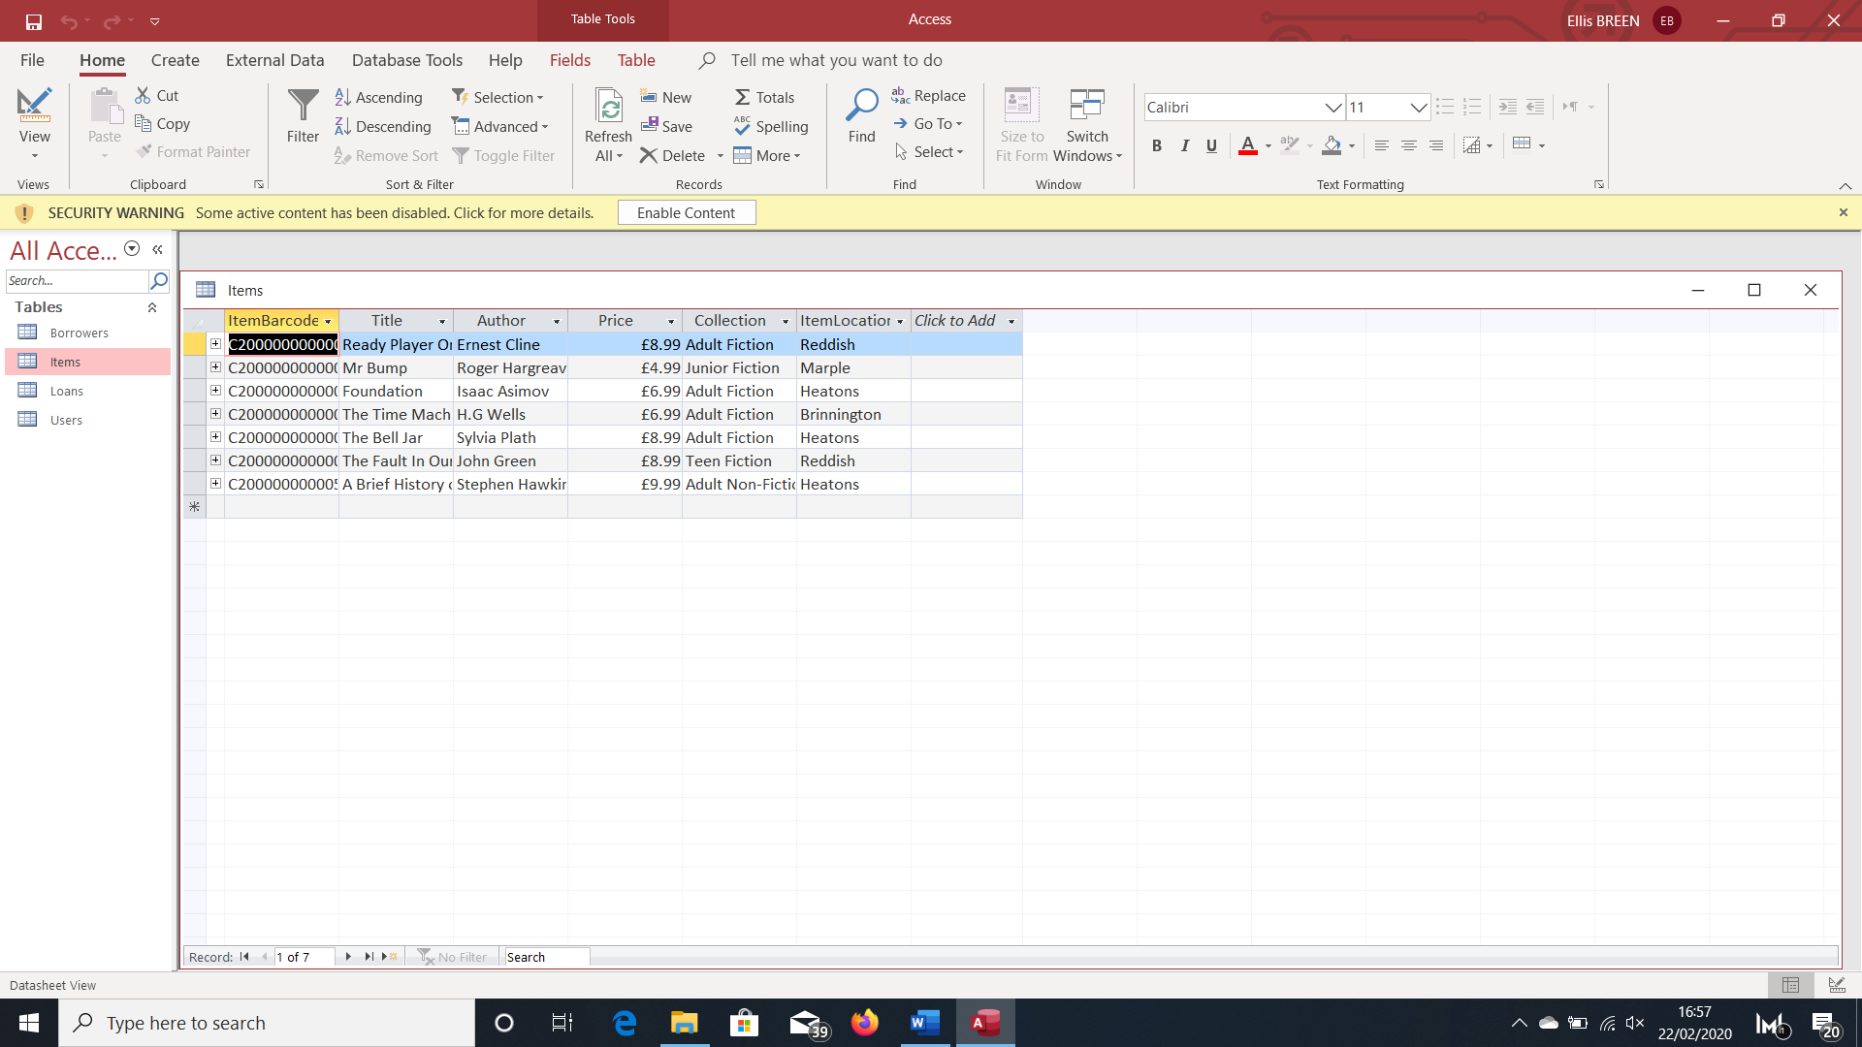

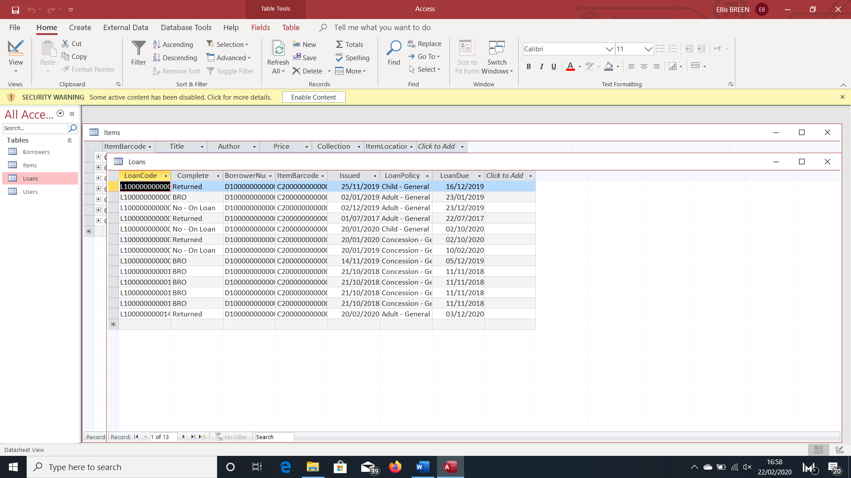

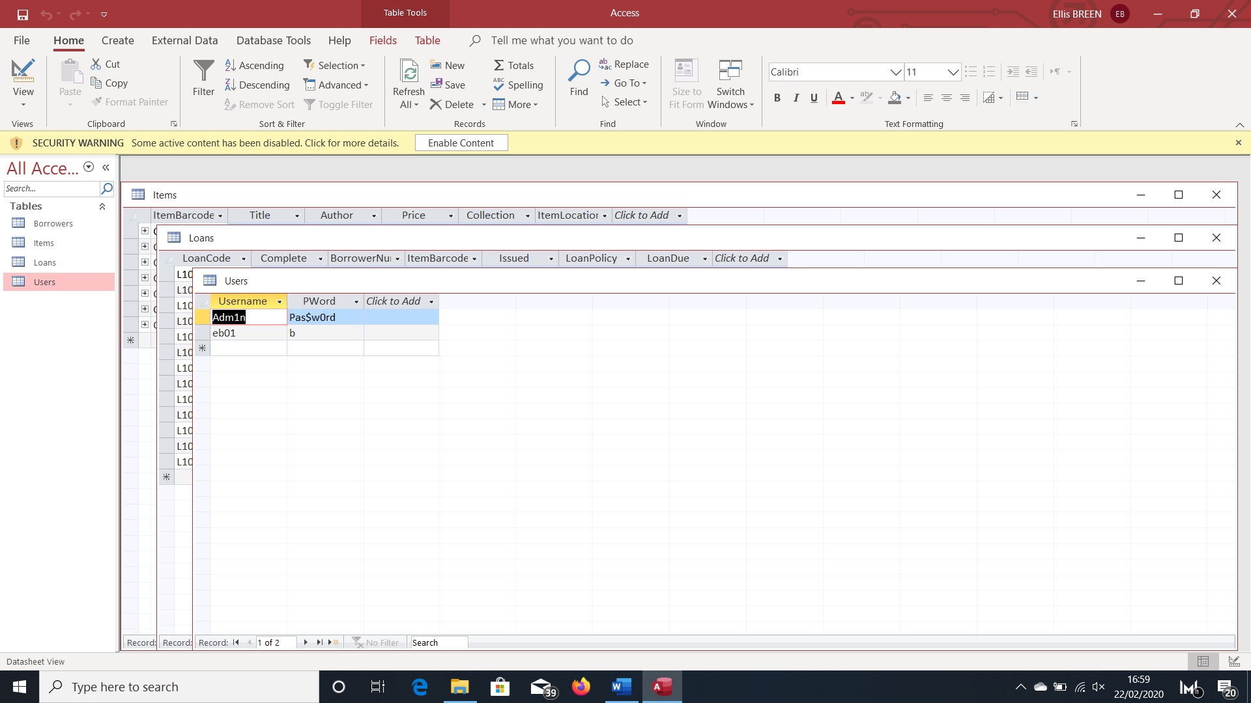

# Testing

|  |  |  |  |  |  |
| --- | --- | --- | --- | --- | --- |
|  | Description Of Test | Test Data and Reason | Expected Outcome | Actual Outcome | Page Number |
| 1. | Running program for first time | None | Creates a new database | Creates a new database | 92 |

Objective 1: Database Creation

|  |  |  |  |  |  |
| --- | --- | --- | --- | --- | --- |
|  | Description Of Test | Test Data and Reason | Expected Outcome | Actual Outcome | Page Number |
| 1. | User enters correct details | Username and Password – Both are required to access the main menu  Valid Data | The log in box is hidden and the main menu is shown | The log in box is hidden and the main menu is shown | 92 |
| 2. | User enters incorrect username | Username – The data we are checking exists in the database  Erroneous data | A message box displays the message ‘Username not found.’ | A message box displays the message ‘Username not found.’ | 93 |
| 3. | User enters incorrect password. | Username and Password – The password is the data being checked and it only does that if a correct username is also entered.  Erroneous Data | A message box displays the message ‘Wrong Password’. | A message box displays the message ‘Wrong Password’. | 93 |
| 4. | Borrowers selected from the Main Menu | None – Tests link to new form | Sends the user to the ‘Borrowers’ form | Sends the user to the ‘Borrowers’ form | 93 |

Objective 2: Create a user interface

|  |  |  |  |  |  |
| --- | --- | --- | --- | --- | --- |
| Objective 3: Create the ‘Loans’ Menu | Description Of Test | Test Data and Reason | Expected Outcome | Actual Outcome | Page Number |
| 1. | Entering a loan made by a borrower with 10 or more current loans. | None | A message box displays the message “Borrower already has max number of items out”. | A message box displays the message “Borrower already has max number of items out”. | 94 |
| 2. | Entering a correct loan when the borrower has less than 10 current loans. | BorrowerNumber, ItemBarcode, LoanPolicy – Will only record the loan if all of these are correct. Everything else to be recorded is predetermined and already correct.  Valid Data | A message box displays the message ‘Recorded’ and loan is added to the database in table ‘Loans’. | A message box displays the message ‘Recorded’ and loan is added to the database in table ‘Loans’. | 94 |
| 3. | Entering a loan with an incorrect BorrowerNumber and ItemBarcode | BorrowerNumber, ItemBarcode – Assuming all other data is correct  Erroneous Data | A message box will display ‘Not Found’ and the loan will not be recorded. | A message box will display ‘Not Found’ and the loan will not be recorded. | 95 |
| 4. | Generating a new and unique LoanCode each time a new loan is made/entered | LoanCode – Needs to be unique as it’s the primary key in Loans | The program generates a new and unique LoanCode each time the form loads/a new loan is entered. | The program generates a new and unique LoanCode each time the form loads/a new loan is entered. However when the ending digits are more than 2 characters the total length of the loan code is less than 14 characters. | 95 |
| 5. | Searching for all current loans | None – Tests that when the correct radio button is checked all current loans are displayed. | All current loans (ie Complete = ‘No – On Loan’) are displayed in the data grid view. | All current loans (ie Complete = ‘No – On Loan’) are displayed in the data grid view. | 96 |
| 6. | Searching for all current loans by a specific BorrowerNumber. | BorrowerNumber  Valid Data | All current loans (ie Complete = ‘No – On Loan’) for that particular borrower are displayed in the data grid view. | All current loans (ie Complete = ‘No – On Loan’) for that particular borrower are displayed in the data grid view. | 96 |
| 7. | Searching for all current loans by a specific BorrowerNumber when the BorrowerNumber doesn’t exist in the database | BorrowerNumber  Erroneous Data | A message box displays the message ‘Borrower not found’ | A data grid view without any records is shown. | 96 |
| 8. | Searching for all overdue loans | None – Tests that when the correct radio button is checked all overdue loans are displayed. | All long overdue loans (51 days past due date, still on loan and have a total cost of £25 or more) are displayed in the data grid view. | Loans that are 51 days past due date and still on loan are all displayed in the data grid view regardless of the total price. | 97 |
| 9. | Updating a loan | Complete – Only valid data can be entered as the user selects from a predetermined list. | Updates the database and changes ‘Compete’ to whatever was selected from the list. | Updates the database and changes ‘Compete’ to whatever was selected from the list. | 97 |

Objective 4: Create the Borrowers Menu

|  |  |  |  |  |  |
| --- | --- | --- | --- | --- | --- |
|  | Description Of Test | Test Data and Reason | Expected Outcome | Actual Outcome | Page Number |
| 1. | Successfully adding a new borrower to the database | Valid Data | A new borrower and all of the details entered will be added to the database in ‘Borrowers’ | A new borrower and all of the details entered will be added to the database in ‘Borrowers’ | 98 |
| 2. | Attempting to add a new borrower with missing data | E.g Address –Left Blank  Erroneous Data | A message box displays “Please make sure that there are no empty fields and everything entered is valid.” | A message box displays “Please make sure that there are no empty fields and everything entered is valid.” | 98 |
| 3. | Attempting to add a new borrower with an invalid email address | EmailAddress - Either left blank or without ‘@’ symbol  Erroneous Data | A message box displays “Please enter a valid email address”. | A message box displays “Please enter a valid email address”. | 99 |
| 4. | Attempting to add new borrower with an invalid contact number | ContactNumber – Needs to be 11 numbers long.  Boundary Data (Just above) | A message box displays “Please enter a valid contact number”. | A message box displays “Please make sure that there are no empty fields and everything entered is valid.” | 99 |
| 5. | ^ | ContactNumber – Needs to start with either ‘07’ or ‘0161’  Erroneous Data | ^ | A message box displays “Please enter a valid contact number”. | 99 |
| 6. | Testing the length of the borrwer’s first name | FirstName – Needs to be 25 or less characters long  Erroneous Data | A message box displays “Please make sure that there are no empty fields and everything entered is valid.” | A message box displays “Please make sure that there are no empty fields and everything entered is valid.” | 100 |
| 7. | Searching for a particular borrower | BorrowerNumber  Valid Data | All the details for that particular borrower are displayed in the data grid view. | All the details for that particular borrower are displayed in the data grid view. | 100 |
| 8. | Entering an incorrect borrower number | BorrowerNumber – Left blank or incorrect  Erroneous Data | A message box displays the message “BorrowerNumber not found” | A message box displays the message ‘BorrowerNumber not found’. | 100 |
| 9. | Generating a new BorrowerNumber each time the form loads/a new borrower is added | BorrowerNumber – Needs to be unique as it’s the primary key in Borrowers | The program should generate a new and unique BorrowerNumber each time there is a new borrower. | The program should generate a new and unique BorrowerNumber each time there is a new borrower. | 101 |
| 10. | Updating a borrower’s details | Valid Data | The database updates to include the changes made in the program. | The database updates to include the changes made in the program. | 101 |
|  | Validation for updating a borrower’s details is much the same as entering the details of a new borrower. | | | | |
| 11. | Deleting a borrower | None – A borrower may want to remove themselves from the database/may no longer use the libraries services. | The borrower and their details are deleted from the database along with all of the loans they have ever taken out. | The borrower and their details are deleted from the database along with all of the loans they have ever taken out. | 102 |

Objective 5: Create the Reports Menu

|  |  |  |  |  |  |
| --- | --- | --- | --- | --- | --- |
|  | Description Of Test | Test Data and Reason | Expected Outcome | Actual Outcome | Page Number |
| 1. | Selecting which report the user wants to run | None – Testing that the form links are working. | The appropriate form loads. | The appropriate form loads. | 102 |
| 2. | Generating the annual report. | None | The form displays how many new overdue items there were last year, how many of these were recovered and the total cost of the items recovered. | The form displays how many new overdue items there were last year, how many of these were recovered and the total cost of the items recovered. | 103 |
| 3. | Generates a graph | None | The form displays a graph showing each month and how many items became overdue in that month last year. | The form displays a graph showing each month and how many items became overdue in that month last year. | 103 |
| 4. | Returning the details of all overdue loans | None - The user needs to know all of the overdue loans and the details of the borrowers that made them. | Returns each overdue loan and the appropriate details in the data grid view. | Returns each overdue loan and the appropriate details in the data grid view. | 104 |

Objective 6: Create the Users menu

|  |  |  |  |  |  |
| --- | --- | --- | --- | --- | --- |
|  | Description Of Test | Test Data and Reason | Expected Outcome | Actual Outcome | Page Number |
| 1. | Selecting an option | None – Testing form links | The appropriate form loads. | The appropriate form loads. | 104 |
| 2. | Adding a new user | Username and Password – The two credentials needed to create a new user  Normal Data | The username and password entered will be stored in the Users table in the database | The username and password entered will be stored in the Users table in the database | 105 |
| 3. | Attempting to create a new user using an existing username | Username – Compared against the usernames already stored in the database  Erroneous Data as it’s already in use | A message box displays ‘Username already exists’ | A message box displays ‘Username already exists’ | 105 |
| 4. | Testing the length of the username | Username – If the username is too long the database will corrupt  Erroneous Data | A message box displays “Username is too long” | A message box displays “Please make sure everything is valid” | 106 |
| 5. | Testing the length of the username | Username  Boundary Data (Just below) | The username should be accepted and if the password is valid they should be stored in the table | The username should be accepted and if the password is valid they should be stored in the table | 106 |
| 6. | Testing the length of the password | Password  Boundary Data (Just above) | A message box displays “Password is too long” | A message box displays “Please make sure everything is valid” | 106 |
| 7. | Changing the user’s password | Password, Confirm Password – They need to be the same for it to work  Valid Data | The password in the database will update | The password in the database will update | 107 |
| 8. | Changing password when Password and Confirm Password are different | Password, Confirm Password  Data type doesn’t matter as it won’t check if the two are different | Message box displays "Please make sure passwords are the same" | Message box displays "Please make sure passwords are the same" | 107 |
| 9. | Checking length of password | Password  Erroneous Data | A message box displays “Password is too long” | A message box displays “Please make sure everything is valid” | 107 |

Objective 1:

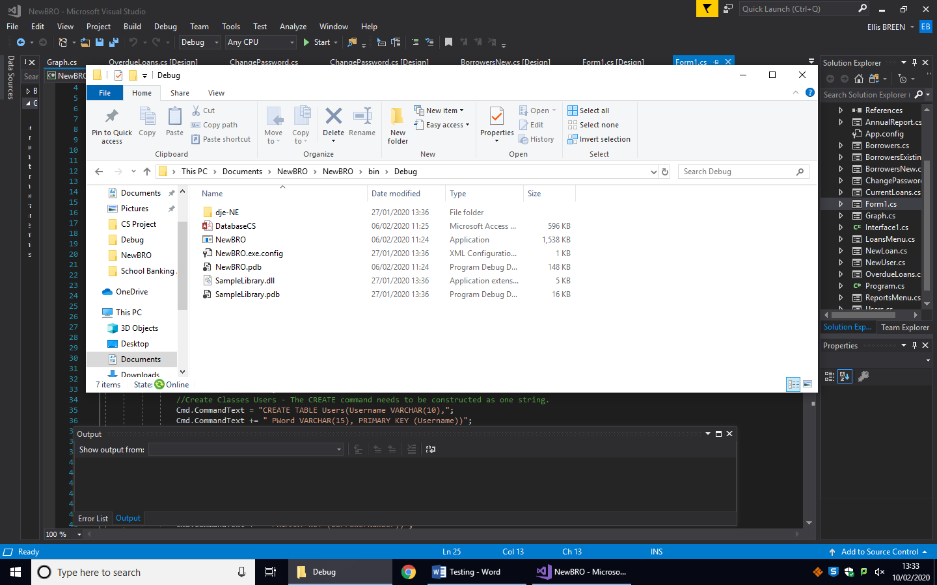

Objective 2:

1.

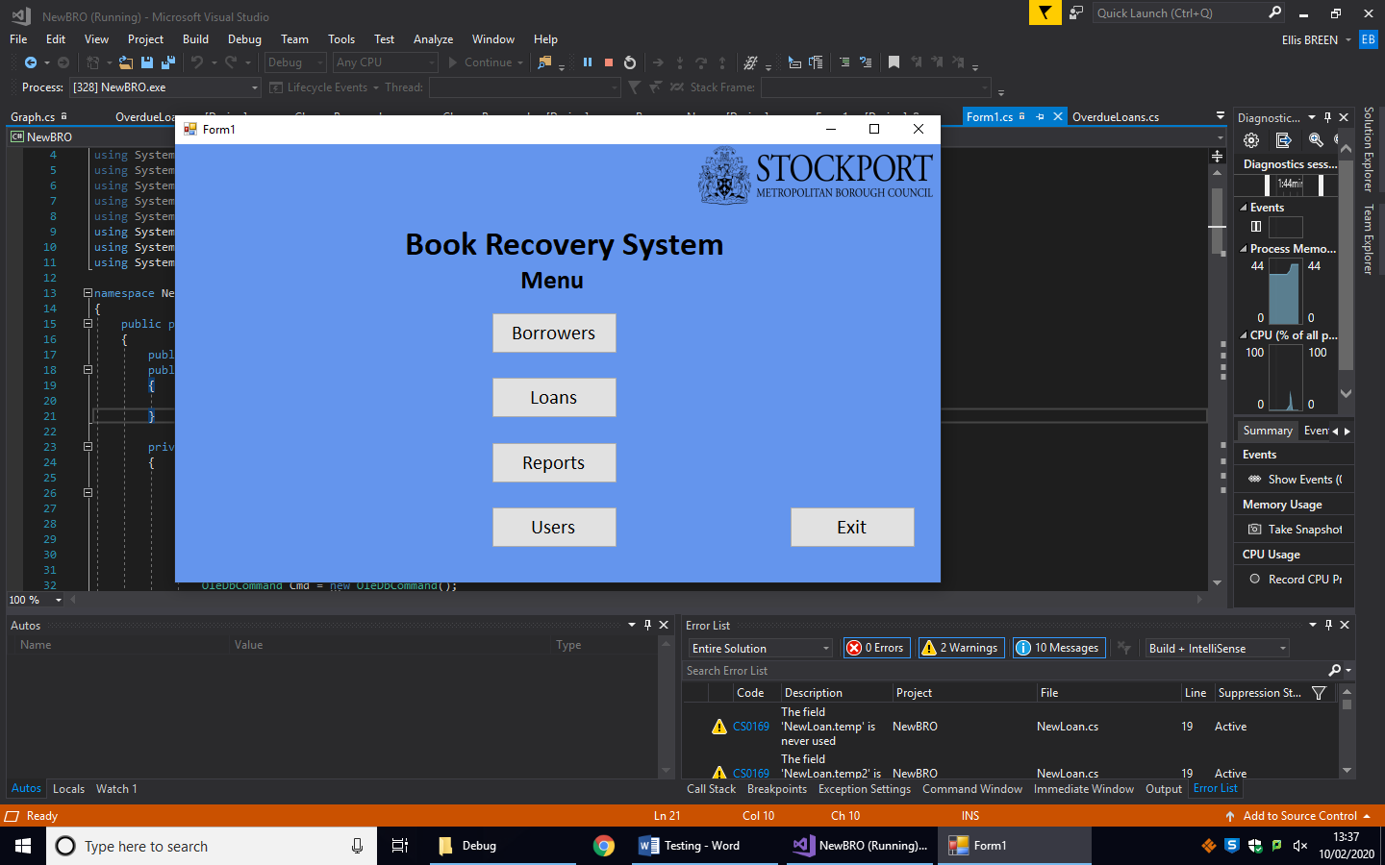Before: After:

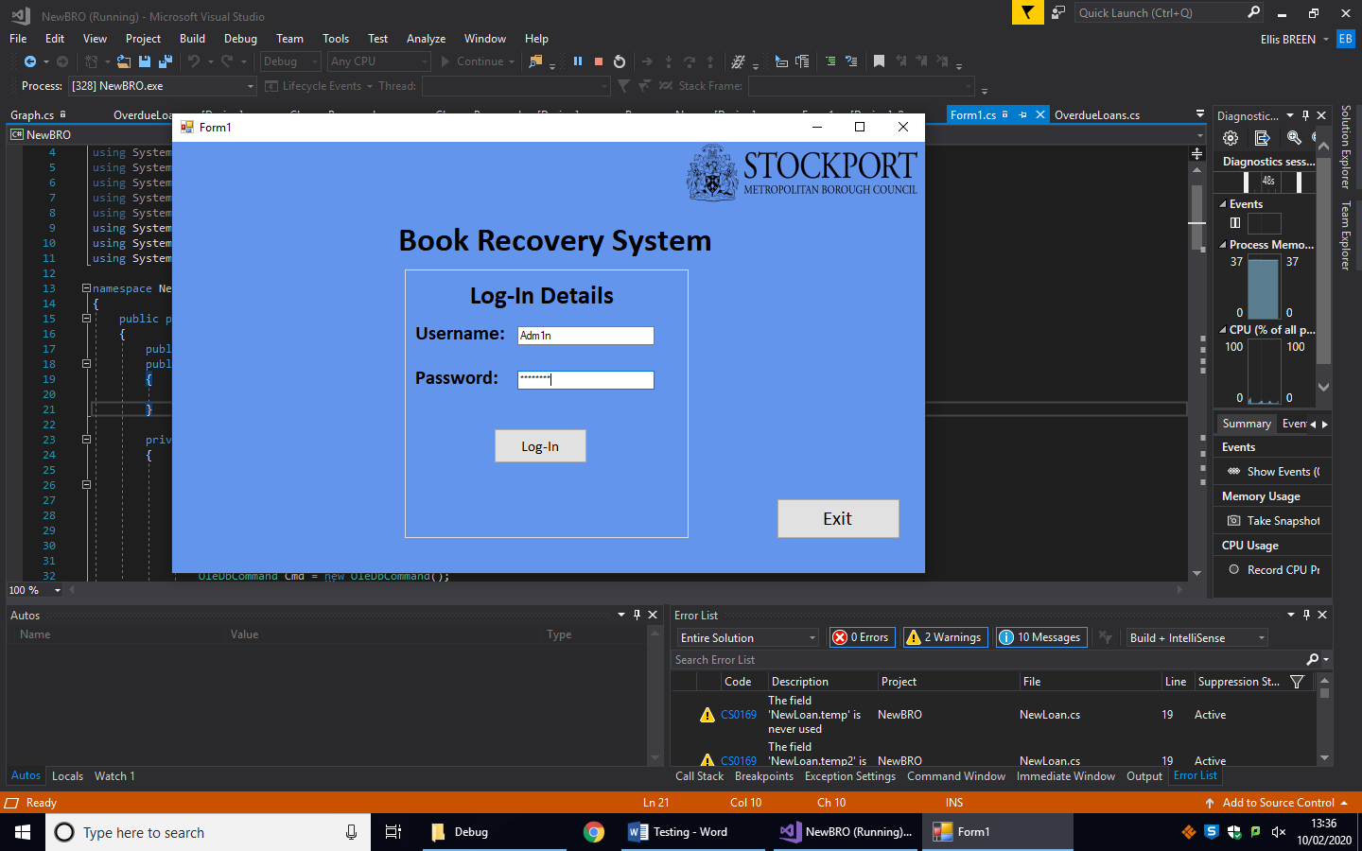

2.

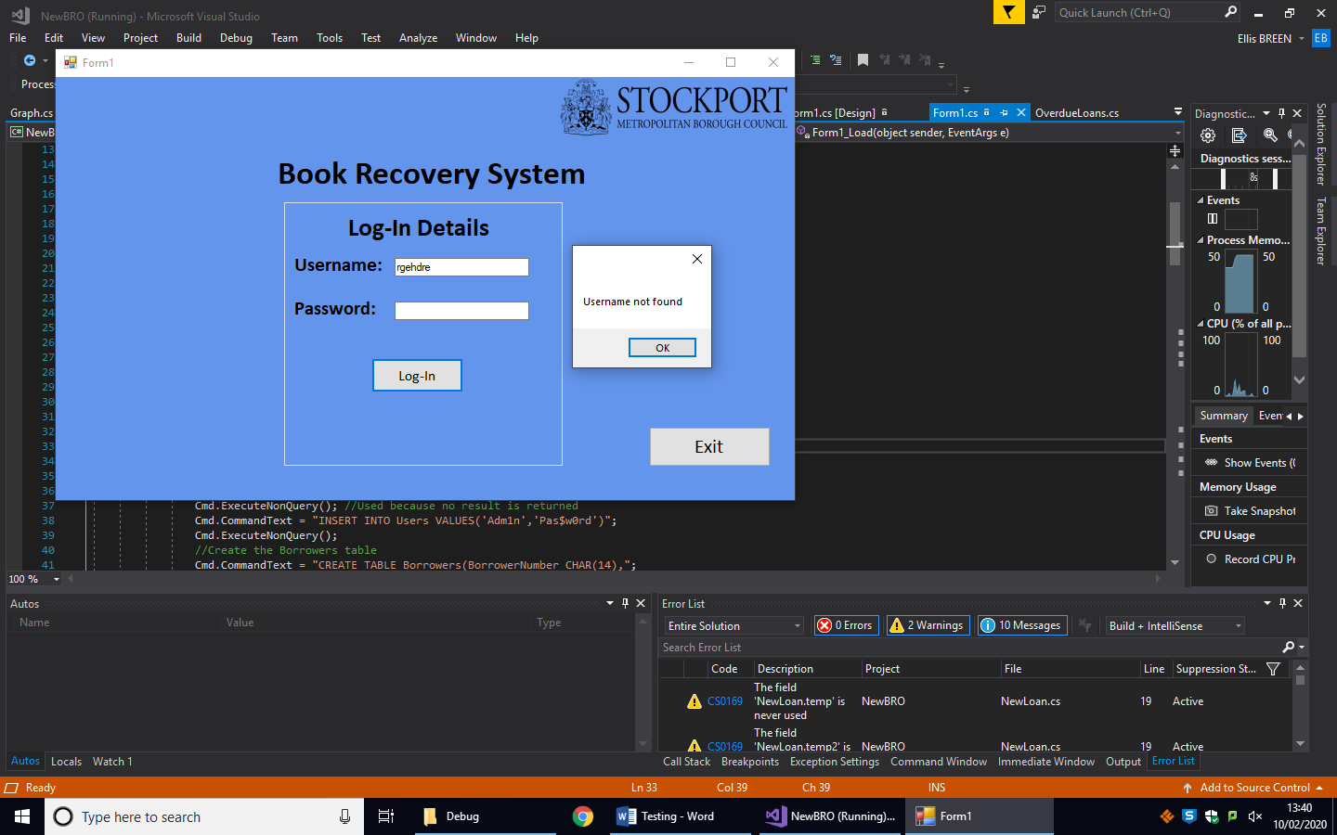

3.

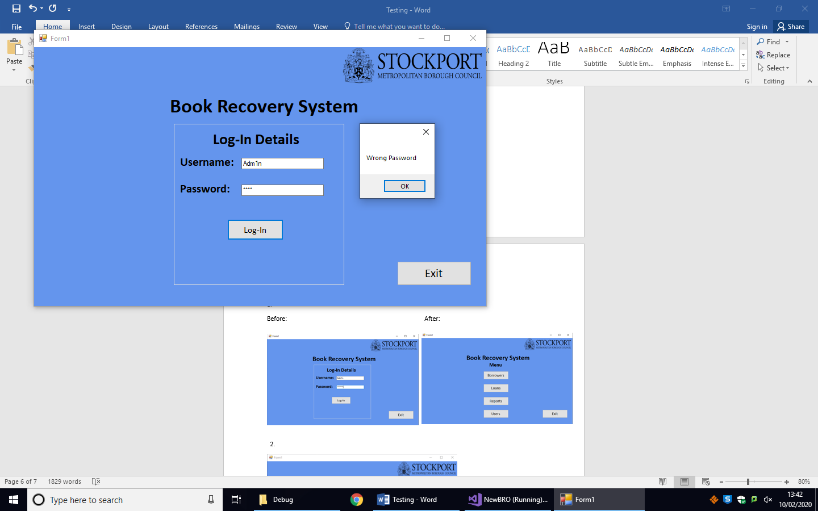

4.

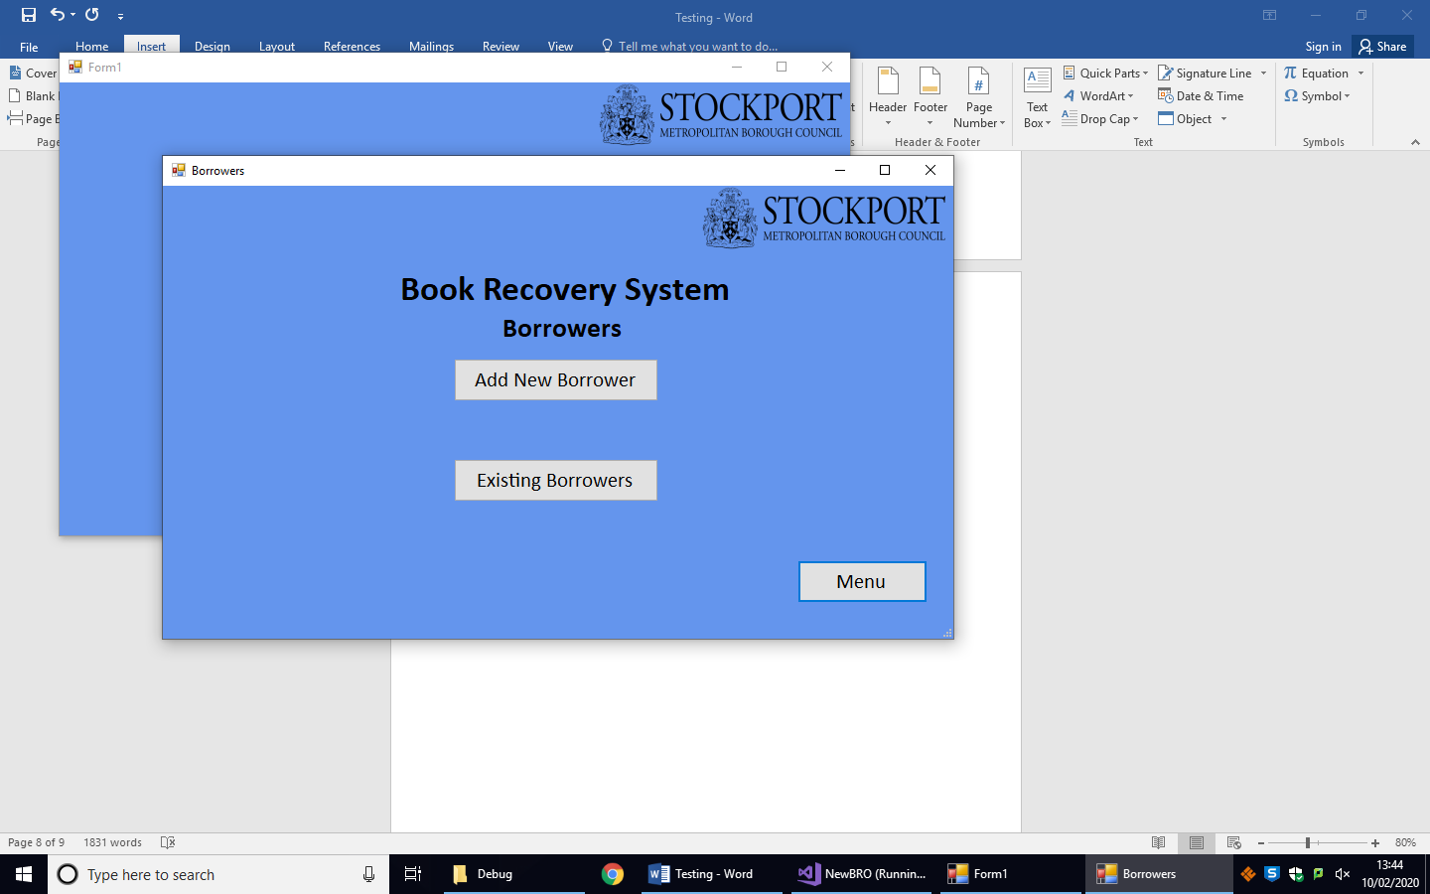Before:

Objective 3:

1.

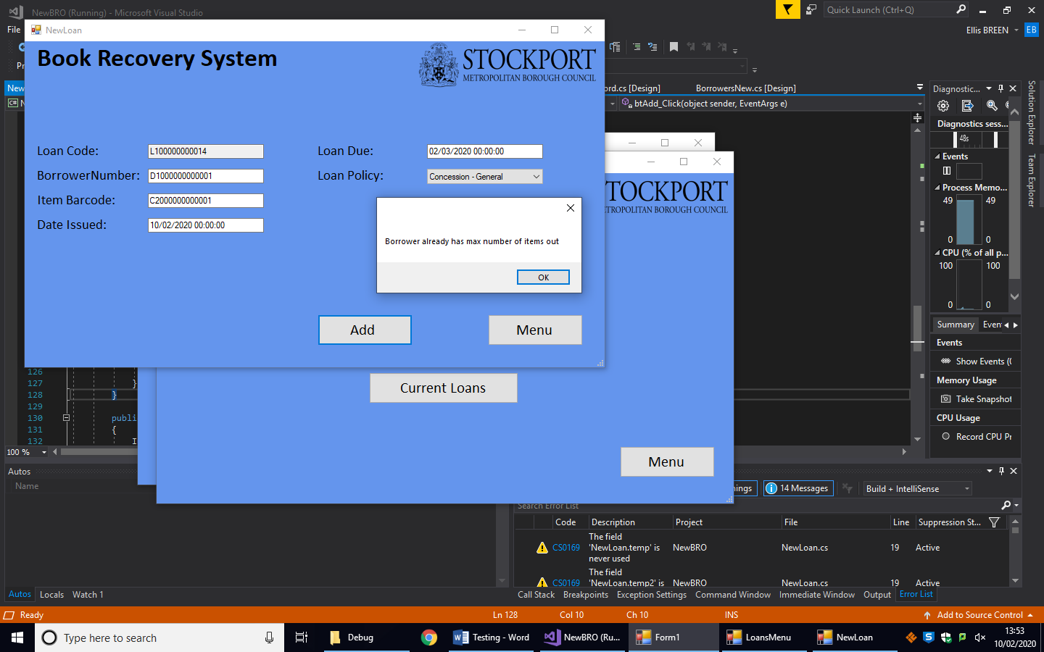

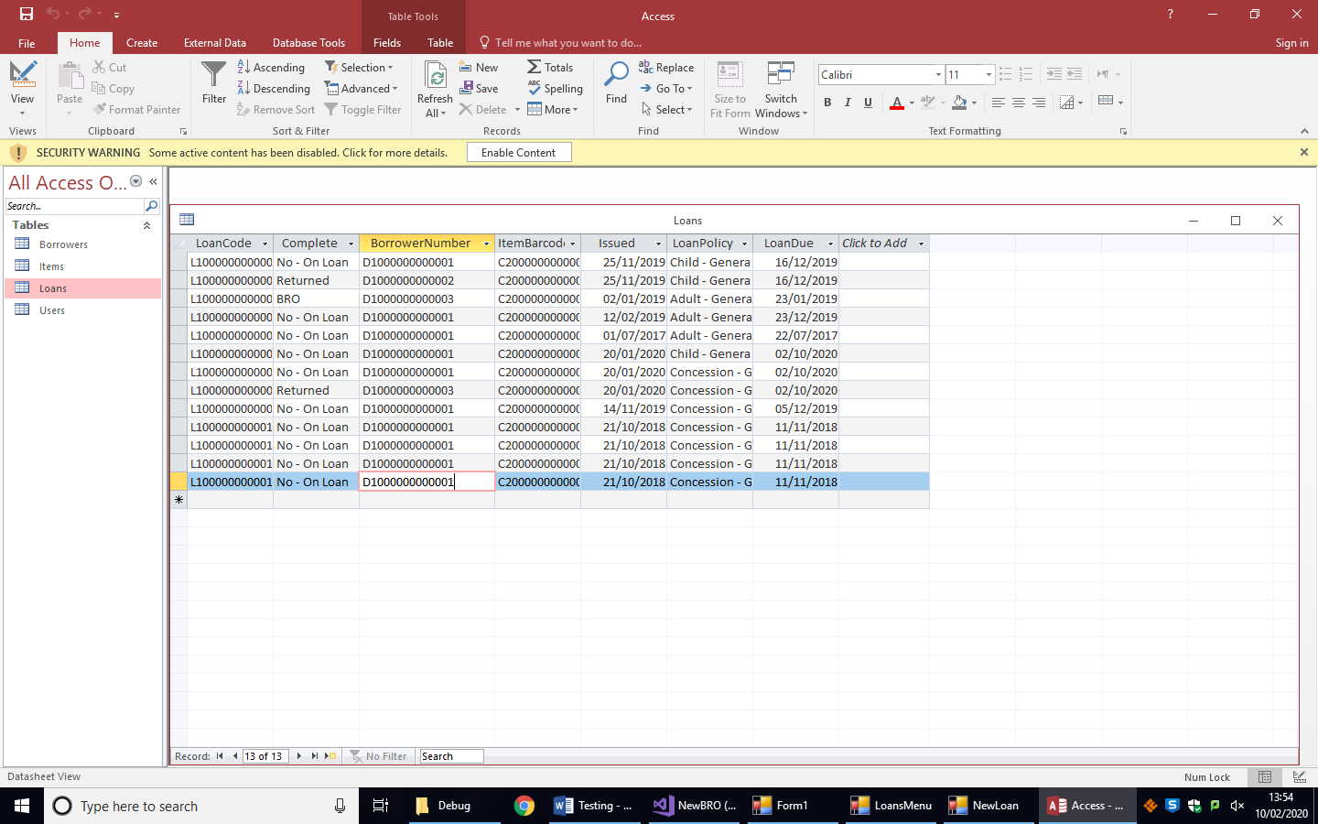2.

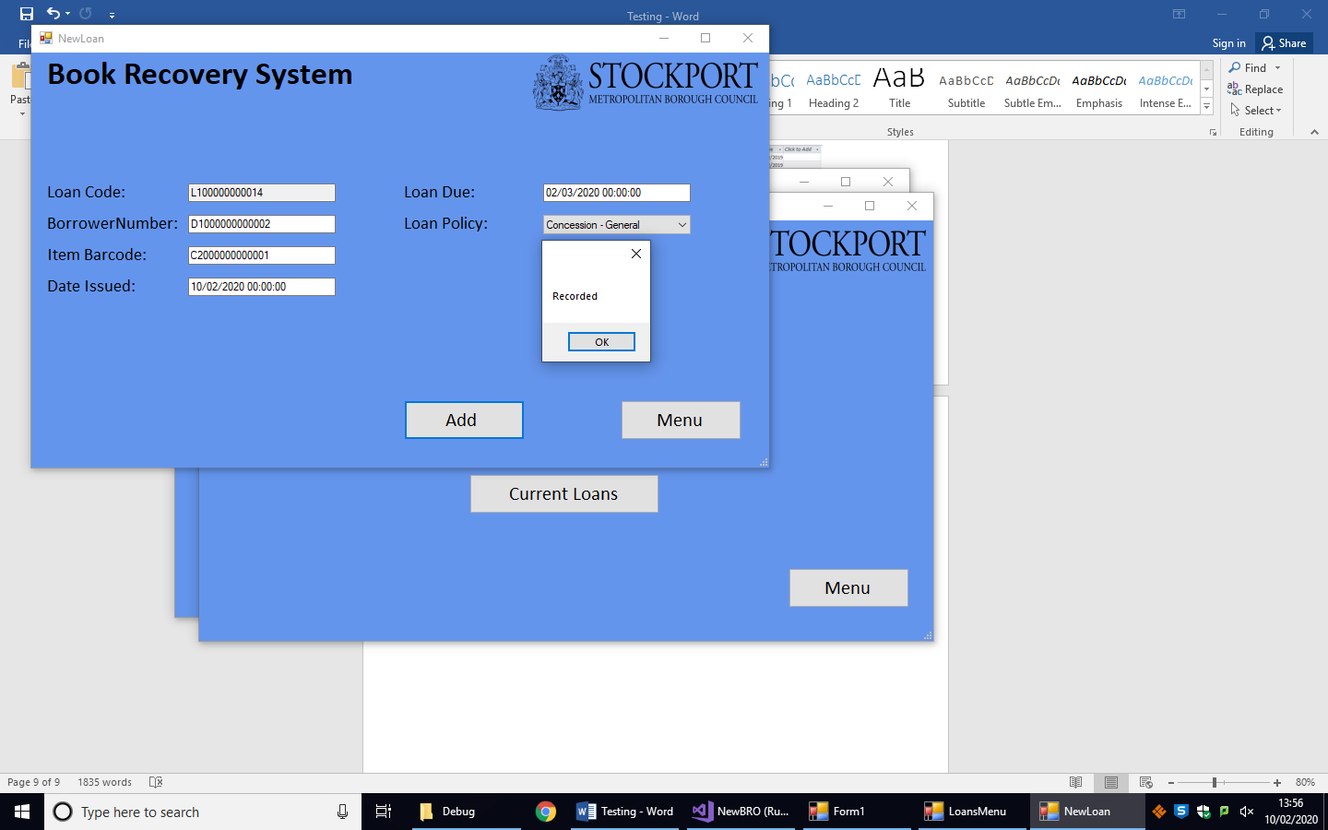

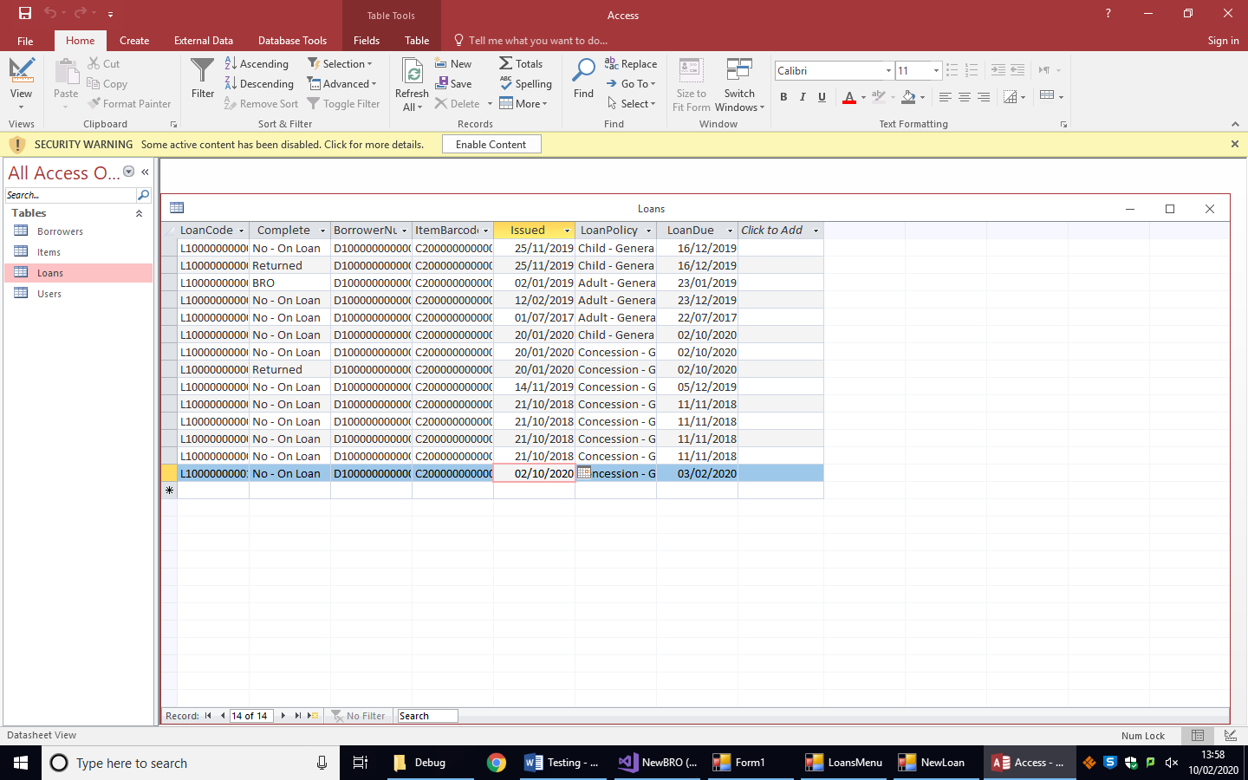

3.

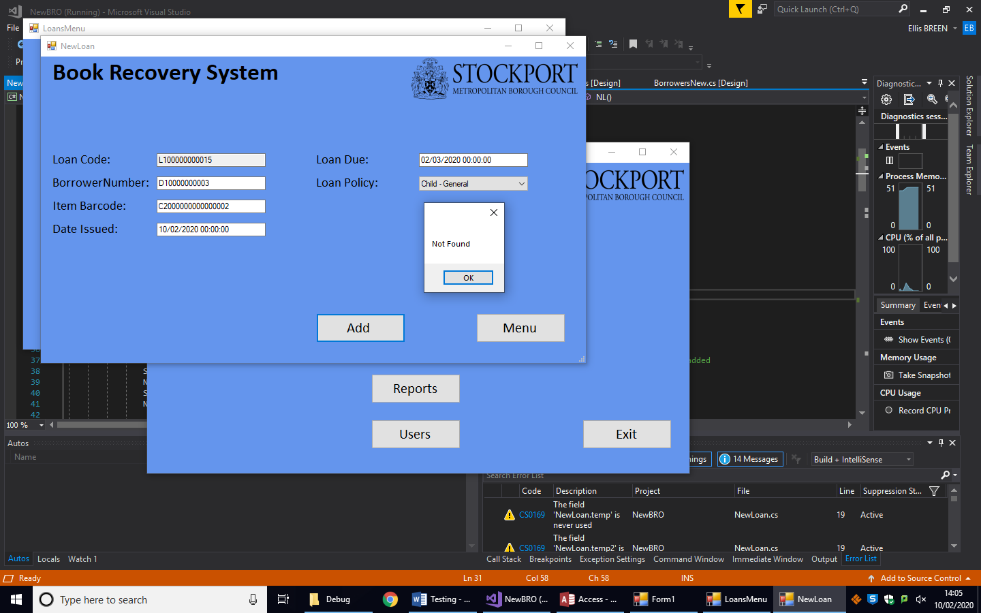

4.

Only 13 characters, LoanCode should be 14 characters

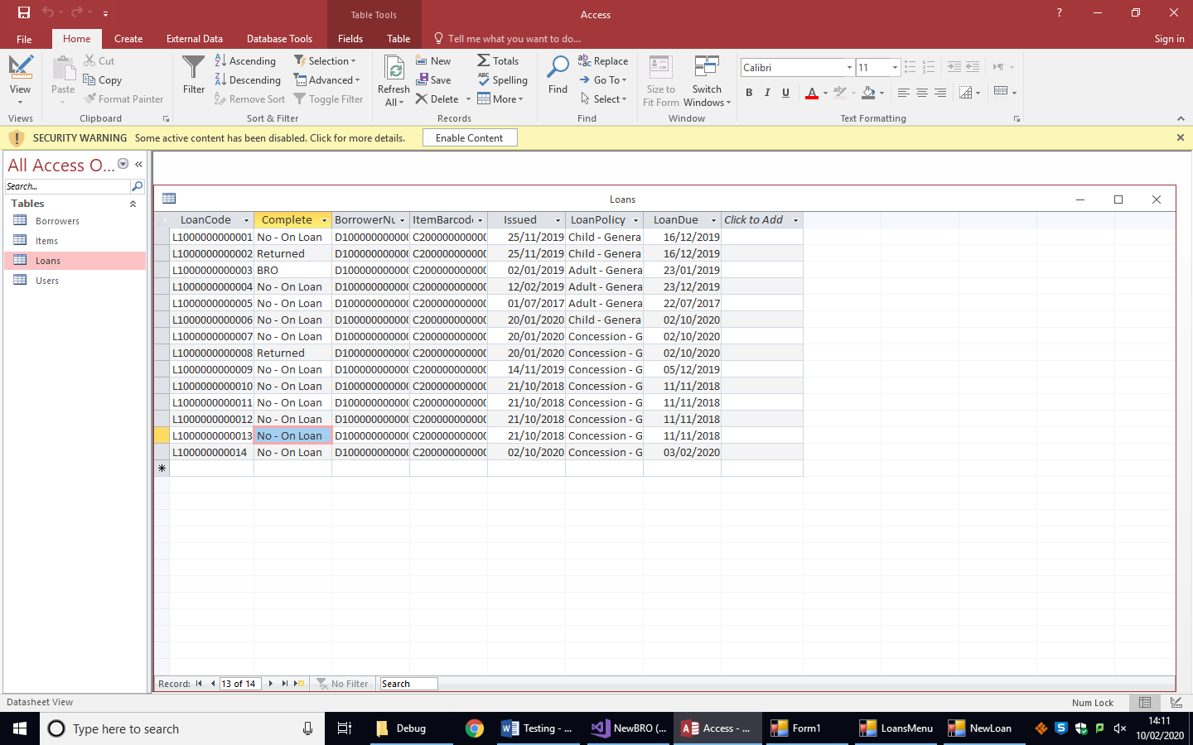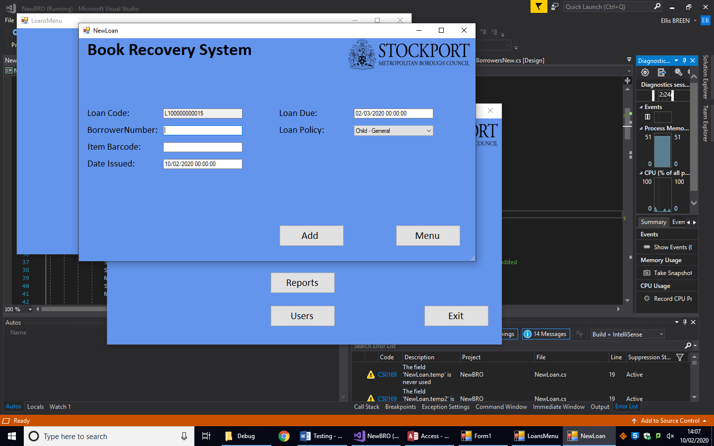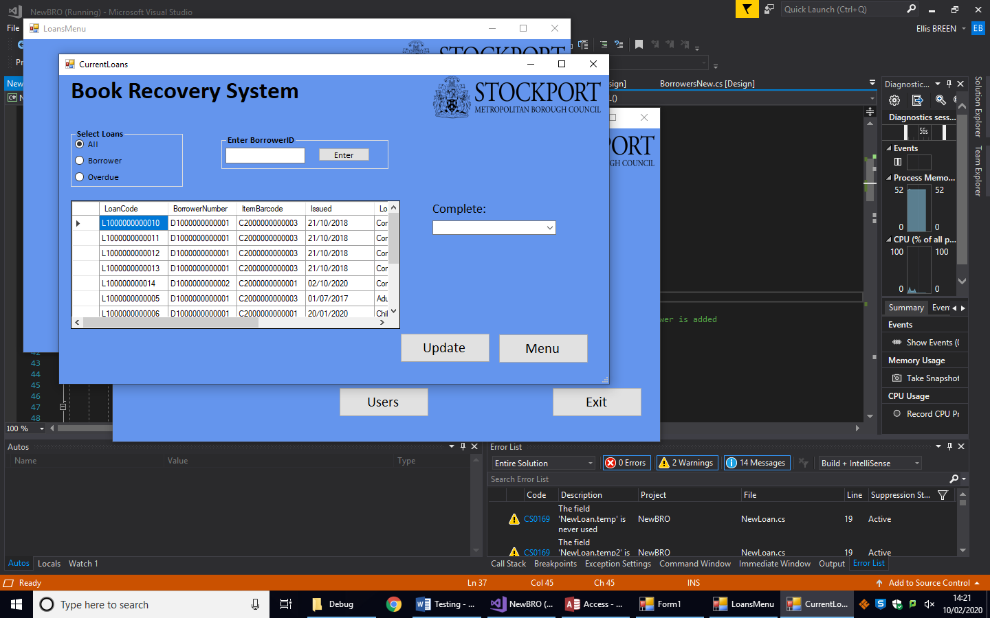5.

Last loan entered

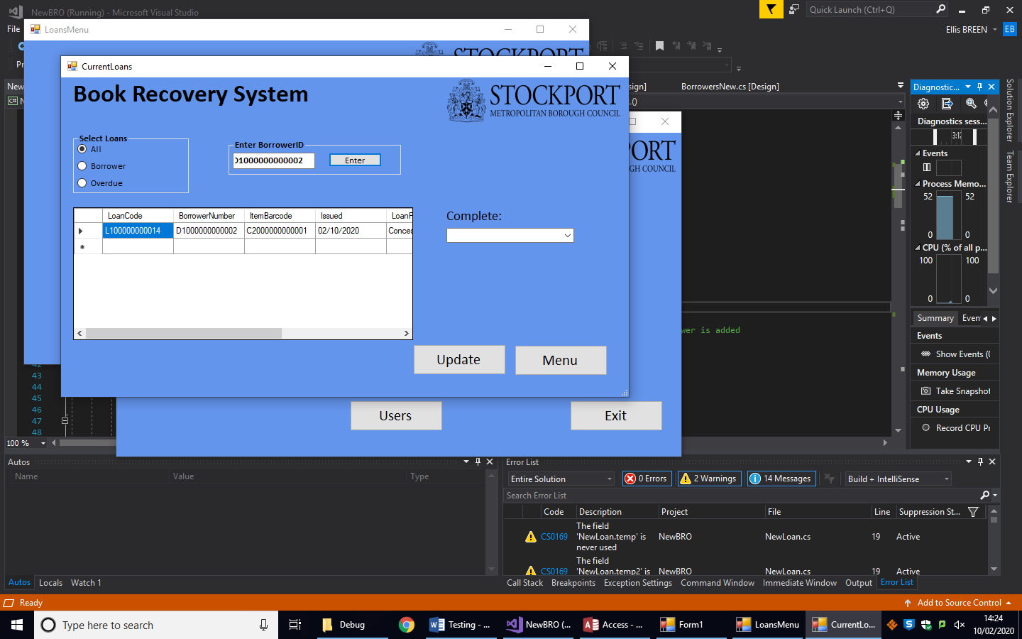6.

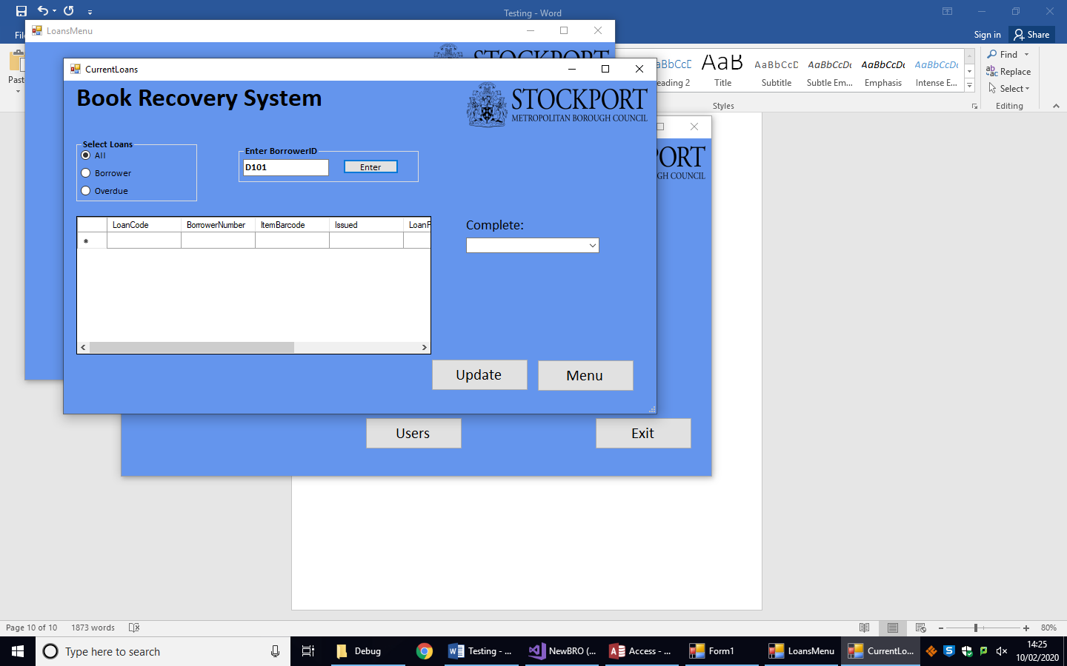7.

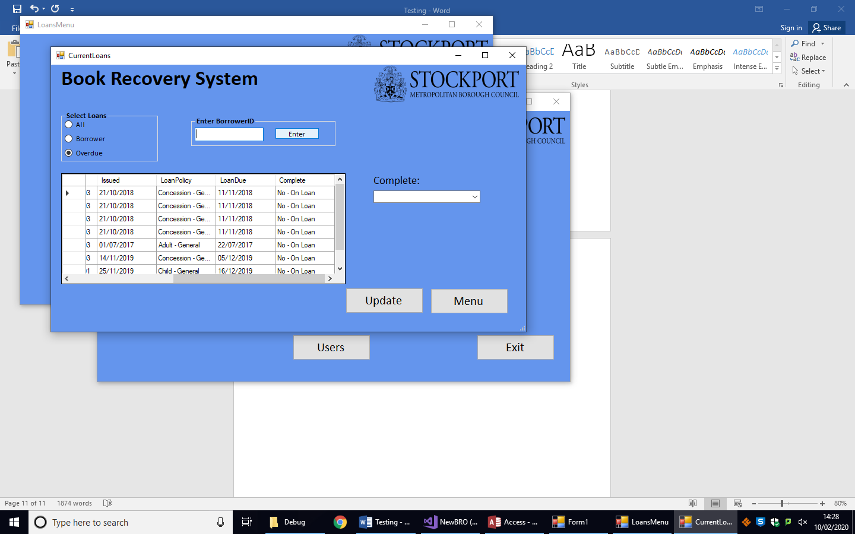8.

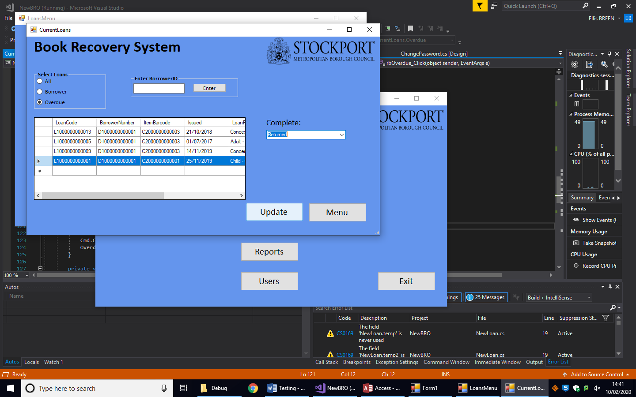9.

Before updating Complete = No – On Loan

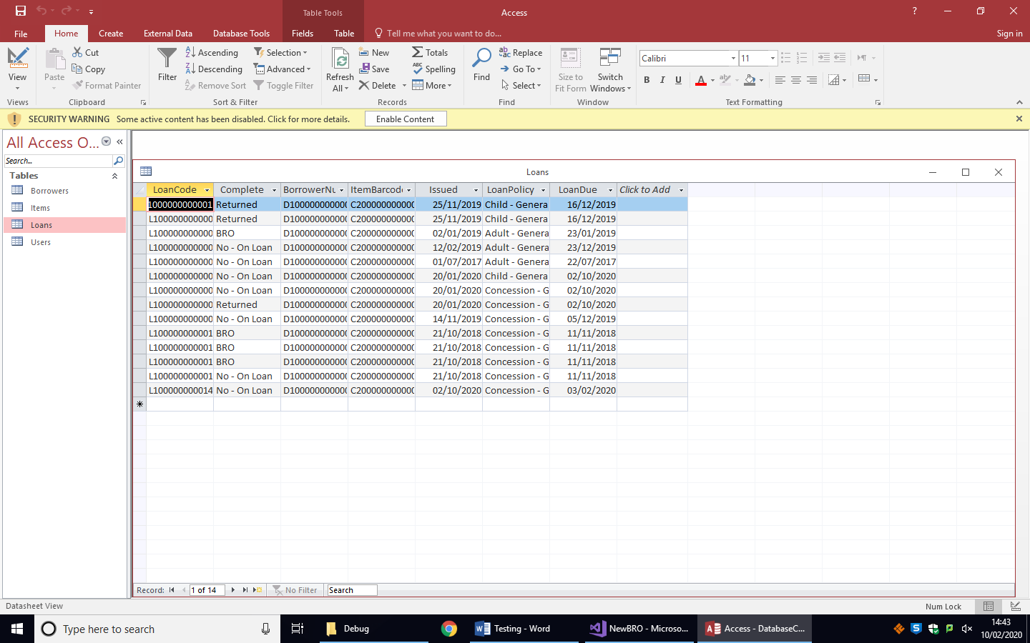

After updating

Objective 4:

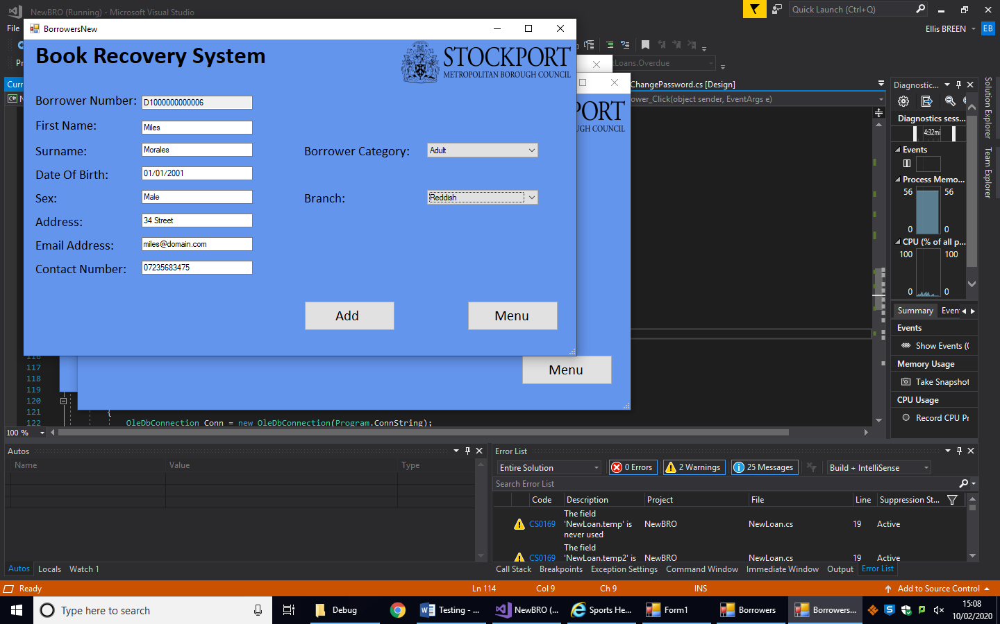1.

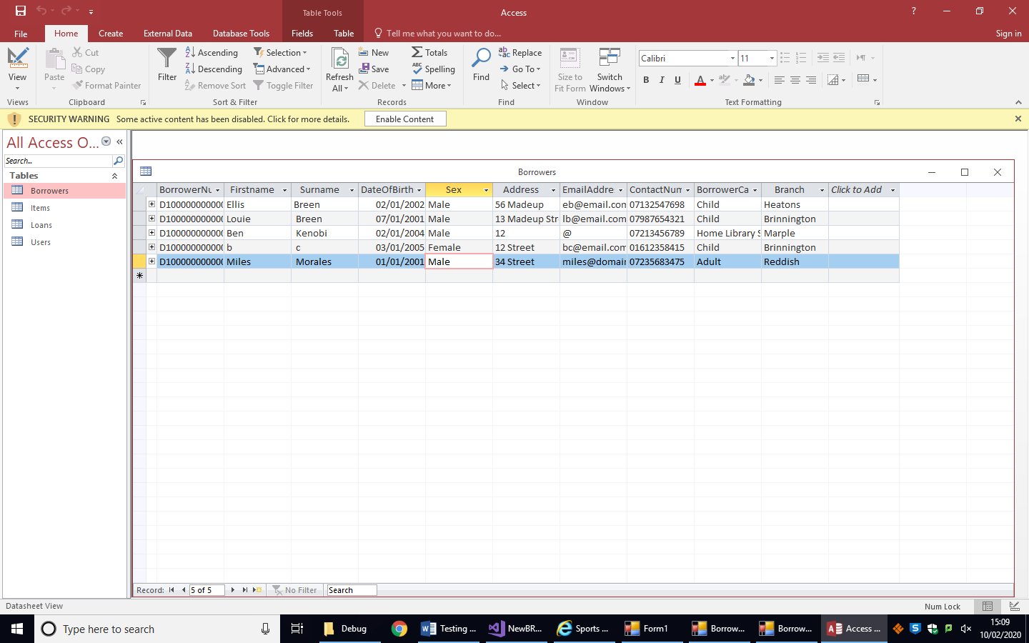

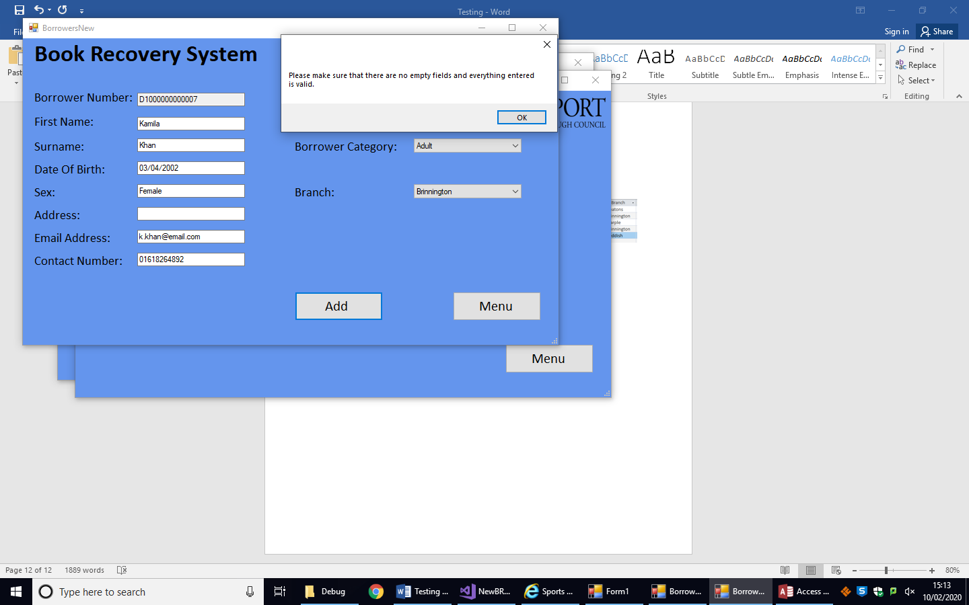2.

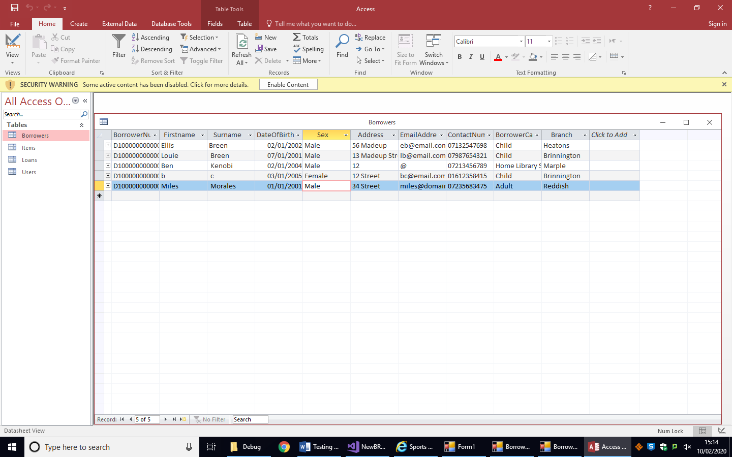

The borrower has not been entered into the database

3.

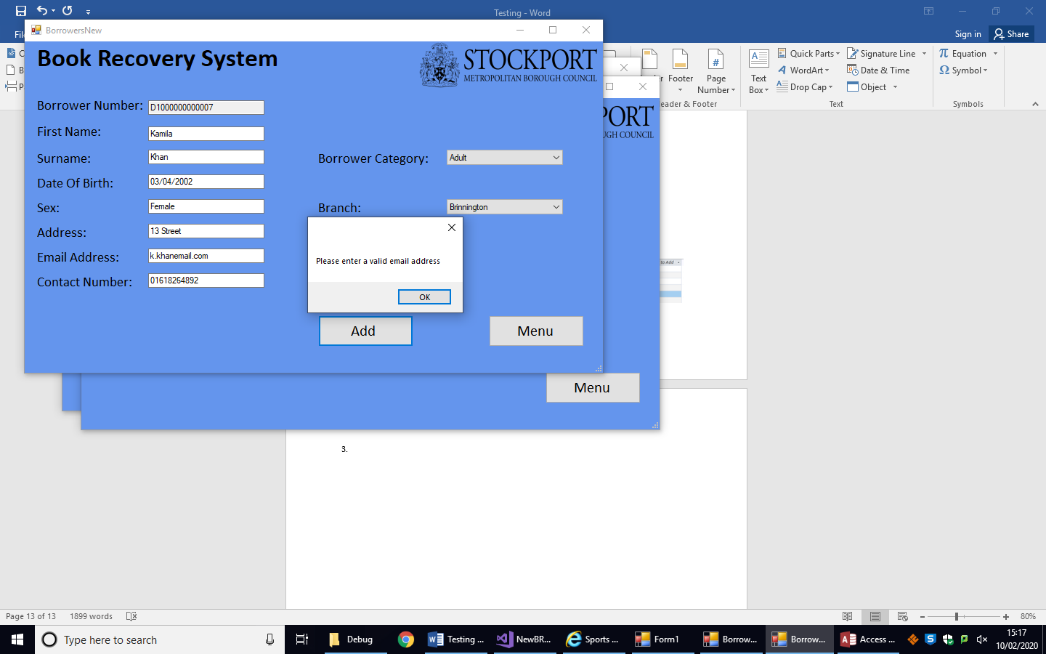

4.

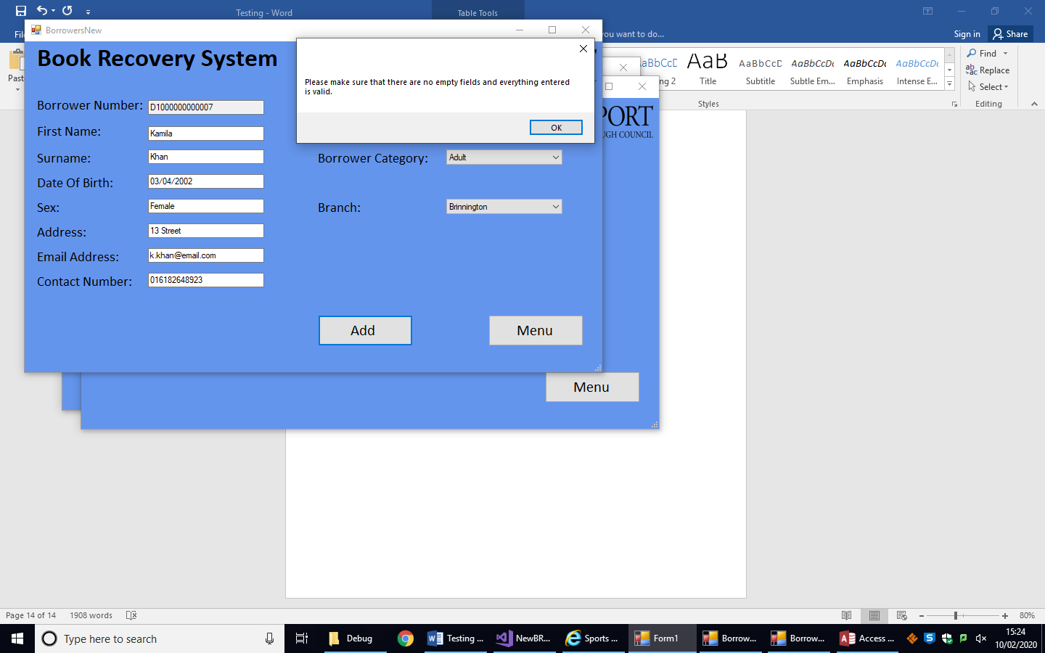

5.

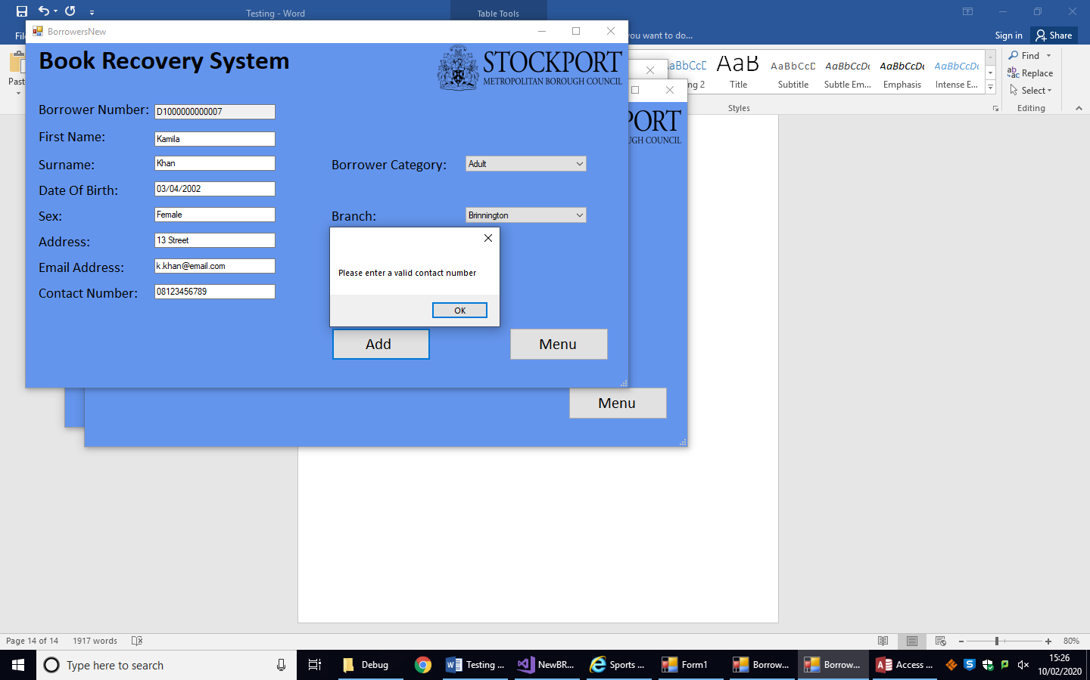

6.

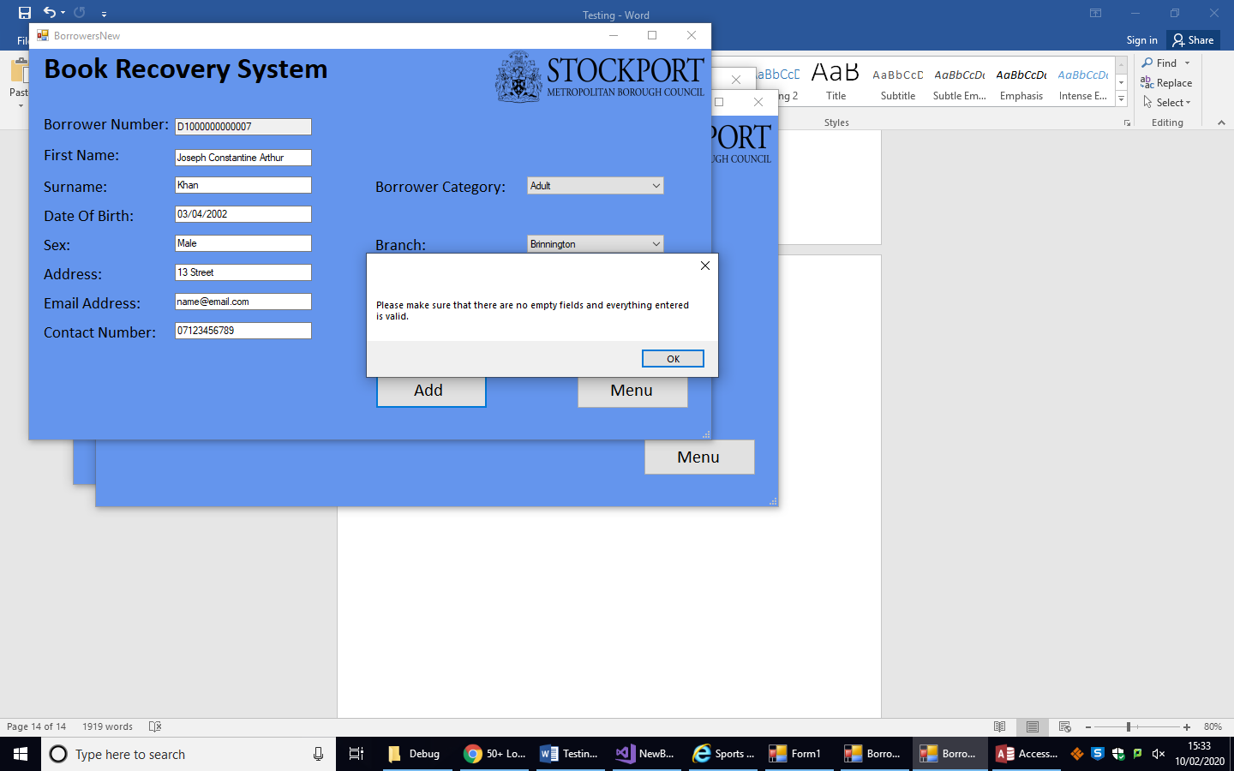

7.

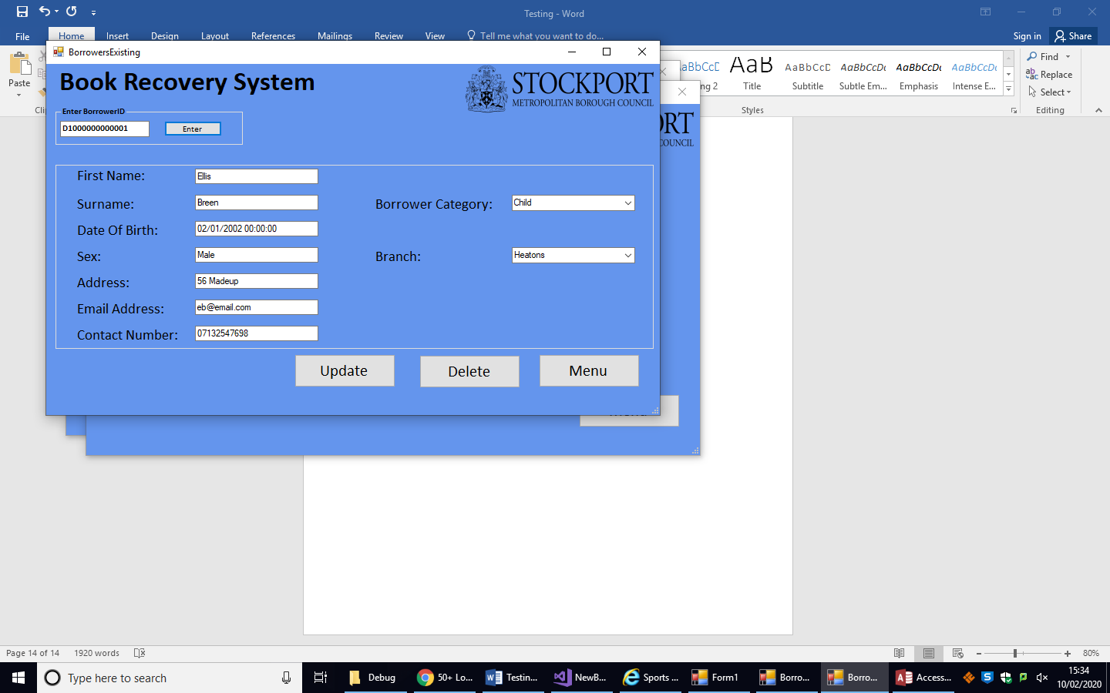

8.

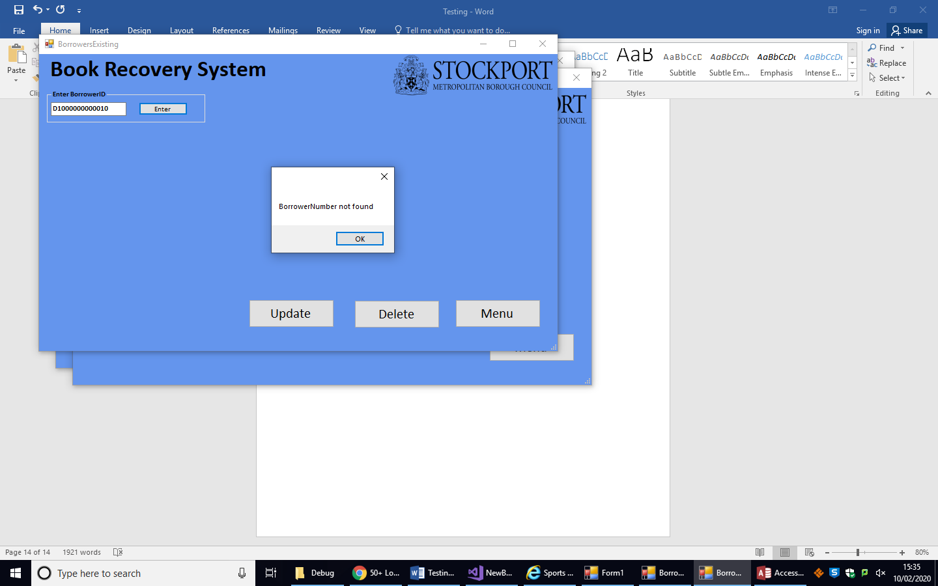

9.

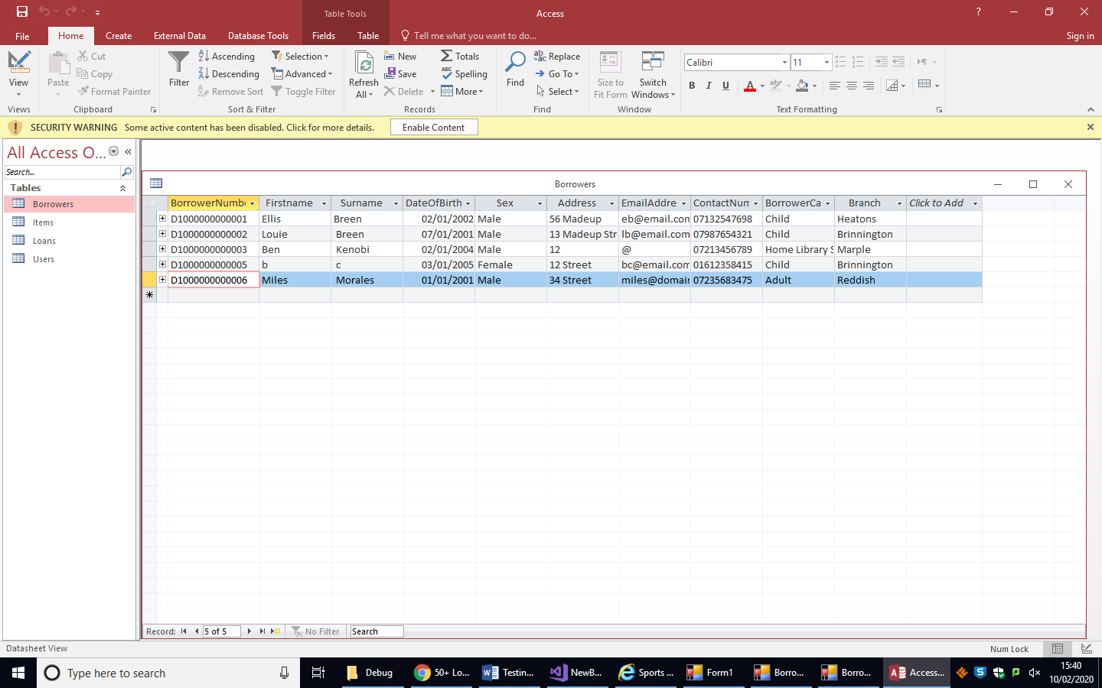

Latest BorrowerNumber

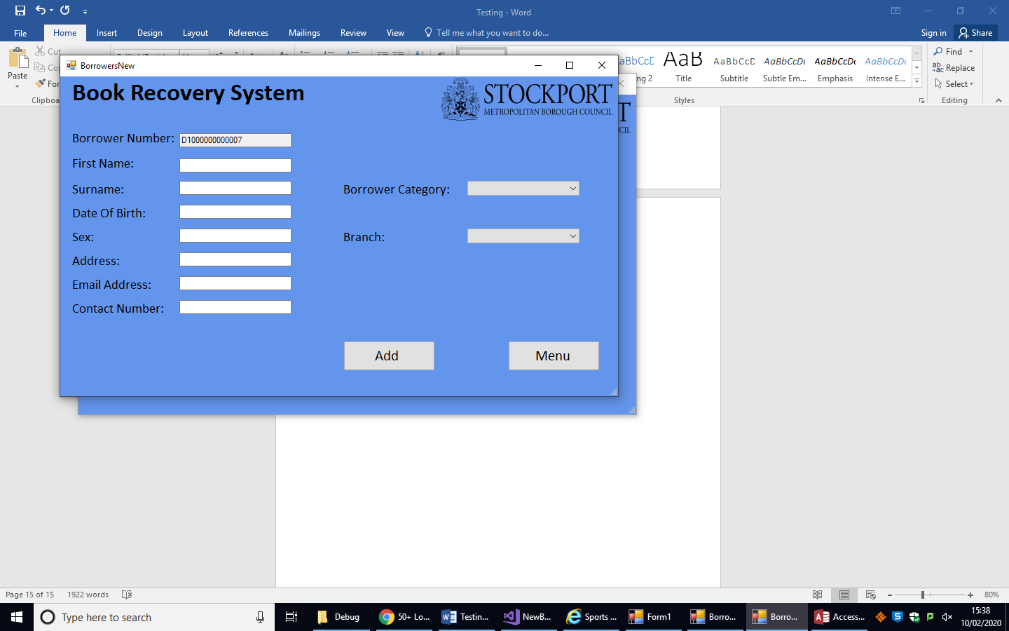

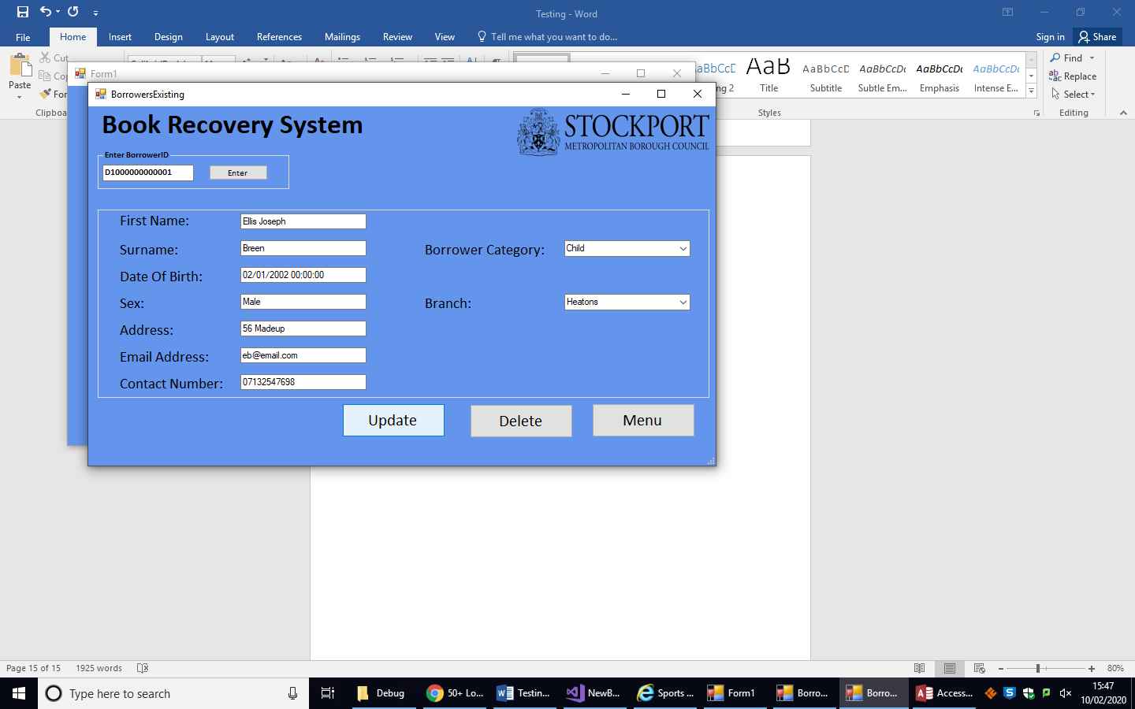10.

Added ‘Joseph’

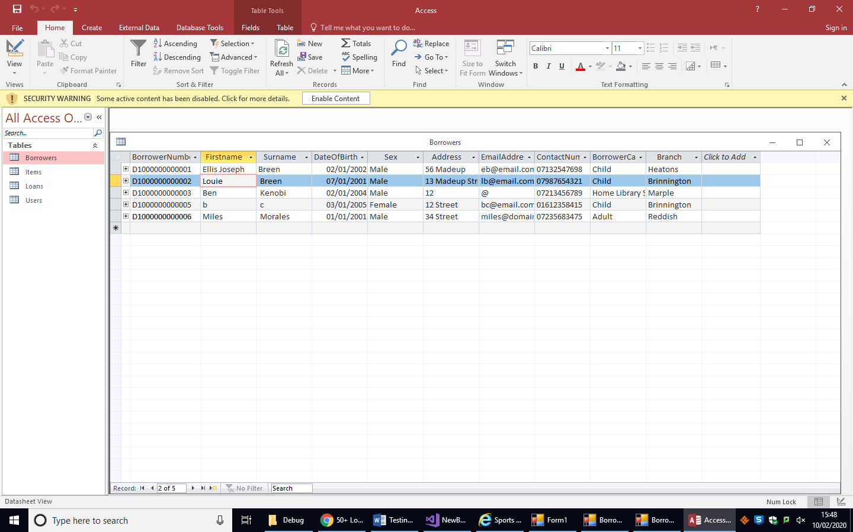

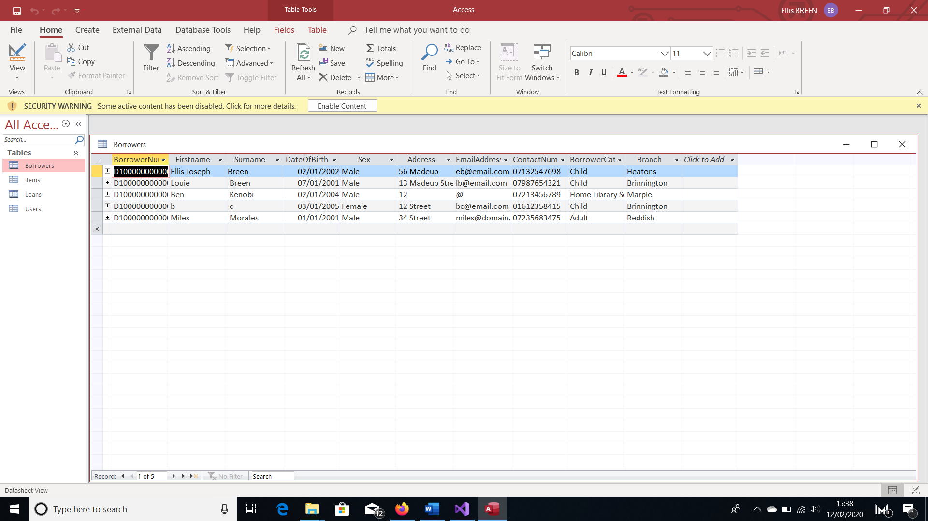11.

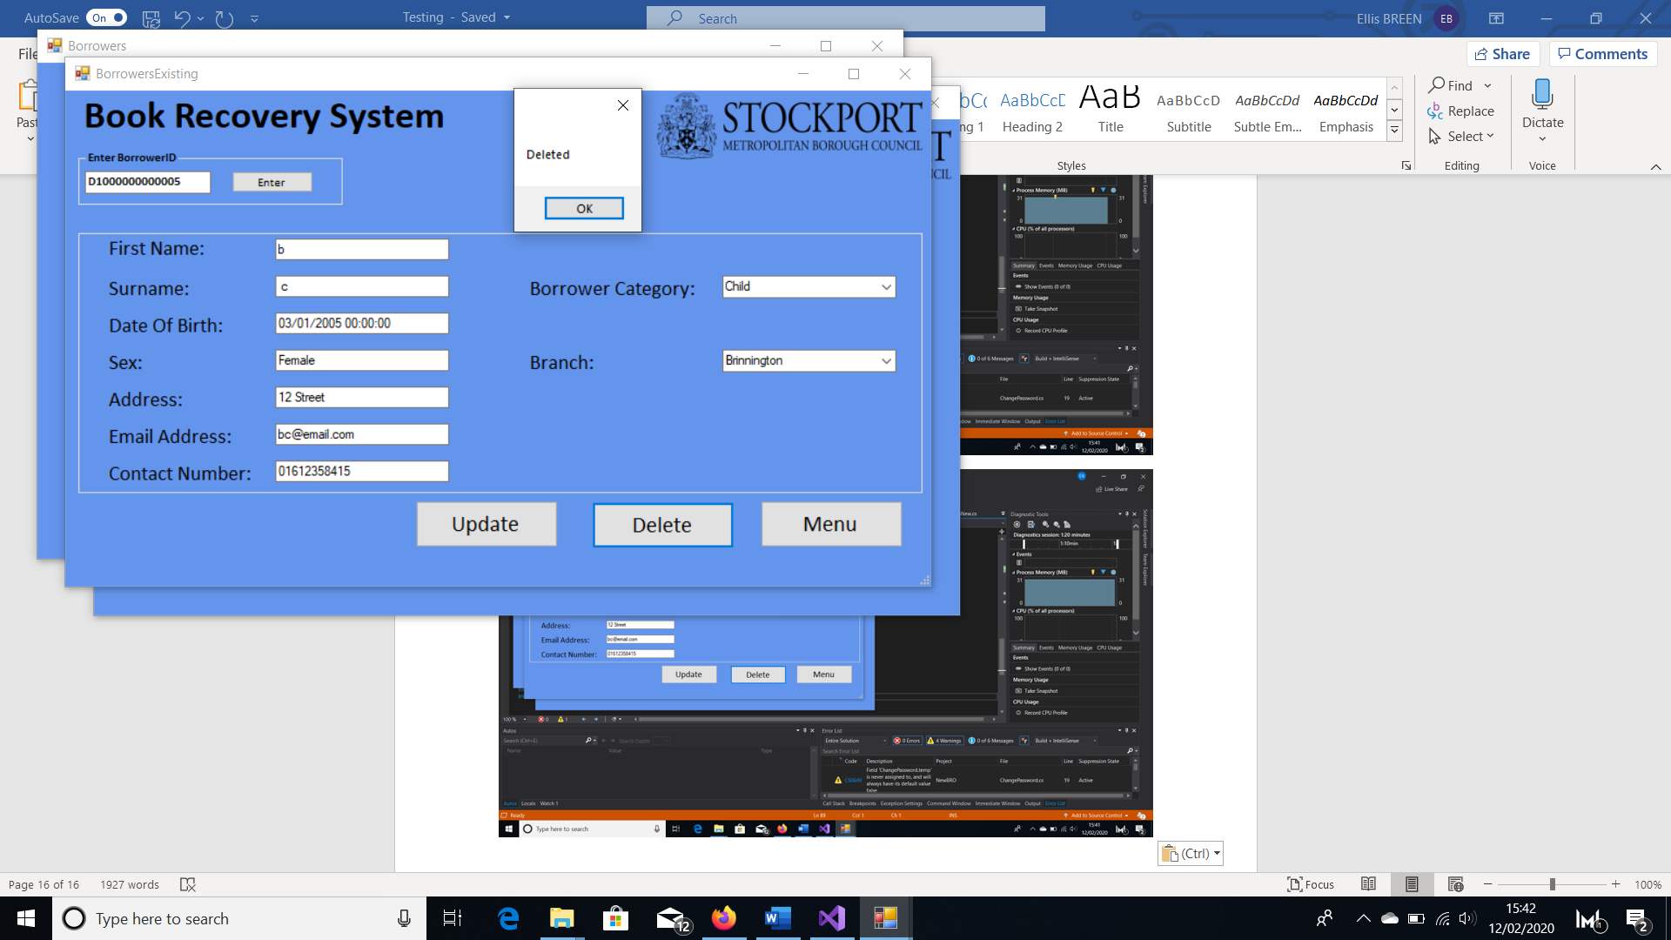

The borrower has been deleted from the database

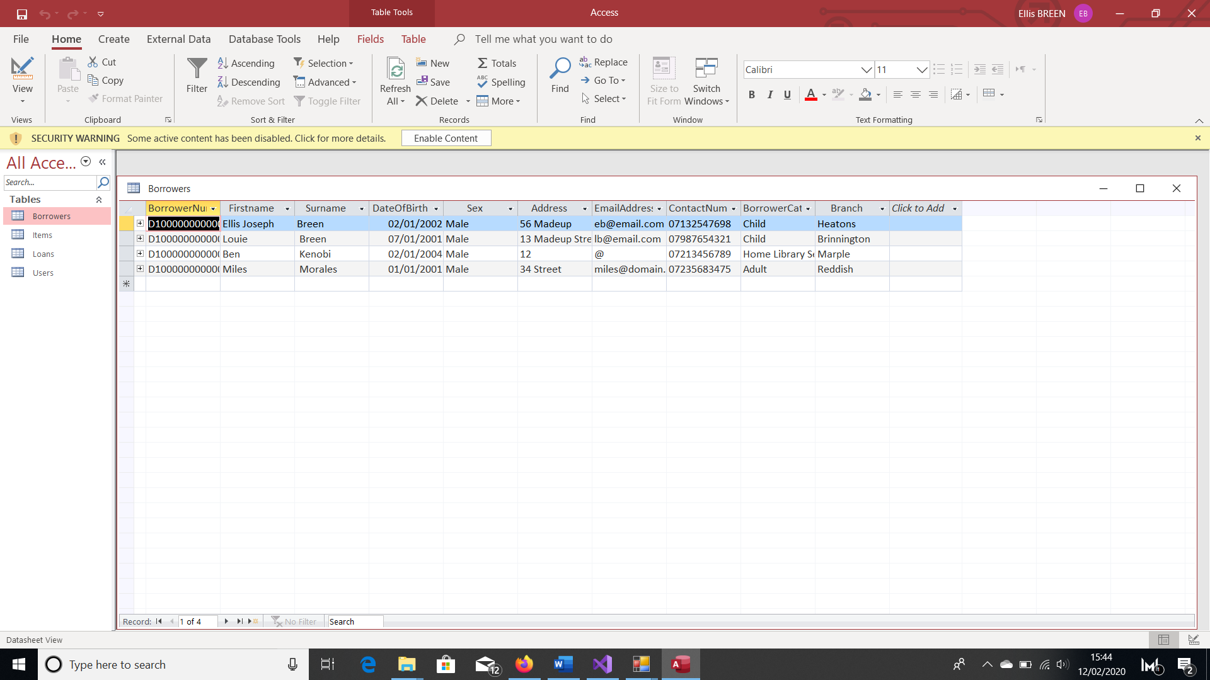

Objective 5:

1.

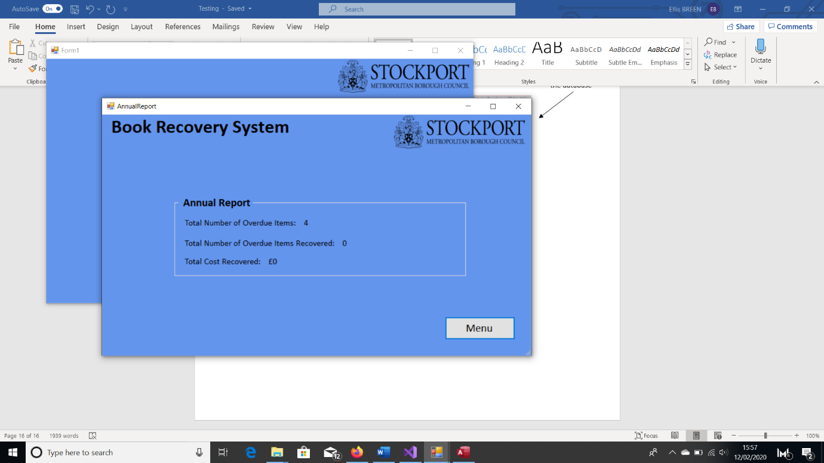Before: After:

Button pressed

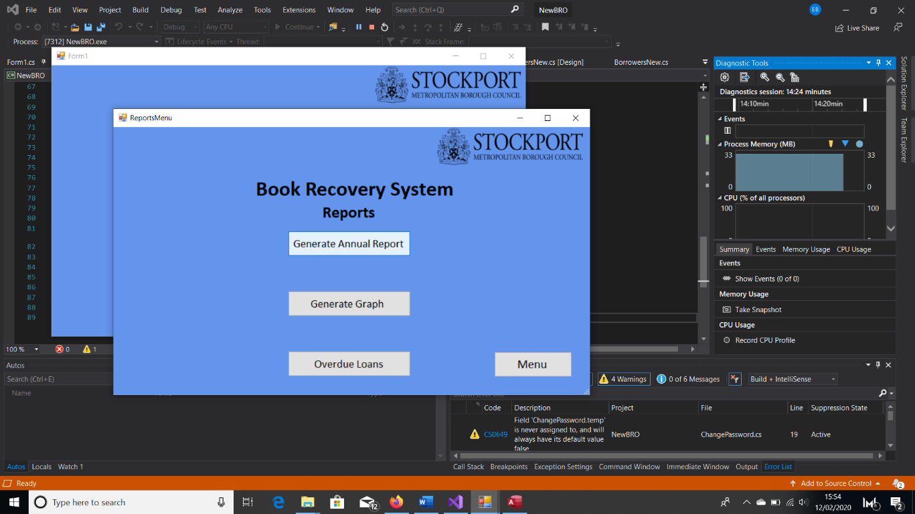

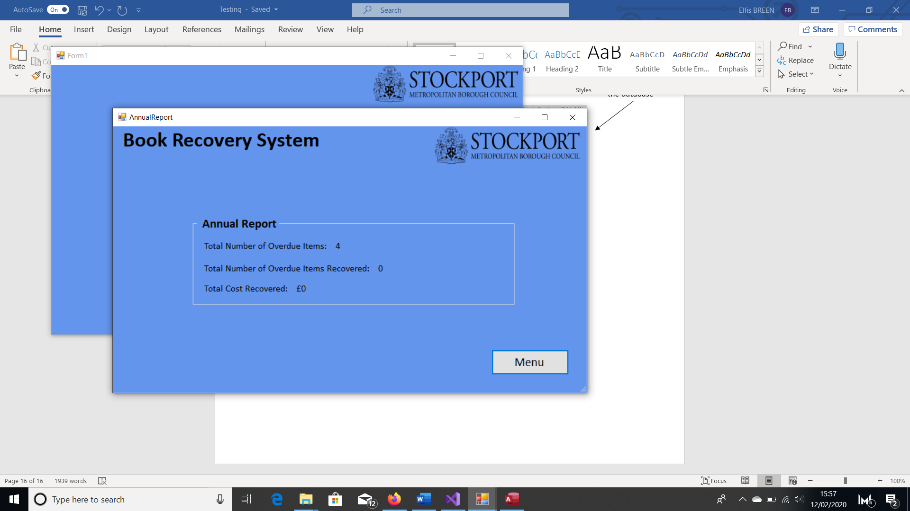2.

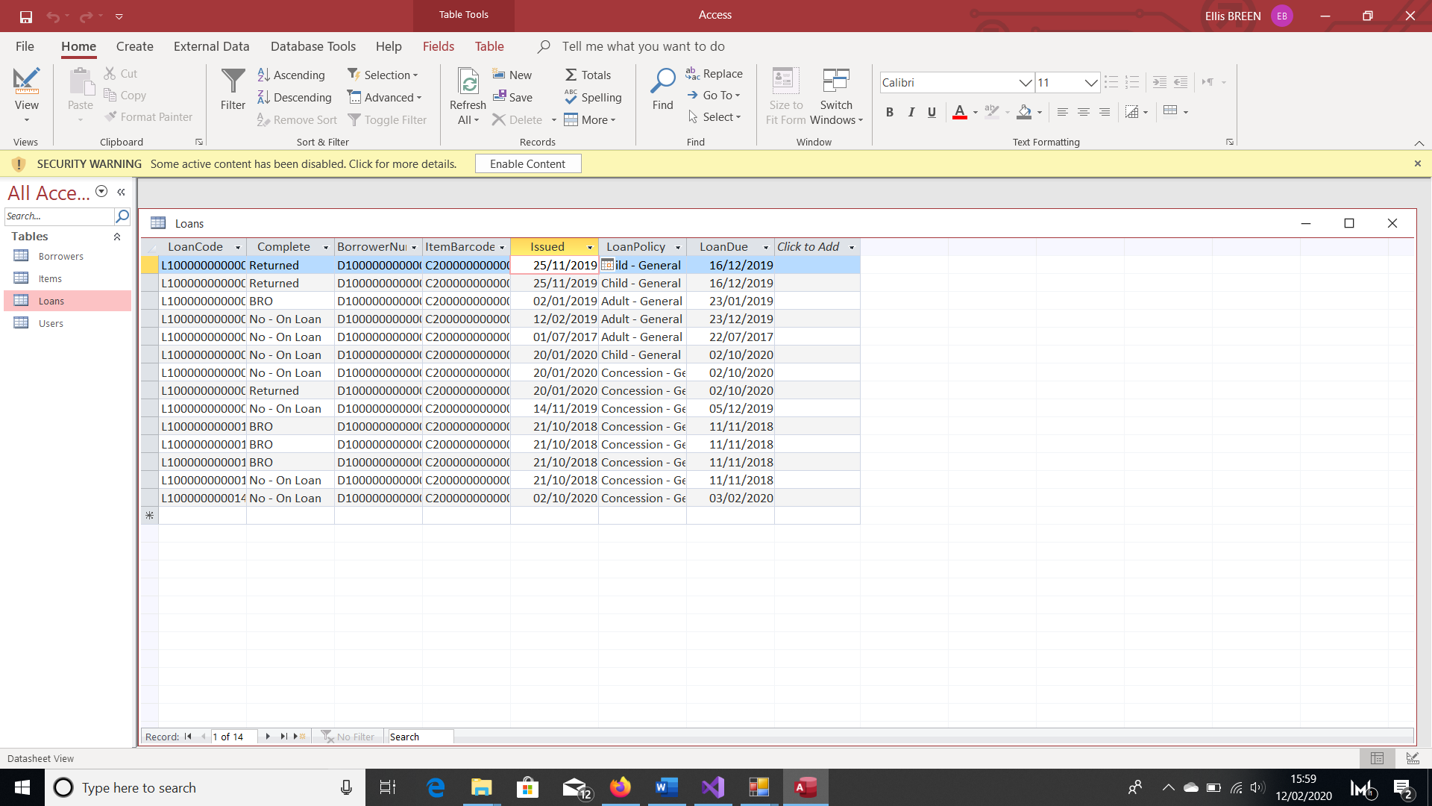

The overdue loans

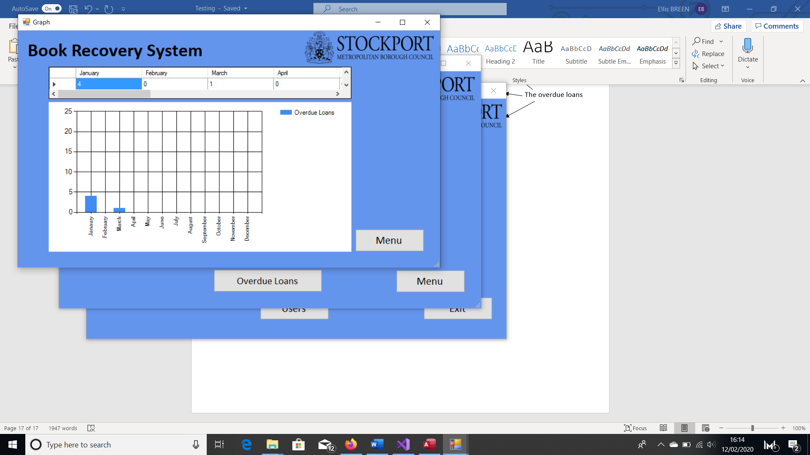3.



Loan that became overdue in March of last year

Loans that became overdue in Jan of last year

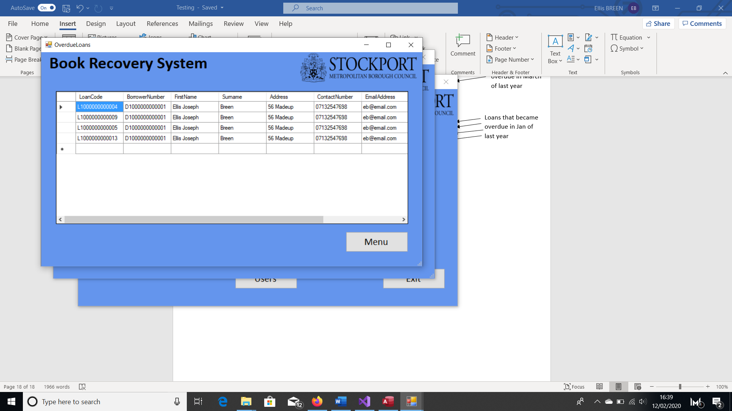4.

Objective 6:

1.

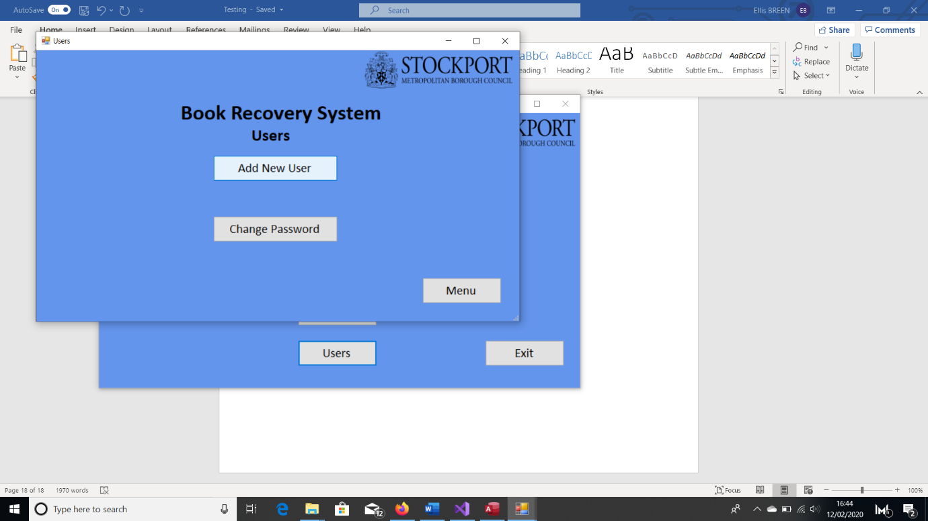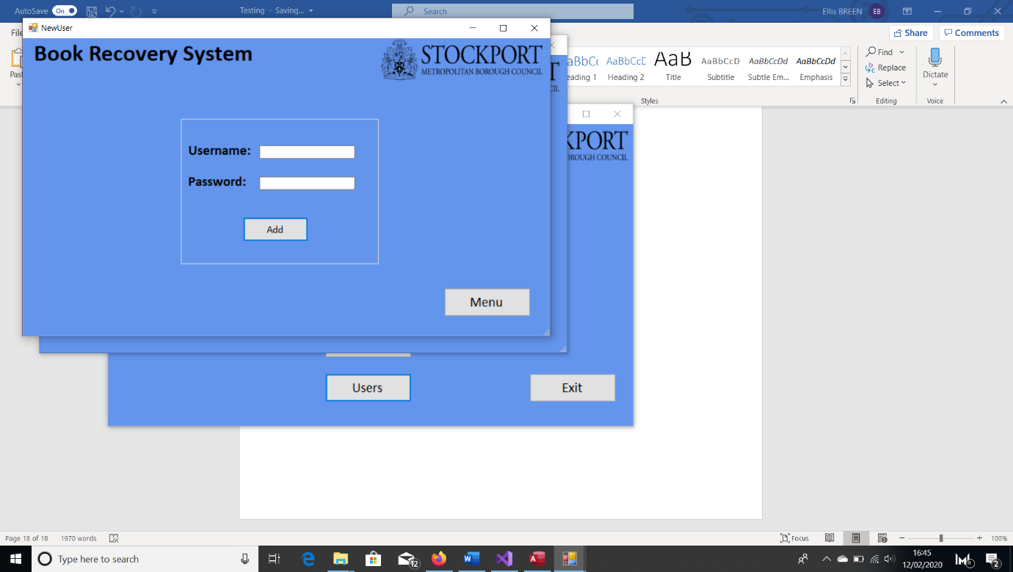Before:

2.

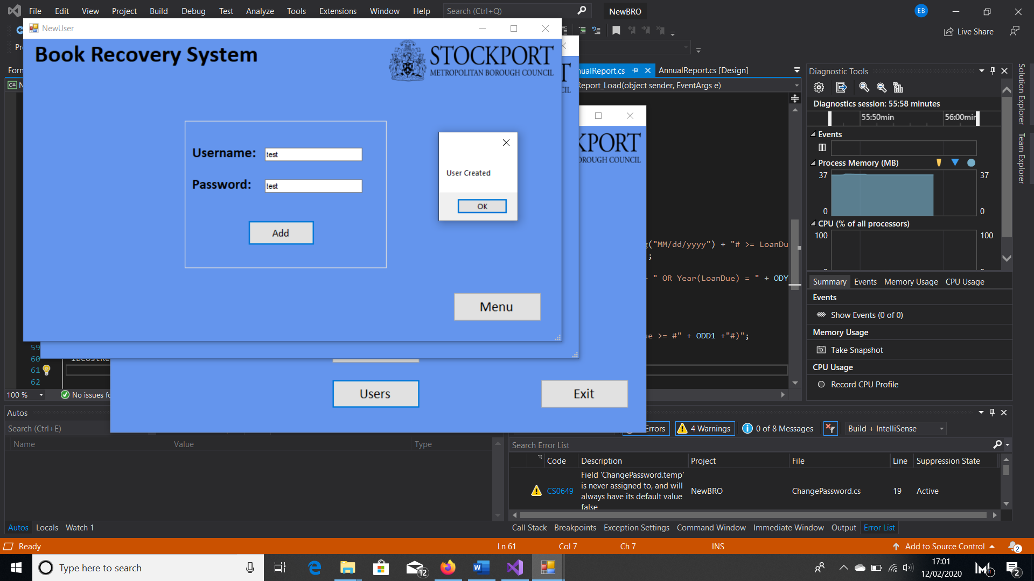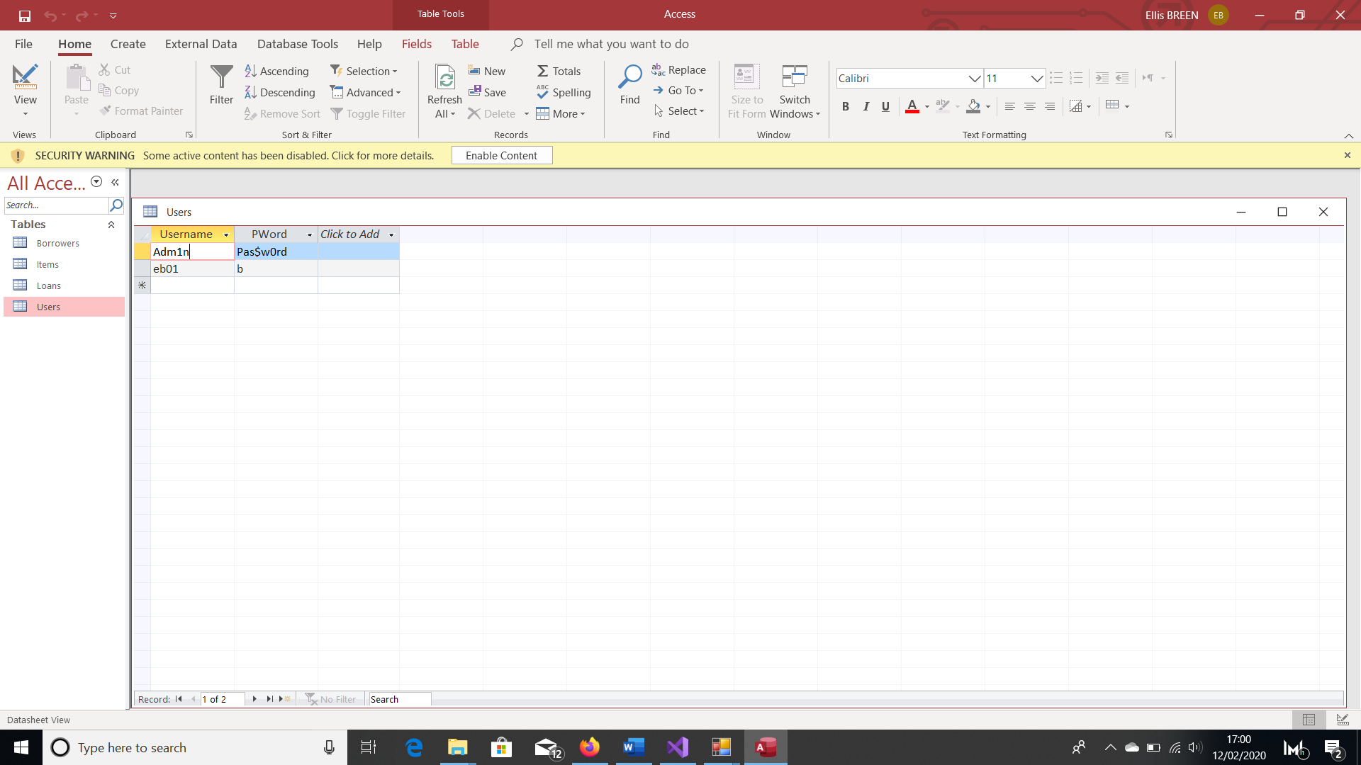

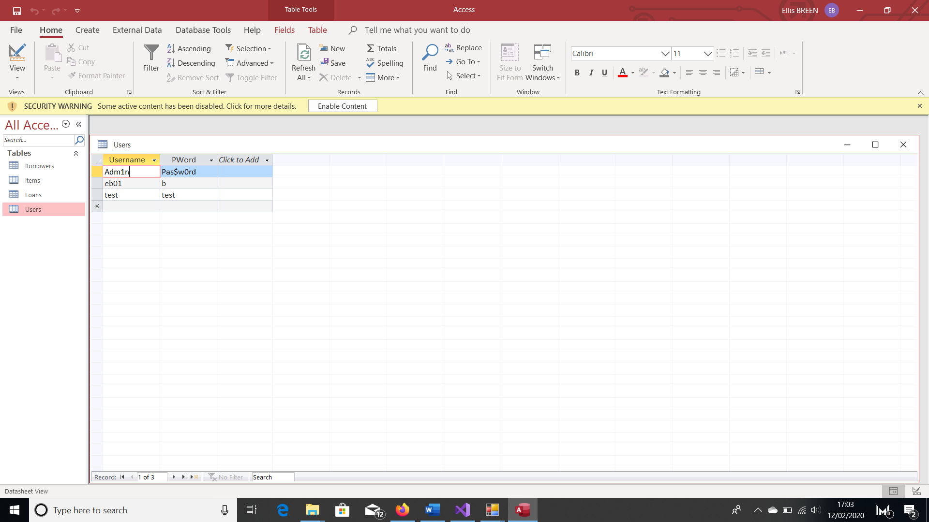

3.

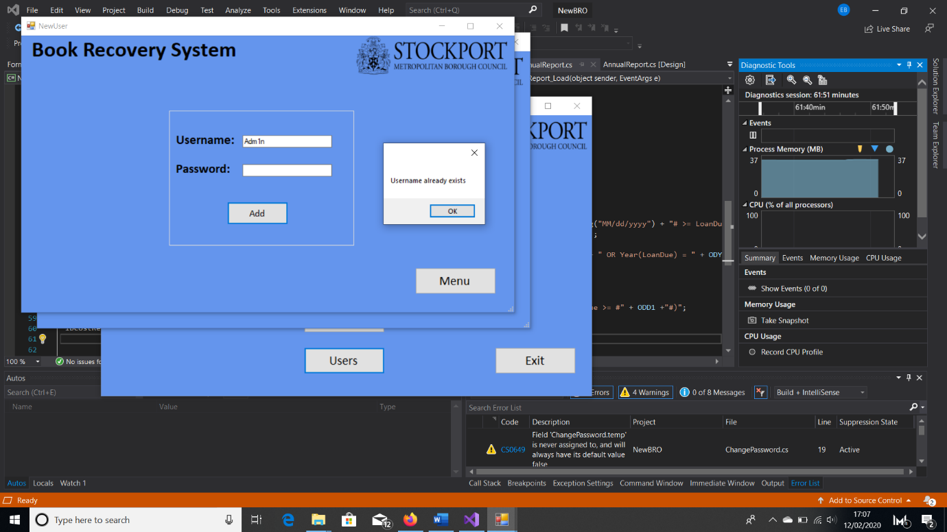

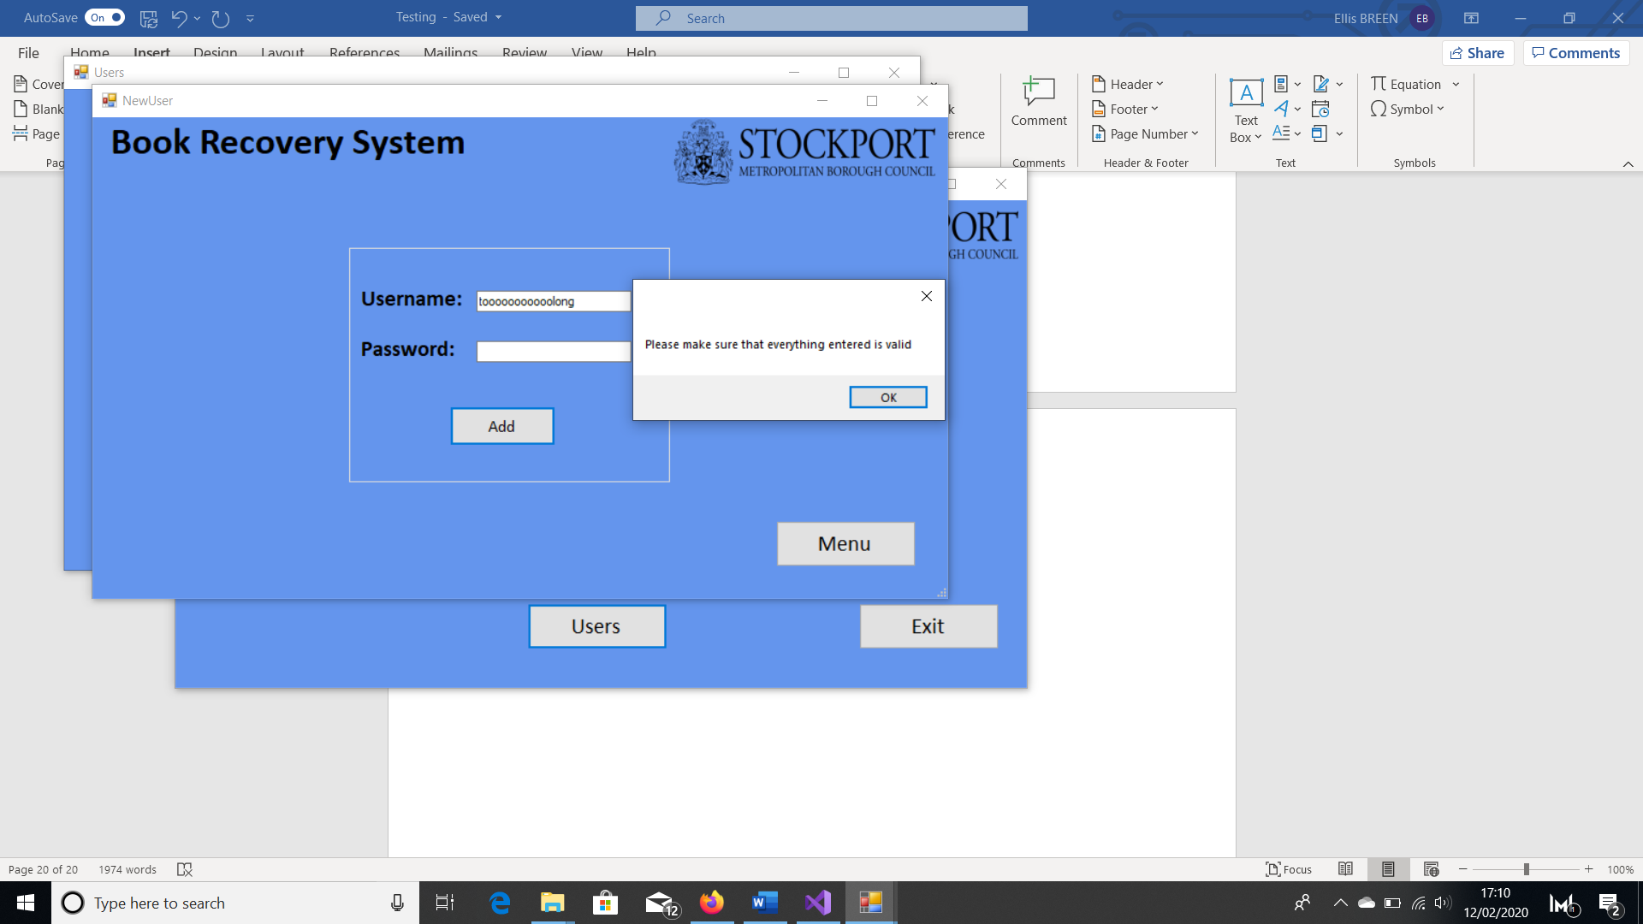4.

5.

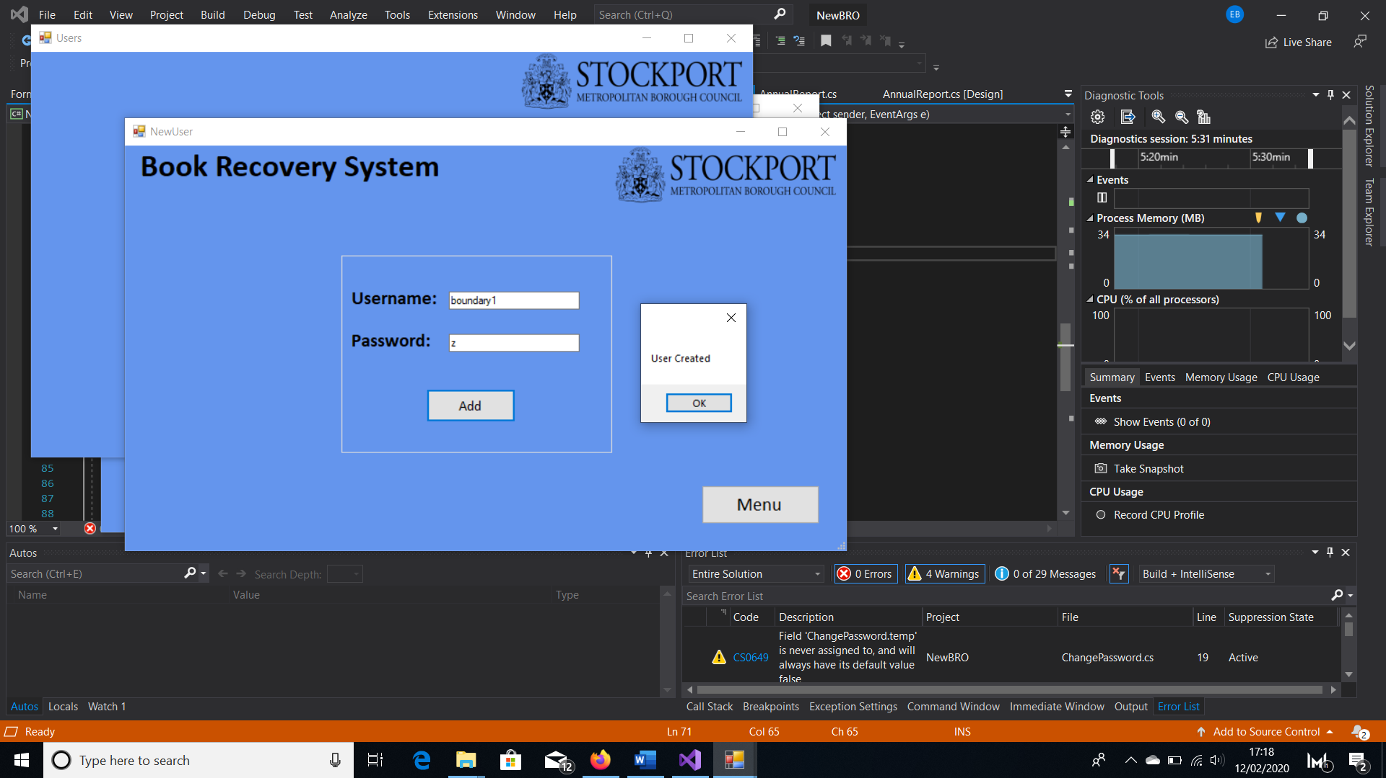

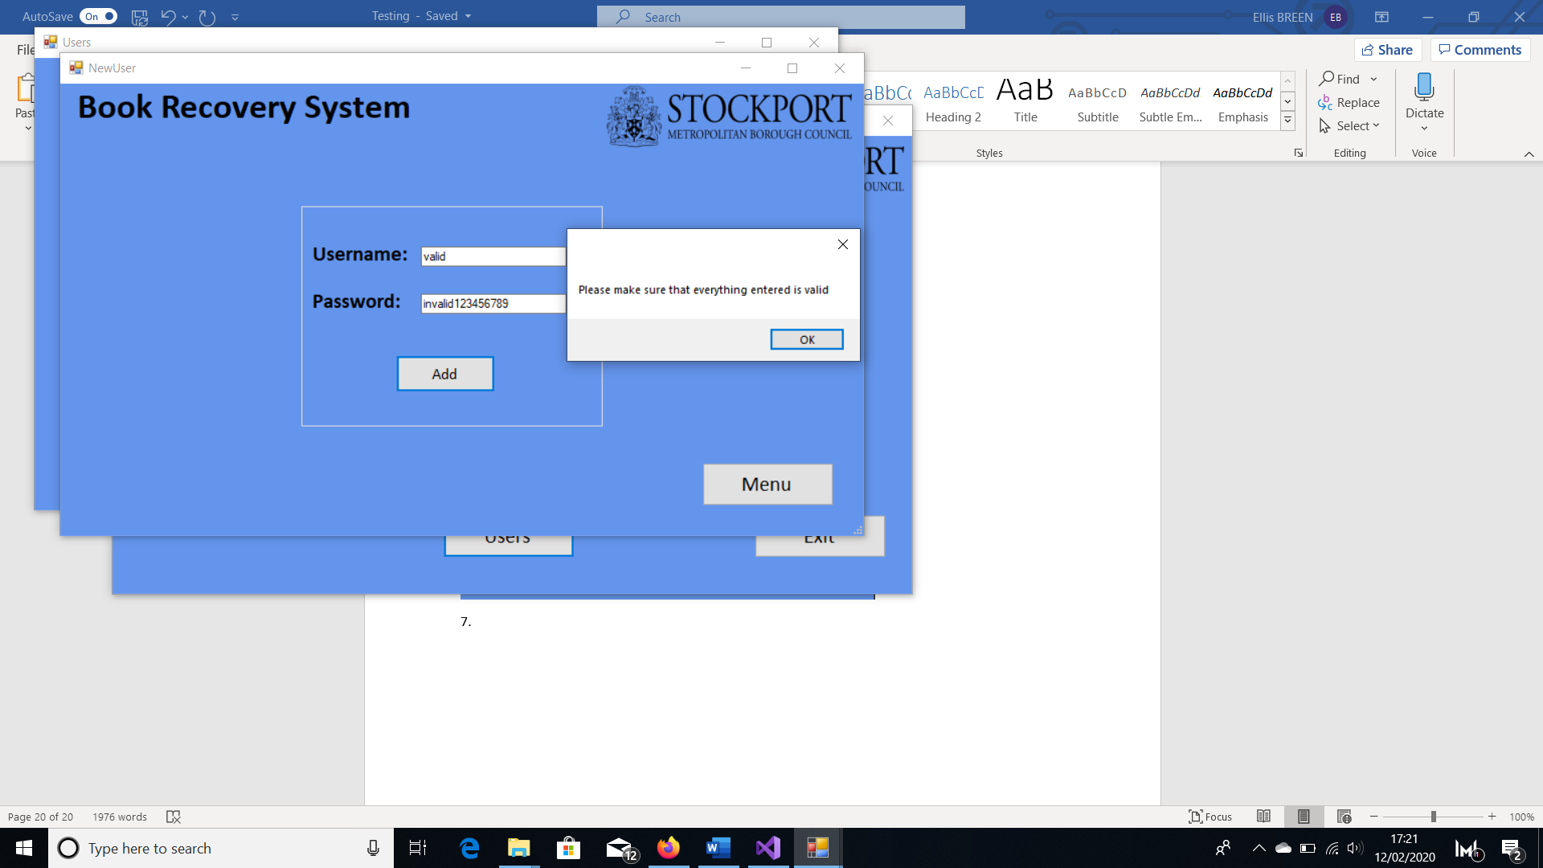6.

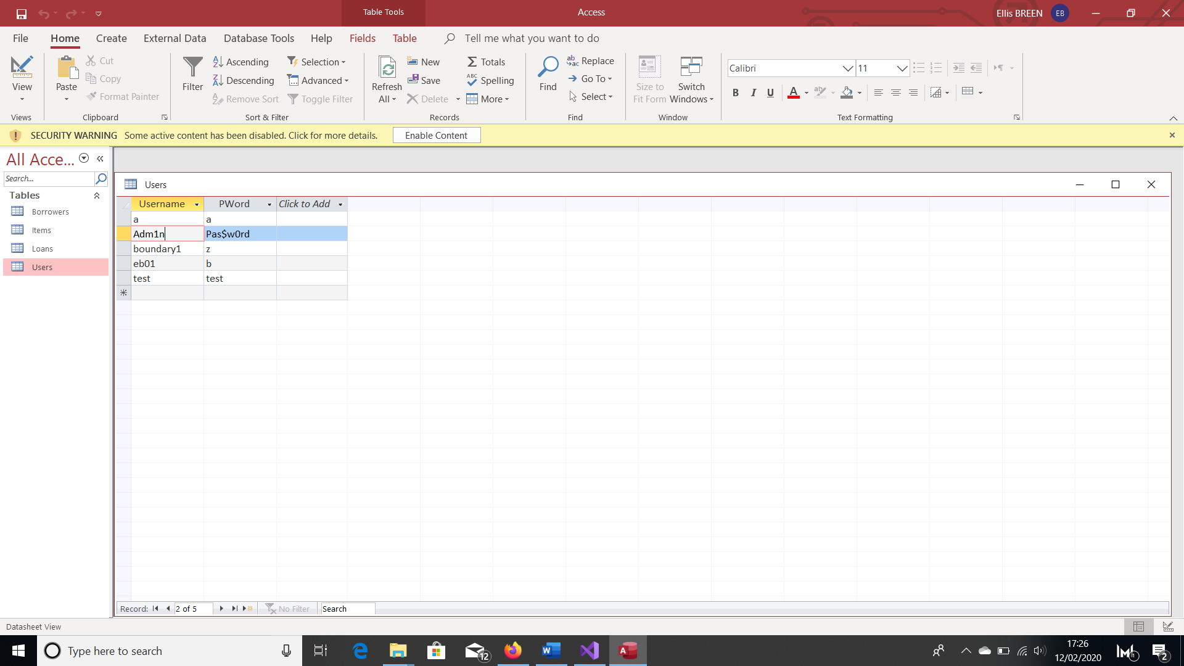7.

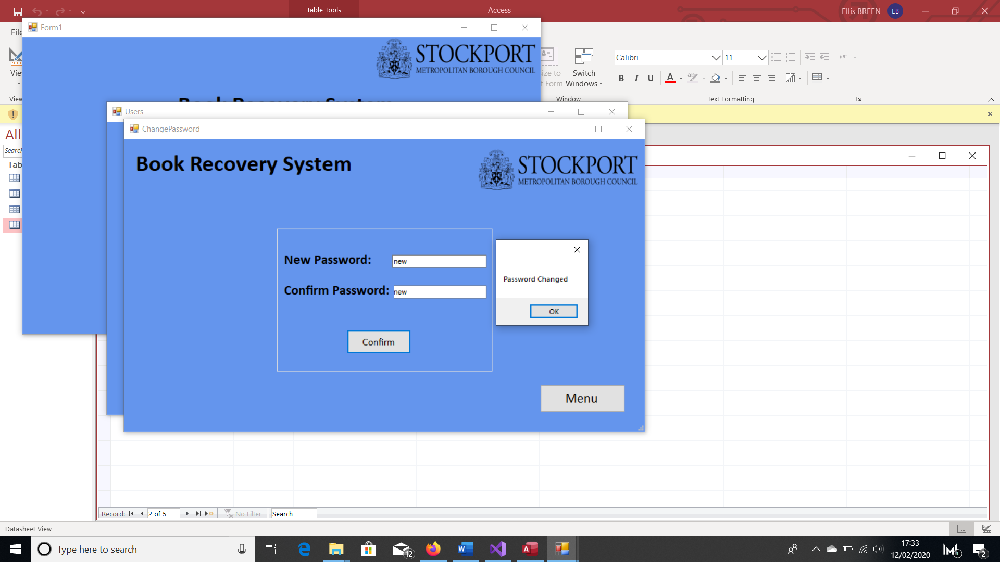

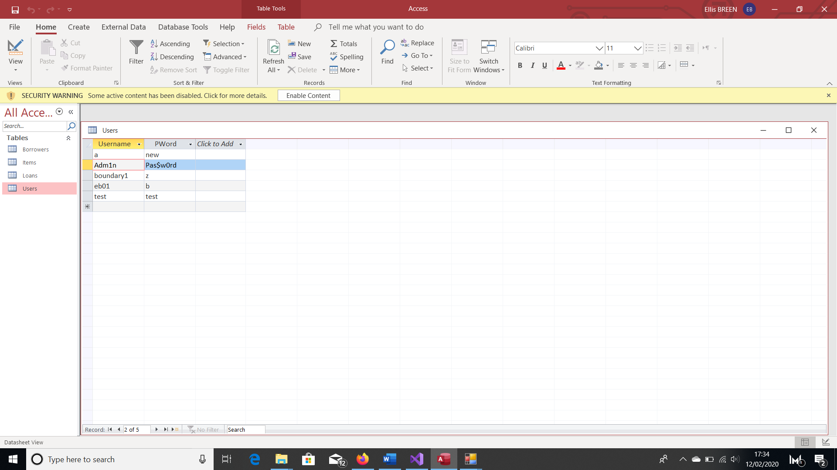

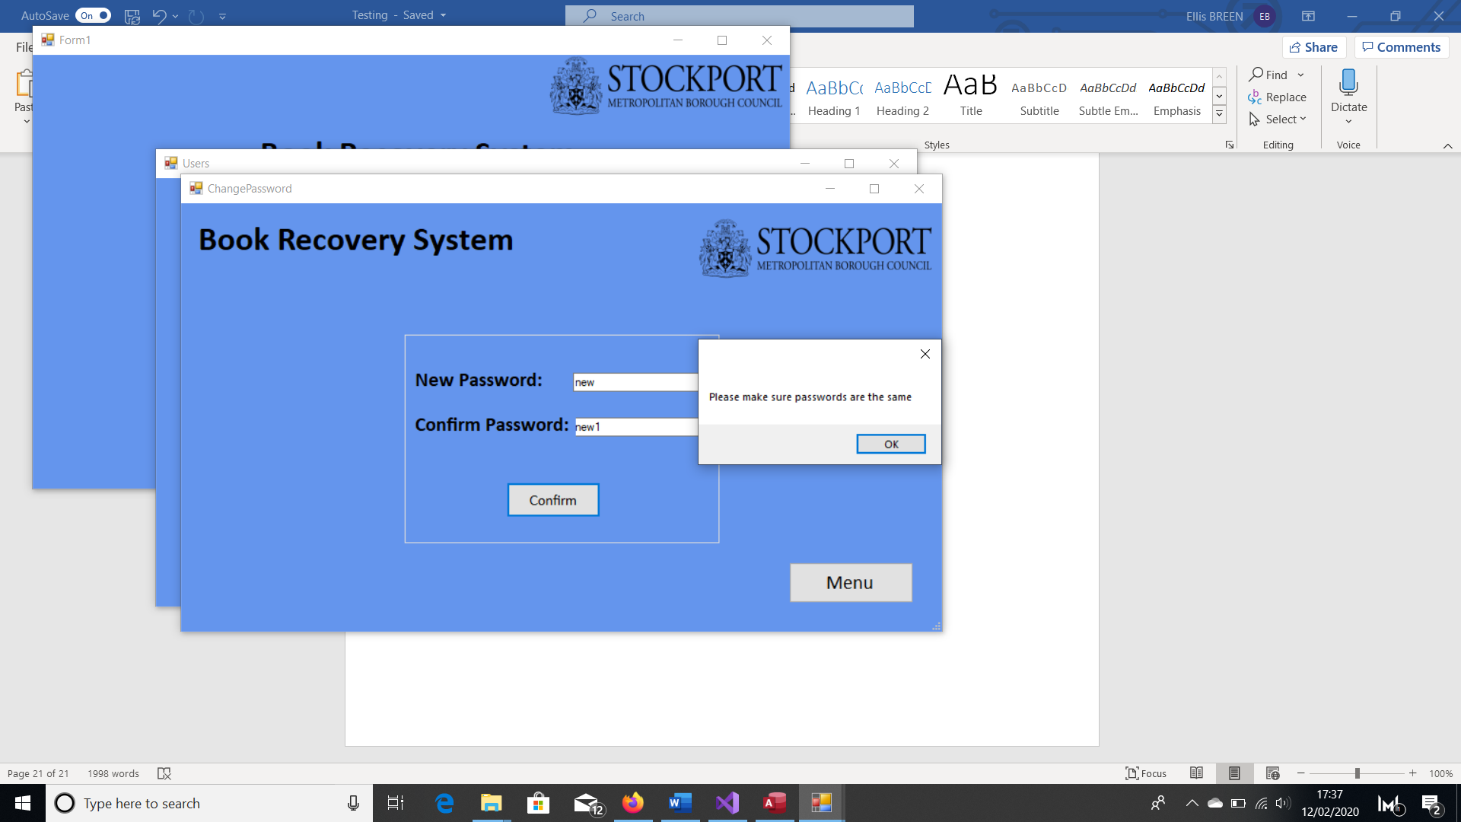8.

9.

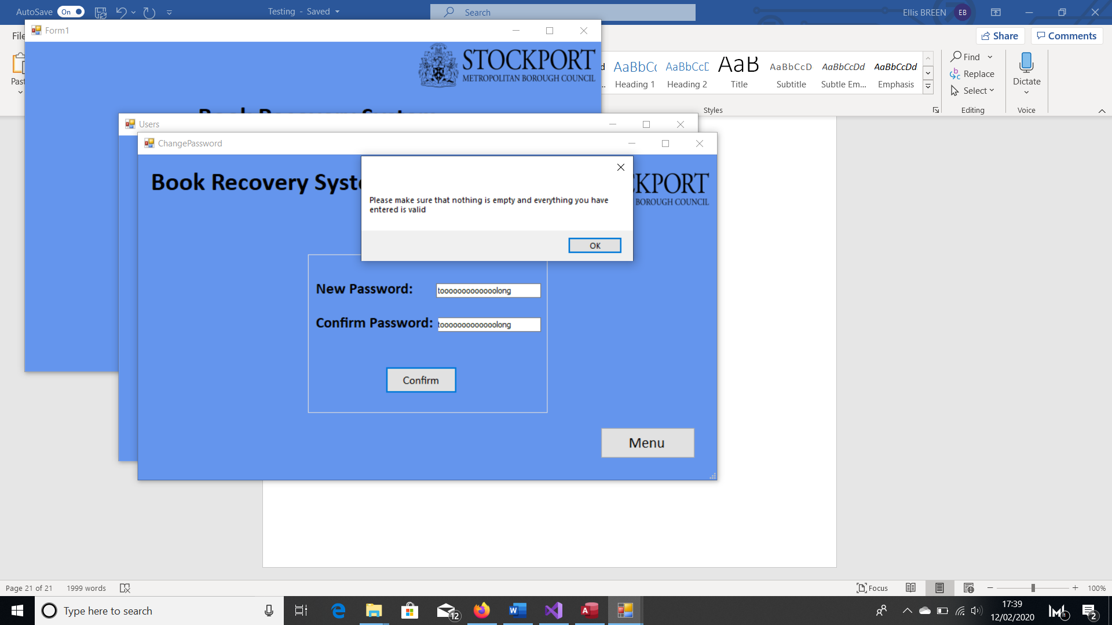

# Evaluation

|  |  |  |
| --- | --- | --- |
| **Objectives** | **How the objectives were met** | **Possible Improvements** |
| 1. When the program is first opened, the database needs to be created.    1. The program will check if the database exists.    2. If it doesn’t exist, the program will create a new database, which will include all of the necessary tables.    3. If it does exist, the program will open the existing database when needed. | Objectives met.  The program checks whether a database already exists using the File.Exists function. If the file already exists, it will use that one. If it doesn’t exist, the program uses DDL to create the database and will create an admin account by inserting the appropriate username and password into ‘Users’. |  |
| 1. Create a user interface.    1. The user will be sent to a log in screen.    2. Once logged in the user will be sent to a menu with options relating to loans, borrowers and reports.    3. There will be separate ‘Loans’, ‘Borrowers’ ,‘Reports’ and ‘Users’ menus that the user will be sent to depending on where they choose to go to from the initial menu. | Objectives met.  As soon as the program loads the user will be asked to log in. If the user enters correct log in details the menu will appear. Here the user will be able to select where they want to go next by clicking the appropriate buttons.  If the log in details are incorrect, the user will be notified and they will not be able to access the menu, but can still attempt to log in.  The program determines the validity of the log in details by looking at the ‘Users’ table in the database. |  |
| 1. Create the ‘Loans’ menu.    1. Once on the loans menu, the program will give the user the ability to add loans to the database and edit loans currently in the database.       1. When adding or editing loans, the program must check that the borrower for which the loan is for exists in the database.       2. The user must be able to choose which loan they want to edit if the borrower has multiple loans.    2. When adding loans, the program must check how many loans the borrower already has and the type of item the loan is for.       1. The loan is rejected if the borrower already has 10 items out.    3. The program must automatically enter a due date that is 21 days from the day the loan was made.    4. They can view all loans in the database or search for specific loans.       1. The program will allow the user to search for loans based off borrower number.       2. The program will allow the user to display all long overdue loans that have a total price of £25 or more. | Objectives mostly met.  If the user clicks the Loans button, they will be sent to the Loans Menu.  Here they can choose whether they want to add a new loan or view existing loans.  When a user wants to add a new loan or view loans for a particular borrower, the program checks the database to see whether the borrower exists. If the borrower doesn’t exist in the database, a message saying ‘Not Found’ will be displayed. This same message is displayed if the item to be loaned out isn’t found by comparing the ItemBarcodes found in the database with the ItemBarcode entered by the user.  Before a loan is saved, the program must check how many items/loans the borrower has currently by looking at the Loans table in the database and counting how many have a ‘Complete’ value of ‘No – On Loan’.  If it is less than 10 and everything entered is valid, the loan is added to the database.  If the borrower has 10 or more loans/items currently out, than the program notifies the user and doesn’t add the requested loan to the database.  The program calculates the LoanDue date by adding 21 days to the current date.  When the user wants to view loans, they can choose from all loans, all overdue loans or all loans for a specific borrower. This is done by them clicking on the correct radio button and entering a BorrowerNumber if needed.  When the user wants to look at overdue loans, all loans that are 51 past their due date are displayed, regardless of the total cost per borrower.  The user is also allowed to edit the ‘Complete’ value of a loan by clicking on a loan and choosing from a drop down menu which value they want to update it to. | When the user wants to add a new loans and either the BorrowerNumber or ItemBarcode are incorrect, a generic ‘Not Found’ message is displayed. The program should be able to specify which detail is incorrect to help the user in correcting the necessary one.  When looking at overdue loans, the user should be given the option to look at the total cost of all overdue loans for a particular borrower by clicking on an overdue loan made by that borrower. |
| 1. Create the ‘Borrowers’ menu.    1. Once there, the user will be able to add new borrowers to the database.       1. The user must be able to enter the borrower number, name, date of birth, address, email address, contact number, borrower type, sex and branch of the borrower into the database.    2. The user must be able to update the details of existing borrowers.    3. The user can search for the details of a specific borrower by entering their unique borrower number. This will include name, address, email address, contact number, borrower type and branch. | Objectives met.  The user is sent to the Borrowers Menu if they click the Borrowers button.  When the user wants to add a new borrower, once all of the details are valid the borrower will be added to the database.  If the user wants to search for a new borrower, they will enter the appropriate BorrowerNumber into a textbox. The program will then search for that BorrowerNumber in the database and return all of their details if the borrower is found.  If the borrower is not found, the user is notified  Once all of the borrowers details are on screen, the user can change them by editing what is in the text boxes and clicking the ‘Update’ button. The program will then use DML to update the record in the table to whatever the user has changed if it is valid. |  |
| 1. Creates the ‘Reports’ Menu.    1. Once there, the user must be able to choose what report they want to run and generate.    2. The program should be able to generate a graph showing the number of long overdue loans for each month from last year.    3. The program should be able to show the user how many items the book recovery officer has recovered over the past 12 months and the total value of the items.    4. The program should generate a report that gathers all of the information needed for collecting long overdue loans. This should include the title, author, and price of the item, name, address, date of birth and number of borrower, and the due date of the loan. This should be grouped by address/household. | Objectives met.  The program loads the Reports menu if the user clicks the ‘Reports’ button.  Here the user decides which report they want to run by clicking the appropriate button.  The program generates a graph by accessing the database and counting how many loans became over in a particular month by looking at the LoanDue date and the Complete status (has to be either ‘BRO’ or ‘No – On Loan’). Again this only takes into account whether the loans are long overdue and not the total cost.  When running the annual report, the program displays all overdue loans for the year so far, including loans that became overdue this year and loans that still haven’t been returned from previous years. It also displays how many overdue loans have been recovered by the officer (where ‘Complete = BRO’) this year, assuming that they have only recovered items that became overdue this year.  The program also calculates and displays the total cost of the items recovered by looking at the ‘Price’ value in the Items table.  When required the program also displays all overdue loans regardless of the total price and the following details required by the officer:  LoanCode, LoanDue, BorrowerNumber, FirstName, Surname, DateOfBirth, Address, ContactNumber,EmailAddress, Title, Author and Price.  This is grouped by address using ‘Order By’ in the query. |  |
| 1. Creates the ‘Users’ Menu.    1. Allow the book recovery officer to create a new user that can access the system. They should be able to enter a unique username and password.    2. If the username and password are valid, it should be stored in the Users table in the database.    3. The current user should be able to change their password, as their original password will be one created by the book recovery officer.    4. The program should allow the user to enter a new password and re-enter the new password to confirm it. If they match and the password is valid, it will be update the database and store the new password in the Users table. | Objectives mostly met.  The users can create new users by entering a username and password into the appropriate text boxes. When they press enter, the details are then checked and, if valid, are stored in the Users table.  The current user is also allowed to change their password. They enter the password into the appropriate text box, and will then confirm it by re-entering it into another textbox. The text boxes are then compared and if they match, the password is checked and updated if valid. | Currently, all users can add a new user to the database. Ideally, only the book recovery officer should be able to do this to make it more secure. |

## User Feedback

Here you can see that overall, the user is satisfied with the system, however there can still be some improvements. The first critique is that the book recovery officer wouldn’t necessarily change the Complete status of a loan. Initially, I included this because it was part of the basic library system and I didn’t have access to the machines that the borrower’s put the items in when they return them. However I extended it so that the book recover officer could edit a loan to show that they have retrieved it from a borrower once it became long overdue. This feedback shows that an overdue item is still seen as retrieved by the book recovery officer if they have just notified the borrower of the long overdue loan and they have returned it. Again, as I have no access to the machines mentioned before, I would still include a feature to manually edit a loan, but include an additional option that the book recovery officer can choose to show that they have intervened, and then once it is returned wilfully by the borrower it would update to the code that shows it has been recovered by the officer using the ‘intervened’ code as an indicator.

The second piece of useful feedback was about the details stored for each borrower. In the program and the database I have made it so that only a one address line can be entered per borrower. The feedback states that it should include multiple fields for the address. To rectify this I would change the database so that it included ‘Address Line 1’, ‘Address Line 2’, ‘City’ and ‘Postcode’ attributes, with only ‘Address Line 2’ that can be left blank. The program would also include additional text boxes to accommodate this change to the database so that the user can input what it is required.

## Additional Adjustments

Like what I wrote for objective 3, when the user enters something invalid sometimes only a general error message is displayed. To improve this, I would specify which input is invalid and the reason for it being invalid. For example, if an input is too long, the program would display which input it is and tell the user it is too long, rather than displaying the general “Please make sure everything entered is valid”.

Another improvement in order to more fully complete objective 3 is the option to show the total cost of the long overdue loans per borrower so the book recovery officer can decide which ones to prioritise when it comes to initially contacting and home visits.

Back in the User Requirements, I said that I would include the option to group long overdue loans by library. I haven’t done that yet, so in order to fully achieve this I would include radio buttons that allow the user to decide how to sort the long overdue loans, and the SQL would incorporate the user’s choice.

## Overall Assessment of Project

Overall, I think the project has been a success. It is a huge improvement of the old system, as it includes the reports needed and requested by the book recovery officer. More importantly, these reports are done wholly by the program itself, with input from the user when necessary. Previously, the book recovery officer had to run these reports manually, but as they are now done by the program it is much more efficient, saving them time and any frustration caused by the complexity of the manual reports and any human error it may entail.